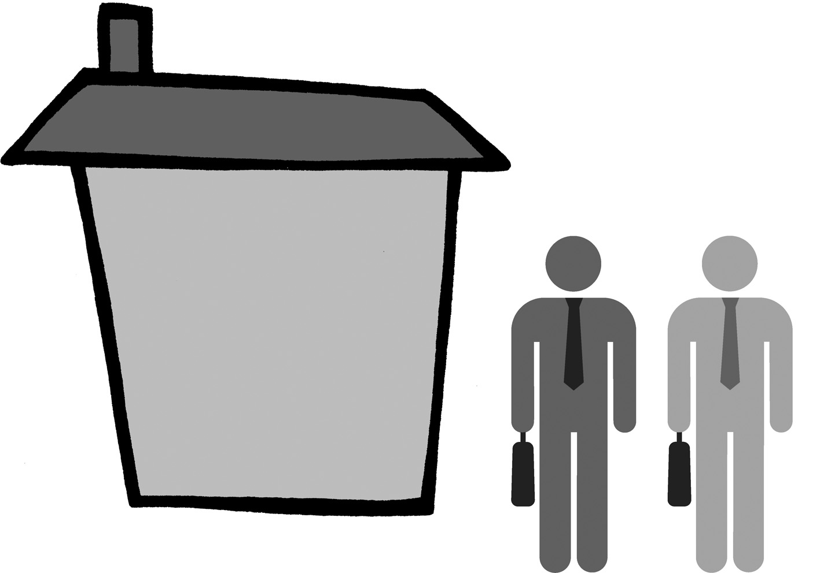
Our Sharers’ Charter
This is YOUR charter –
You & your housemates can add or change anything on it together.
Displaying it on your kitchen notice board, may be a good reminder.

We recognise that we are all responsible for the things we share in common. And so, we agree:

- To share the following and to allow each other equal access to the:
- kitchen
- washing machine/dryer
- TV, remote control and DVD

If there are any arguments over what to watch, we will…. [add what you’ve agreed]

- To be fair with our energy use – and not to have the heating on unless the others agree
- To pay our share of all bills and to contribute £[?X? ] per week to a kitty for common items such as toilet paper, washing up liquid [add what you’ve agreed].
- To take turns each week to top up the electricity meter [and gas meter].
- Not to use up all the hot water

- For reporting repairs (which are the responsibility of the Council)

We recognise each other’s right to live in a clean & peaceful environment. And so we agree:

- To keep any common areas tidy. This includes cleaning the bathroom and washing up.

- Not to play our stereo, radio or TV so loud at night that it can be heard outside our room. If our music is annoying our housemate or neighbour at any time it must be turned down.
- Not to smoke cigarettes / only to smoke cigarettes in [add what you’ve agreed]

- To tell the others in advance if we wish to have more than one visitor and to make sure our visitors do not cause any nuisance.
- Not to threaten one another and to sort out disagreements as peacefully as possible.

- To sort any damage that we, or our visitors, have caused which is our responsibility.

We recognise that we all have our own possessions and need our own space. And so, we agree:
- Not to borrow anything without permission.
- Not to use one another’s food or drink without permission
15. To keep out of one another’s rooms unless invited.
Housemate Signature & Date ……………………………………………………
Housemate Signature & Date ……………………………………………….

