

**Inverness Voluntary Transport Scheme is a project managed by Partnerships for Wellbeing**

Scottish Charity No: SCO 36055

**Inverness Voluntary Transport Scheme**

* affordable transport to community health & social care facilities

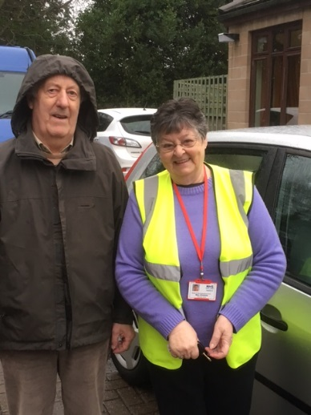Snapshot 3: Robert & Morag

***Inverness Voluntary Transport Scheme (IVTS) provides door to door affordable transport to vulnerable, frail and older people in Inverness who cannot access public transport.***

**Robert, who has dementia, lives at home with his wife, Morag. He attends the Woodland Centre in Inverness twice a week to provide him with company and support and to offer respite to Morag.**

**Before finding out about IVTS, Morag used to accompany Robert on the bus from their home down to the city centre, then catch another bus up to Woodlands. Sometimes they would miss the second bus, and had to get a taxi for the second leg of the journey. Morag, who has health issues of her own which affect her balance, would then make the same return journey, before repeating the whole process in the afternoon to collect Robert. It could take up to 2 hours each way, putting a huge strain on Morag as well as Robert. Getting there and back safely was difficult for both of them.**

**Now Meg and Annmarie, two IVTS volunteers, collect Robert one day a week and make sure that he gets to and from Woodlands safely.**

**Morag tells us:**

***“It gives me great peace of mind, knowing when Robert will be picked up and when he’ll be home. Robert feels so comfortable with Meg and Annmarie. He talks non-stop…he’s not lost his sense of humour.”***

**Morag now has more time to herself and is enjoying this valuable respite. She says:**

***“I now have time to go shopping and meet up with friends.”***

**Over time, Meg, our Volunteer, has come to know Robert and Morag. She says:**

***“I can see that the service we provide is as vital, maybe even more so, to Morag as a Carer than to Robert. When I arrive at the house, there is visible relief that someone else will take over for a short time. I am so proud of the help we give.”***