Redesign Board 17 October 2017

Management of Lets Project – Discussion Paper

Summary

This report outlines the progress made to date with redesigning the management of school lets. The redesign of the let bookings process, undertaken as a Lean project is reported to the Redesign Board separately. This report outlines proposals for future lets pricing and for making more efficient use of the schools available for lets. While school lets are relatively minor in financial terms, they have the potential to create political difficulties, particularly locally. Given this, Redesign Board is asked for views and comment on these proposals, which will be amended accordingly, and where required reported to Committee before implementation.

1 Introduction

On 18 October 2016 The Redesign Board considered a business case for the transfer of Catering, Cleaning and Facilities Management (CCFM) and secondary school Janitors from Care and Learning to either High Life Highland or Development and Infrastructure. The transfer included responsibility for the management of lets, itself subject to an ongoing review in Care and Learning. On 27 October 2016, full Council agreed the recommendation of the Redesign Board for the transfer of CCFM and Janitorial Services to the D&I with effect from April 2017.

The transfer is now complete, with the creation of a comprehensive Property and Facilities Management (PFM) service in D&I. With regards to the responsibility for the management of lets, a project was set up to complete the lets review and to create a new lets management system.

2 Management of Lets Project

The objectives of the project are:
- Increase public and community use of schools and other Council buildings
- Generate income to cover both the full cost of providing the service and earn income for the Council
- Provide a quick and efficient lets booking system
- Provide a seamless approach alongside HLH and PPP schools
- Reduce the administrative burden on HTs, school offices, RPOs.

The project comprises the following four areas of work:
- Rationalise properties available for lets
- Income and charging
- Design an improved process for booking
- Develop the letting business.

1.2 Current Management of Lets

HC lets school facilities to internal and external users outwith school hours (evenings and weekends). The arrangements depend on the type of school:
- In PPP schools (15 schools financed through Public Private Partnerships), lets are mostly booked through the Council and are facilitated by the contracted FM service providers (Mears or Mitie)
- In non-PPP schools lets are booked through the Council (School Office and Business Support) and facilitated (open, set up, close etc.) by PFM staff
- In some PPP and non-PPP schools lets are managed by High Life Highland (HLH). This mostly applies to the leisure facilities attached to community (secondary) schools although there are also primary schools where lets are managed by HLH (e.g. Ben Wyvis).

Lets charges are broadly in line with 2009 Council policy which standardised prices charged for sporting facilities, meeting rooms, halls and theatres at schools and leisure centres. The policy introduced charging bands for community groups (“Band A”), and for semi-commercial (“Band B”) and commercial operators (“Band C”) as well as 50% discounts for activities exclusively for under 18s, full time students and over 60s (see Appendix 1 for current price list). High Life Highland charges for lets are based on the same policy, however different year on year increases have been applied by HC and HLH in the intervening period, leading to a divergence in pricing.

1.3 Profile of Current Lets

- In 2016/17 there were a total of 10,206 lets in non-PPP schools and a further 3,153 in PPP schools giving a total of 13,359. The total duration was 33,074 hours (average duration of approx. 2.5 hours)
- Lets took place in 96 schools (roughly half of all Highland schools) although only 30 schools hosted more than 100 lets per year: roughly 3 per week in term time (38 weeks)
- The majority of lets (70%) take place in schools in Inverness and Nairn ASGs. There is also significant letting activity in Thurso, Fortrose and Invergordon ASGs
- Lets are mainly for classrooms/meeting rooms (31%), small halls (30%), large halls (22%) and sports pitches (grass and all weather) (12%)
- Lets appear to be declining. Full financial year data is only available from April 2016, however a report to ECAS in August 2014 estimated annual use at 50,000 hrs based on data gathered Aug 2013 to April 2014. Compared with 16/17 volumes, this indicates a decline of one third over 4 years. A comparison of lets Apr-Sept 16/17 with Apr-Sept17/18 (see Section 5.2) indicates a further decline of 25% in the number of lets.

1.4 Lets Income and Costs

Income
- The total income for 10,206 lets in 89 non-PPP schools was £138,660 (average £13.59 per let or £5.66 per hour)
- The total income for 3,153 lets in 7 PPP schools was £79,905 (average £25.34 per let or £9.33 per hour). Millburn Academy alone generated £60,139
- 6,647 lets, half of all lets, were not charged for.

Costs
- The “whole” cost of making Council facilities available for public use is difficult to quantify exactly. The principal costs are:
  - PFM staff to facilitate the let (opening, closing, set up, etc.)
  - School office and Business Support staff to process bookings and invoice for payment
  - Wear and tear resulting from the additional use for lets
  - Consumables (for example soap, hand towels) used during lets
  - Utilities.
- An estimate of current costs in non PPP schools is approx. £254,000, but this does not include utilities, indicating income does not cover costs in non-PPP schools
- In PPP schools, lets costs, including utilities are covered by the contract cost and cannot be separated. However in 2013 the Council negotiated additional out-of-hours access to accommodate lets. The current cost of these is £30.30 per hour, although this does not include the cost of booking which the Council administers
- The current Council approach to covering costs is to provide a budget to cover costs and then to recoup some or all of that through income budgets.
Income from lets in non-PPP schools is paid into a PFM income budget, which is used to partly offset facilitation (i.e. staff) costs. Income from PPP lets is received in Education non devolved budgets from which PPP contract costs are met
- In 2016/17 non-PPP income almost achieved the income budget of £139,705 and PPP income delivered a surplus on an income budget of £68,120; total from lets: £218,565 income against budget of £207,825.

1.5 Savings Target

The 15/16 and 16/17 budgets allocated following savings to the school lets income budget.

Cttee Date | Ref | Description | FY | Saving (£m) | Note
Dec 2014 | C&L27 | Consistent application of 2009 charging policy | 2015/16 | 0.020 | Achieved
Dec 2014 | C&L27 | Consistent application of 2009 charging policy | 2016/17 | 0.020 | Achieved
Dec 2014 | C&L28 | Removal of free lets | 2016/17 | 0.150 | Partially achievable
Feb 2016 | C&L/RES/15 | Additional lets income | 2016/17 | 0.035 | Achievable
 |  | Aggregate |  | 0.225

The position on 1 April 2017 (start of FY17/18 and the date of transfer of responsibility for lets from Care and Learning to Development and Infrastructure) is set out below:

 | Saving (£m)
Aggregate saving | 0.225
Amount achieved by 1 April 2017 (date of transfer C&L D&I) (ref C&L 27) | 0.043
Outstanding saving still to be allocated to budgets (ref C&L28, C&L/RES15) | 0.182

Care and Learning has identified one-off savings/ income to cover the £182K saving in 17/18, meaning that a temporary solution has been found for the current year only; from 18/19 the saving will need to be found, presenting a risk for future years. Of £182K, the £35K additional income target is achievable in 18/19, but the £150K target for removal of free lets (Ref C&L28) will be extremely challenging, because, as outlined in Section 5 below, charging free lets will only yield a maximum of £40K assuming current letting volumes are maintained.

The saving against free lets was based on a pro rata estimate of the value of free lets made in the 2014 report to ECAS, the best information available at that time. However, analysis by this project, based on a more robust dataset collected in the intervening period, has found this estimate to be high for three reasons:
- The volume of lets has declined by a third since 2014 (and this trend appears to be continuing)
- The estimate was based on 12,000hrs of free lets that could be charged for, whereas the Lets Project has found that only approximately 3,000hrs are free lets that could be charged for (i.e. the majority are non-chargeable school lets)
- The 2014 estimate assumed that free lets followed the same balance of Bands A and B as other lets, however free lets are almost all Band A and approximately three quarters of these qualify for 50% discount as participants are under 18s.

Given the current budget is £208,497 (including PPP and non-PPP schools where lets are not managed by HLH), the budget would need to increase to £390,526 to recoup the complete saving which means that lets budgets would be £171,289 in deficit, based on 16/17 out-turn. Options for addressing the deficit by reducing costs and/or increasing income are examined in the following sections.

2. Control Costs

2.1 Redesigned Booking Process (Lean)

The booking process is being redesigned as a lean project. Once implemented the redesigned process will deliver an improved service by reducing the amount of time it takes to complete the process and by eliminating duplication and non-productive steps. It will reduce the admin burden on HTs and reduce costs by reducing the need for school office involvement. The creation of a central booking function (in PFM), managing lets based on pre-agreed times and facilities in the schools open for lets, will allow consistent and rapid allocation of PFM staff to facilitate lets. Furthermore a central booking function will ensure consistent and transparent application of the pricing policy.

2.2 Rationalise the Schools Open for Evening Lets

The project aims to direct lets to selected premises in each Associated School Group (ASG) delivering a more efficient use of staff and premises. A review of premises will be carried out on an ASG by ASG basis, in consultation with HTs and will follow the following principles:
- Facilities – the schools with the best facilities should remain available - often these are situated at the secondary school in each ASG
- How busy – lets should be focused in the busiest schools to minimise disruption and to support community activity
- PPP2 – where appropriate, lets should be directed to PPP2 schools to ensure that the contracted allocation of hours is fully utilised
- Local facilities – account needs to be taken of local facilities so that using schools does not undermine the viability of community run facilities.

In the busiest and fully serviced/ staffed facilities, much shorter booking lead times should be possible for pre-agreed facilities and time slots. Otherwise, reducing the number of facilities open for single lets reduces the need for staff and reduces wear and tear and utilities costs. In fully serviced facilities re-organisation of rotas will reduce the need for overtime, although it is noted that all daytime/evening to 10pm weekend working (straight time or overtime) is paid at time-and-a-half. Having facilities that are staffed and serviced during lets also supports implementation of Council security policy, and ensures buildings are safe for users.

All schools, whether available for lets or not, will still be able to host their own evening activities e.g. parent evenings, school concerts, fundraising events etc. Where PFM support is required for these events, it will booked as at present. Note, it is also important that even where PFM staff are not required to facilitate a school event, a record should still be kept of the let for security and liability purposes. A quick, “light touch” process will be required for this. Similarly many schools are busy up to 6pm with after school clubs and activities, including Active Schools and other sports clubs and activities. These will continue to be available in all schools and current building closing arrangements will continue. Where schools are selected to open for evening lets, the school will get first refusal on slots and be able to block out dates in the calendar to ensure facilities are available for school events.

70% of lets take place in Inverness and Nairn ASGs. These will be the focus for the first stage of rationalising premises available for lets. Thurso, Fortrose, Invergordon ASGs also have significant number of lets, In many rural areas there are very few lets recorded (11 ASGs had fewer than 100 lets in 2016/17), suggesting the only suitable approach is to accommodate lets on request where resources are available, as at present.

The project is piloting the ASG by ASG rationalisation in Culloden ASG. Following discussions with HTs agreement has been reached that lets will be accommodated in Culloden Academy and Cradlehall PS with existing lets in Smithton PS honoured. There are few or no lets in Ardesier, Balloch and Croy. There are lets at Duncan Forbes Primary but it is very close to Culloden Academy where evening lets will be directed, although after school activities will continue as at present. Detailed discussions are now required around which facilities and time slots will be available for lets in those selected schools; to address any concerns or safety issues (e.g. ensuring safe fire escape routes); and to ensure after school activities in other schools can still be accommodated.

2.3 Staff Costs

There is significant scope to reduce staff costs associated with facilitating lets. Rationalising school premises will reduce the overall need for staff and better management of rotas will reduce the need for overtime. Detailed work on the actual reduction in costs associated with lets can only be completed once it has been agreed which schools will offer lets and once staffing allocations under the roll out of FM are completed.

2.4 Contribution to Savings

The cost reductions outlined above are not savings - the reduction in staff requirements frees resources so PFM can provide Janitorial support to all Highland schools including 42 currently with no cover and a further 70 or so with peripatetic Janitorial support. Therefore the reduction in costs reduces the need for additional expenditure elsewhere to deliver a service commitment to all schools agreed by the Council rather than a direct cashable saving. Similarly, the reduction in school admin and HT time required to administer and approve lets will release resources that can be put to more effective use supporting the management of teaching and learning in the school (Management of Schools), but no direct cashable saving.

Therefore all efforts to meet agreed savings must come from increasing income.

3 Strategic Approach to Income

It is important that the Council defines and sets out its commercial strategy to inform the future direction for commercial activities such as lets in Council buildings. There are a number of approaches that can be taken:
- Provision of a subsidised service that supports community activity by making facilities available at minimal cost
- A cost based approach to pricing where the Council aims to cover its costs and generate surplus for investment in the service and facilities
- A competition based approach that benchmarks prices against the competition
- A profit maximisation approach that charges the maximum the market will bear and only opens profitable facilities
- A demand based approach that uses dynamic or differential pricing to maximise income from high demand facilities.

The approach proposed for lets would be a mix of b) and c) although in time as the lets service develops demand based pricing may also have a role.

4 Effective and Efficient Charging

4.1 Central Booking Function

Effective charging will be supported by the establishment of a central booking function (in PFM) to ensure consistent and transparent charging. There is some evidence that charging is inconsistently applied by different schools, partly through a lack of clarity as to which organisations and events are eligible for free lets and for community rates. The classification of lets need to be made clearer, and this will be effectively supported by a central function which can develop a “case history” of decisions.

4.2 Revise Pricing Schedule

The project has considered a range of sources/ approaches to revising the pricing structure:

Other Local Authorities
Analysis shows current Highland prices are broadly in line with the average Scottish Local Authority prices for sports facilities (sportscotland research), although Highland charges for all weather pitches and for changing and floodlighting are significantly lower than the Scottish average. With regards to meeting rooms, HC rates for community users are significantly less than other Highland providers, both hotels and community centres/halls and other LAs (project research). This is principally because the HC Band A (community) rate (£10.35) is for up to 3 hours whereas other providers charge similar amounts per hour. For Band B (semi-commercial) HC charges an hourly rate of £20.90 which is comparable with commercial providers.

High Life Highland
Like HC rates, High Life Highland lets charges are based on 2009 Council policy, although it introduced some changes that simplify the price structure including for example, an hourly rate for meeting rooms (not “up to 3 hr” rate), pro rata charges for all weather pitches, and no 25% surcharge for weekend use. Since its formation in 2011, High Life Highland has consistently applied 5% increases in the intervening period, whereas the Council has not, leading to a small divergence in pricing. There is a strong case for HC and HLH charging the same prices for the use of the same facilities, in line with the original aims of the 2009 policy.

Costs
Covering costs is another approach on which to base prices and to achieve a project objective. However, as outlined in above, it is not easy to determine the whole cost of lets incurred by the Council and this is reflected in the disparity between costs and income budgets.

4.3 Well Defined Facilities

There needs to be clarity about some of the facilities – for example it is not always clear what is a MUGA (Multi Use Games Area) and what is an all-weather pitch. HLH has resolved this by establishing a standard charge for all weather pitches and charging pro rata for half or third of a pitch (e.g. 5 aside plays across a third full sized pitch). It is proposed that HC replace the MUGA rate with a pro rata all weather pitch rate. The Council needs to be more consistent and diligent in charging for changing and floodlighting as there were practically no charges for either in 2016/17 despite both being used regularly in the locations that make them available. Effective charging will be supported by a comprehensive database of the facilities available at each school, to assist with charging decisions.
4.4 Exclusive Use and POA rates

There have been instances where an organisation has either hired a whole school or required exclusive use of the school for a day/ weekend (for example Feisean events) and been charged per hour for each classroom/ facility used resulting in very large bills. Further thought is required on charging levels - one approach may be to have a maximum price per hour / maximum daily rate so that events that exceed this are charged at the capped rate. It is important that capped rates do not undermine the pricing logic – so for example it should be more than the hourly rate for the most expensive facility in each band. For whole day rates the level should cover costs plus a margin - for example at weekends staff costs are approx. £30/hr

Given this suggested maximum charges could be set at:
 | Band A | Band B
Max hourly rate | £75/h | £125/h
Whole day rate | £300/day | £500/day

Another way to deal with whole school lets, particularly for commercial events is to negotiate a price on application (POA). This would particularly apply where there are high charging or one-off events (such as concerts) or where high charges are the norm, for example for commercial filming or providing a base for filming. Guidance and criteria would need to be developed.

4.5 Summary of Proposals to Support Effective Charging

- Create central booking function
- Increase and consistently apply charges for changing and floodlighting
- Replace MUGA with pro rata all weather pitch rate
- Consider increasing all weather pitch prices to be comparable with Scottish average
- Change the Band A meeting room from 3hr flat rate to a per hour rate
- Remove weekend surcharge (25%)
- Clarify eligibility criteria for each band to improve transparency
- Introduce POA rate for significant events
- Introduce exclusive use rate or cap for large scale/ exclusive use
- Develop comprehensive guidance/ criteria to ensure consistency and transparency
- Review Terms and Conditions.

5 Review Free Lets

5.1 Who Gets Free Lets?

Free lets currently make up 50% of lets in all schools representing significant cost and unrealised income. These free lets fall into several categories - see chart below:

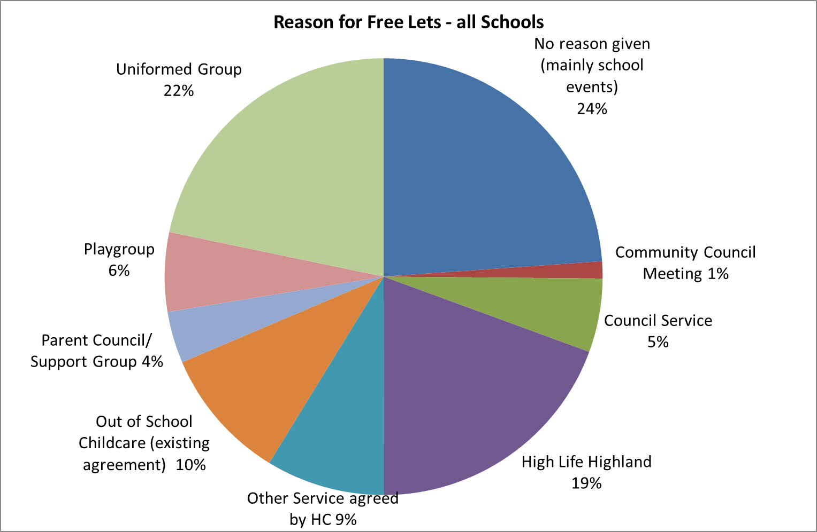

A report to ECAS Committee in August 2014 proposed that only school activities should be free of charge. The report provided a comprehensive list of activities that would qualify:
- School-related events e.g. parents’ nights, school discos, concerts, school sports teams’ practices and matches, information sessions
- Parent Councils – for regular meetings
- Parent Support Groups – for regular meetings
- Fundraising activities that directly benefit the school for example, events organised by schools, pupils or parents for school funds or school trips
- Activities directly organised and under the control of Active Schools’ Co-ordinators and that are delivered as an integral part of the Active Schools’ programme
- Activities that are part of the defined curriculum but happen to take place after school
- Extra-curricular activities for school pupils:-
  - That are run by teachers or parent volunteers or by commissioned groups under the direct control and supervision of the Head Teacher
  - And, where the school retains responsibility for issues such as health and safety, child and adult protection, insurance, security etc.
  - And, are either free of charge to participants or where the school receives the income
- Occasional one-off use as sanctioned by the Head Teacher for activities that contribute directly to the achievement of wider school objectives e.g. quizzes for pupils organised by rotary clubs.

This list is comprehensive and covers all school related use and so it is proposed that this list remains the definition of non-chargeable school events.

With regards to Highland Council, these lets should also not be charged, otherwise the Council would be charging itself, incurring administrative costs for no net gain. Similarly where HLH operate facilities on the Councils behalf, charging would only increase pressure on the grant requirement from the Council and incur administrative cost. However, when hosting a Council event incurs additional cost (such as a Council service organising an event in a school not available for lets, or where HLH hires a venue for its use, for example staff training or a chargeable event) then charges may be appropriate. Guidance will need to be drawn up, and consistency in this area will be supported by the creation of a central booking function.

With regards to playgroups and out of school childcare, statutory entitlement and arrangements for their provision are currently going through a number of changes. It will be worth reviewing the charging regime for the mix of Council, community/third sector and private provision once the new arrangements have settled in.

There are four categories where the rationale for granting free lets is less clear:
- Uniformed groups
- Community Councils
- Feisean and Mods
- Historic/inherited arrangements.

Uniformed Groups
Uniformed groups (i.e. Guides, Scouts, Boys Brigade, Cadets etc.) charge for attendance and the charges proposed Band A (Community Groups) with a 50% discount (participants are under 18) are not excessive.

Community Councils
Community Councils receive grants from Highland Council. These grants, which amount to several hundred pounds, are specifically to cover the costs of operating the Community Council, including costs of meetings. There is no reason why any Community Council should be given free lets (at HC expense) for their meetings. Furthermore schools are often not best suited for Community Council meetings, which are held in public.

Feisean and Mods
Like Community Councils the Feis movement is also in receipt of grants from HC to deliver activities, and like uniformed groups, participants are charged to take part. Normally lets such as these would fall under Band A (Community Groups), however there is a mix of approaches with some Feisean charged and others not. This in part stems from an amendment agreed at Highland Council in May 2009 that sought to exempt Feisean holiday programmes from charges, and is reflected in the lack of charges for whole school lets for Feisean. There needs to be equity and transparency with regards to the treatment of Feisean and it is proposed that they are treated as Band A lets and charged accordingly. For large scale events, exclusive use rates (see Section 3.5) would apply. If Feisean 2016/17 use were charged at proposed Band A and exclusive use rates for 2018/19 that would earn an additional £10,574.

Mods, although fairly irregular, place considerable cost burden on the Council when events are hosted in schools – for example this year in Fort William during the October school break. These are important cultural events, but the Mod should make a contribution to the cost of hosting them. Furthermore participants pay fees to enter and the audiences are charged for tickets, suggesting Band B (Semi Commercial) would be the most appropriate rate.

Historic/inherited arrangements
Finally, there is a fourth category of free lets, where organisations or communities which have raised funds, gifted land or supported in some other capacity the development of schools / community centres enjoy various forms of free access. There are several examples of this across Highland. Naturally these are sensitive locally and some are longstanding. Each would require consideration on its merit, but one approach may be to do a “reckoning up” of the original contribution and the benefit since received to determine whether continuing the arrangement is justified. It should be noted that village halls and community centres, built after extensive contributions from their communities, still charge for use.

These four categories are likely to be politically sensitive and will require careful thought and discussion of options with Members. Any decision on charges for these groups should be applied consistently in all areas to ensure equity and transparency across Highland.

5.2 Financial Implications

The graph below shows the potential income lost by not charging for uniformed groups, Community Councils and Feisean, assuming no reduction in lets volumes. However a comparison of lets in the first half of FY16/17 with the first half of FY17/18 (following a 10% increase in lets charges) reveals a 25% reduction in the number of lets and a 16% reduction in income. It is likely that introducing charges for free lets will have at least a similar impact.

The table below contains three scenarios: 16%, 25% and (worst case?) 50% reductions in income.

Free lets (18/19 rates) | No reduction | 16% reduction | 25% reduction | 50% reduction
Uniformed Groups | £28,026 | £23,542 | £21,020 | £14,013
Community Councils | £1,901 | £1,597 | £1,426 | £951
Feisean (net additional) | £10,574 | £8,882 | £7,931 | £5,287
Total | £40,501 | £34,021 | £30,376 | £20,251

The proposal to phase out free lets, last made in August 2014, was deferred subject to the deliberations of a proposed Member Working Group, however this group was never established, hence the referral to Redesign Board and the inclusion of the issue in this report. The conclusion of the Lets Project Board is that free lets should cease from 1 April 2018 for all groups except school lets, HC and HLH lets as outlined above and to defer decision on childcare until the picture is clearer.

6 Options for Future Price Rises

6.1 Options

Four options for future pricing are presented:
- Offer lets in PPP schools only (alongside HLH provision)
- Restore HC prices to 2009 policy (adjusted for inflation) including retaining bands and discounts, applying year on year increases of 5% to 22/23
- Restore HC prices to 2009 policy (adjusted for inflation) including retaining bands and discounts, applying year on year increases of 10% to 22/23
- Increase prices to meet savings target in 18/19 from income, and thereafter increase by 10% per year to 22/23

Option 1
This option would only offer lets in PPP schools using contracted flexible use hours (i.e. evening, weekend and holidays), in effect incurring no facilitation costs, the only cost being booking administration. Furthermore, if lets were limited to 12,000 hours the Council could renegotiate the additional 3,000 PPP2 hours achieving a PPP budget reduction of £90,000. All income (apart from minimal administration) would be surplus. Prices are assumed to rise at 5% to 22/23 (maintain parity with school lets managed HLH).

Under this option, the current 4,895 evening and weekend lets (16/17 income £90,664) in other schools would cease. School lets (as defined above) held immediately after school (typically finishing before 6pm) would continue and there would be the facility for occasional school evening lets (e.g. parent evenings, school concerts). There would need to be consideration whether to accommodate a small number of non-school lets that offer after school activities in some schools, mostly in the Inverness area.

HLH would continue to offer lets as per current arrangements in 21 schools. The map in Appendix 2 shows the location of PPP schools and schools where (some or all) lets are managed by HLH (operated at no additional cost to the Council). There would be no community access to Highland schools apart from those on the map.

Option 2
Option 2 restores prices to the 2009 policy, with proposed pricing amendments and the removal of free lets as outlined above, then applies 5% year on year increases to 22/23. This means that there is consistent charging between schools and leisure facilities (now operated by HLH). HLH has applied 5% year on year price rises and indicates that this will continue for the foreseeable future. Option 2 follows this future pricing model.

Option 3
This option restores prices to 2009 policy prices, with proposed amendments and removal of free lets as outlined above, but then increases prices at 10% (current Council default price increase) to 22/23. Parity between school and leisure centre pricing would be lost, with HC prices steadily getting comparatively more expensive.

Option 4
This option introduces the amendments to the pricing schedule and removes free lets as proposed above, then applies a one-off price increase (39%) on 1 April 2018 with the aim of achieving the savings target (based on current lets volumes). Thereafter to 22/23 prices increase at 10% per year (current Council default price increase).

6.2 Increase Let Volumes

The current focus of the lets project is to organise the mechanics of lets management - the booking process, facilities available and the price schedule. Underpinning each of the options, particularly Options 2 and 3, is the potential to grow the lets business and increase the volume of lets and income. For example there is scope to apply these tools to the wider Council estate and take a more commercial approach to the generation of income from other Council facilities such as meeting rooms, playing fields and car parks used for events. Promoting and marketing the facilities available can help grow the business. High Life Highland demonstrates how managing customer relationships to promote activities can create new demand.

6.3 Indicative Prices

To give an indication of the impact of each option on actual prices the table and graphs below show the impact on three different booking scenarios:
- All weather pitch for 1hr semi-commercial rate (Band B)
- Meeting room hire for 2 hours (community rate (Band A)
- Uniformed Group using a small hall for 1hr (Band A 50% discount.)

 | 17/18 | 18/19 | 22/23 | Increase  16/17-  22/23 | Increase  over policy price (22/23)
All weather pitch (1hr) semi commercial
Options 1&2 (policy plus 5%) | £35.95 | £35.20 | £42.85 | 19% | 0%
Option 3 (policy plus 10%) | £35.95 | £36.85 | £54.10 | 50% | 26%
Option 4 (savings plus 10%) | £23.20 | £46.60 | £68.35 | 195% | 60%
Meeting room (2hr) community
Options 1&2 (policy plus 5%) | £10.35 | £21.80 | £25.40 | 145% | 0%
Option 3 (policy plus 10%) | £10.35 | £22.80 | £30.50 | 195% | 20%
Option 4 (savings plus 10%) | £10.35 | £28.80 | £38.40 | 271% | 51%
Small Hall (1hr) Uniformed Group (U18)
Options 1&2 (policy plus 5%) | £0.00 | £8.70 | £10.65 | n/a | 0%
Option 3 (policy plus 10%) | £0.00 | £9.10 | £13.35 | n/a | 25%
Option 4 (savings plus 10%) | £0.00 | £11.50 | £16.85 | n/a | 58%

6.4 Income Projections

The graph below shows the relative income projections for each of the four options. Option 4 matches the current income budget increased by the outstanding saving (£182,029) giving an 18/19 income budget of £390,526, which is then increased by 10%, in line with the current default increase for fees.

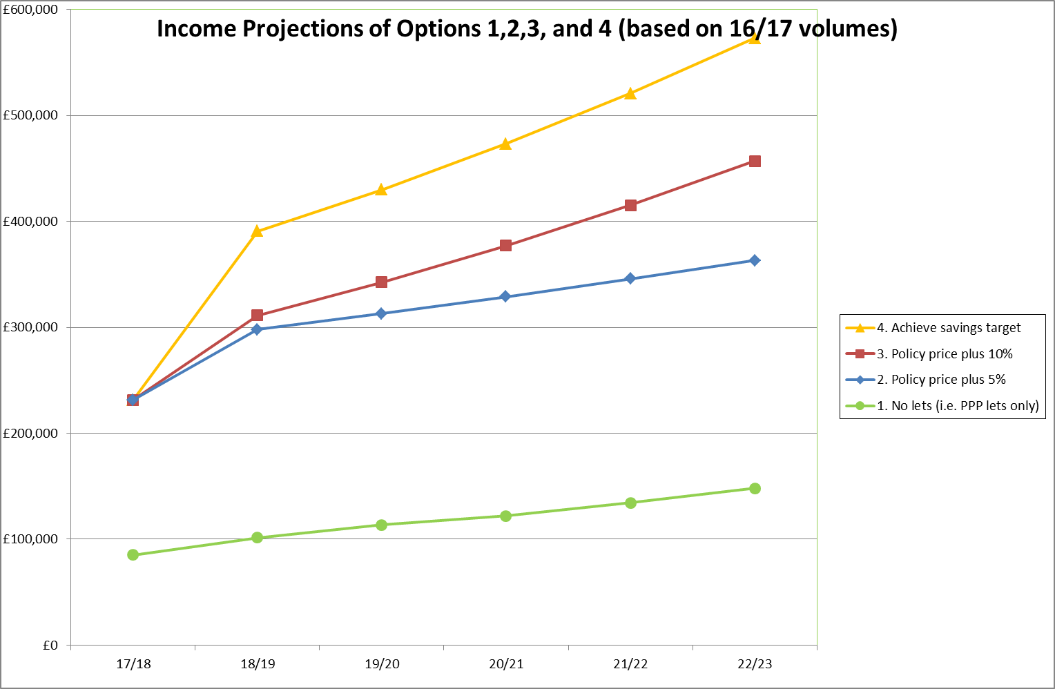

The table below relates those projections to the outstanding savings target.

Contribution to savings (assumes 16/17 volumes maintained)
Option | Increased income | Saving gap  (from £182K) | Note
Option 2 | £66K | £116K | Most likely to be achieved, but well short of achieving savings
Option 3 | £80K | £102K | Increased projected income, but not competitive
Option 4 | £182K | £0 | Highly unlikely this income will be achieved as 39% 18/19 price rise will impact volumes

Option 1 is the projected income from PPP schools only with prices increased at 10% per year. The reduced income received by reducing the venues available for lets increases the deficit in the income budget and although not opening non-PPP schools would create some cashable savings, these would be limited as freed resources would be directed elsewhere i.e. rollout of FM and Management of Schools. Detailed analysis not possible until rollout of FM completed.

Option 2 is based on the 2009 policy with some amendments to the pricing structure (See section 4.5), removal of free lets and year on year increases of 5% to 22/23. This option is the most likely to increase or at least maintain lets volumes as it is competitive in the market place alongside HLH, other LAs and Highland providers. This option will not match the savings income target within the timeframe to 22/23, and indeed never will if the income budget increases at 10% per year. However the increase in income for 18/19 at current volumes is £65K, achieving the £35K saving, and contributing approx. £30K towards the remaining £150K This option is the only one which fulfils a strategic direction that seeks to compete in the market place. Furthermore, it has the potential to cover costs directly associated with lets (apart from utilities) particularly as these will reduce with lets concentrated in fewer premises and reduced overtime costs. This option is also the most likely to grow lets volumes and income.

The key concern with options 3 and 4 is the sensitivity of lets volumes to prices. The above projections assume that 2016/17 volumes will be maintained whatever the price increase – this is unlikely to be the case. It is difficult to predict the impact of increased prices: the comparison of Apr-Sept 16/17 and Apr-Sept 17/18 (latest data) (see section 5.2) shows a 25% reduction in number of lets following a 10% price rise (although other factors may have also contributed to the reduction). Conversely the apparent decline between 2014 estimate of 50,000hrs and 2016/17 (33,000hrs) followed price increases of only 2%. However, there can be little doubt that a single year increase of 39% will have an impact – this underlines how unachievable the free lets saving is. However if this project is unable to achieve the saving, that only transfers the pressure to another budget.

All options remove free lets as outlined above and there is likely to be some reduction in uptake from groups now required to pay, however the future pricing of Options 3 and particularly 4 are likely to have a significant impact on current paying customers as well.

6.5 Pros and Cons

The table below summarises the principal pros and cons of each of the 4 options

Option | For | Against
1 (PPP/HLH only) | - Earns income with minimal costs; increased margin could achieve outstanding savings  - Reduced requirement for overtime/ evening and weekend working  - Parity between schools and leisure centres charges | - Limited community access  - Limited geographic coverage  - Loss of community activities  - Loss of HC income  - Significant political impact
2 (2009 policy + 5%pa) | - Would cover lets costs once schools rationalised (3+years)  - Parity between schools and leisure centres charges  - Competitive with other providers  - Most potential to grow and develop the business  - No staff impact  - Least political impact | - Does not achieve savings
3 (2009 policy + 10%pa) | - Would cover lets costs once schools rationalised, sooner than Option 2  - Competitive with other providers  - No staff impact  - Limited political impact (10% price rise – same as 17/18) | - Does not achieve savings,  - No price parity between schools and leisure centres  - Less competitive in market place
4 (2009 policy + 39% then 10%pa thereafter) | - Achieves savings target  - No staff impact (but reduced volumes) | - Unlikely to maintain volumes  - Limits access due to increased prices  - Uncompetitive in marketplace  - No price parity between schools and leisure centres  - Significant political impact

6.6 Pricing Options Compared with Project Objectives

The table below compares each option with the Lets Project objectives

Project Objective | Option 1 | Option 2 | Option 3 | Option 4
1. Increase public and community use of schools and other Council buildings
2. Generate income to cover both the full cost of providing the service and earn income for HC
3. Provide a quick and efficient lets booking system | - | - | - | -
4. Provide a seamless approach alongside HLH and PPP schools
5. Reduce the administrative burden on HTs, school offices, RPOs | - | - | - | -

Note, the second objective refers to covering the cost of lets rather than achieving the savings target which is only achieved by Option 4. Options 2 and 3 have the potential to cover the actual costs associated with lets (rather than the savings target) particularly once schools open for lets have been rationalised. However Option 2 will take longer to reach this position than Option 3, assuming volumes remain constant. If they do not the10% year on year increases increase could impact volumes to the extent that income is less than that earned under Option 2.

The above appraisal of the options against the project objectives, identifies Option 2 as the favoured option which the project would propose for implementation. Nonetheless it is recognised there are other objectives to fulfil, in particular achieving the outstanding savings target.

7 Issues for Redesign Board Consideration

- Discussion, suggestions and guidance on issues raised in the report, in particular:
- The principle and process for rationalising schools available for lets
- Amendments to the pricing structure
- Free lets
- Options for future pricing.

- Identification of any additional issues or options to follow up.

- Guidance on next steps: further analysis required, whether proposals are ready for Committee, etc.

Appendix 1 Current Lets Pricing policy (2017/18 rates)

SCHOOL LET CHARGES
ACCOMMODATION/FACILITIES | DURATION | BAND A | BAND B | BAND C
Classroom/small meeting room/staff room or space of equivalent size | Up to 3 hrs | £10.35 | N/A | N/A
Classroom/small meeting room/staff room or space of equivalent size | Per hour | N/A | £20.90 | £75.95
Badminton Court within large hall in Secondary School  (Net and stands) (max 4 people) | Per hour | £9.15 | £20.90 | £35.50
Small Hall/dance studio/gym/large meeting room/community room or space equivalent to 1-2 badminton court size | Per hour | £17.70 | £26.40 | £91.50
Games Hall/social space or space equivalent to 3-4 badminton court size | Per hour | £39.20 | £51.35 | £162.60
Theatre | Per hour | £43.80 | £55.70 | £192.35
Grass Playing Field/Track | Per hour | £22.90 | £29.55 | £78.55
All Weather Pitch | Per hour | £29.30 | £35.95 | £107.90
MUGA (Multi Use Games Area) | Per hour | £16.55 | £23.20 | £63.75
Changing (for outdoor sports facilities) | Per hour | £6.60 | £6.60 | £6.60
Lighting (for outdoor sports facilities) | Per hour | £6.60 | £6.60 | £6.60
Notes: (a) The above facilities may not be available to hire in every school
(b) Lets of a non-standard length are charged on a minimum of half hourly basis and rounded up
e.g. 1 hour and 15 minutes is charged 1½ hours.
(c) Charges change from 1st April each year and lets after that date will be subject to the new charges

CHARGING BANDS | Band C: Commercial  Commercial organisations for profit making activities including instruction, dance, events, sales and spectator events
Band B: Semi-Commercial

Instructed activities of educational or sporting content where the instructor retains the income, elections, unlicensed ceilidhs and dances where an individual retains the income, weddings

Band A: Community

Sporting, social, political and religious activities, not for profit instruction, musical competitions, Blood Transfusion Service
DISCOUNTS | 50% reduction where 100% of participants are under 18, full time students or over 60. Discounts only apply to Bands A and B
SURCHARGES | An additional 25% per Let booking will be applied for additional staffing outside standard opening hours – after 10pm, weekends and school holidays.
VAT ON SPORTING AND RECREATIONAL LETS | VAT is chargeable at the current rate on sporting Lets as per the conditions set out in section 5 of HMRC Notice 742 Land and Property, shttp://customs.hmrc.gov.uk/channelsPortalWebApp/channelsPortalWebApp.portal?_nfpb=true&_pageLabel=pageAboutUs_ShowContent&id=HMCE_CL_000154&propertyType=document#P210_24269 for more information.

Appendix 2 Locations of PPP Schools and Schools where HLH Manage Lets

