**The Highland Council**

**Redesign Board: Music Tuition**

**19 December 2017**

**Report by: Head of Revenues & Customer Services (Review Team Leader)**

|  |  |
| --- | --- |
| CONTENTS | Page |
| 1. Background………………………………………………………………….…………. | 2 |
| 2. Approach to the review ………………………………………………………………. | 5 |
| 3. Staff and customer engagement ……………………………………………….…… | 7 |
| 4. Objectives ……………………………………………………………………………… | 17 |
| Objective 1 - Review current strategic aims and objectives of the Music Tuition service …………………………………………………………………………..…….. | 17 |
| Objectives 2 & 3 –In-depth appraisal of current financial management and business planning & In-depth appraisal of current business and administrative processes ………………………………………………………………………….… | 18 |
| Objectives 4 – Benefits of Music Tuition…………………………….….……. | 34 |
| Objectives 5 - Review relationships and partnership working with Council and other services (e.g. Looked After Young People, third sector organisations) ... | 38 |
| Objective 6 - Consider the service delivery options…………..…………………. | 42 |
| Objectives 7-9 – Options appraisal, strategic vision, recommendations …..…. | 42 |
| 5. List of Recommendations …………………………….……………………….……… | 52 |
| 6. Appendices …………………………………………………………………..………… | 56 |
| Appendix 1 Press releases and examples of successes.………………….…… | 56 |
| Appendix 2 SQA Results…………………………………………………………… | 60 |
| Appendix 3 Redesign options……………………………………………..……… | 61 |
| Appendix 4 Price & take-up ……………………………………………….……… | 56 |
| Appendix 5 Hiring of instruments ………………………………………………… | 63 |
| Appendix 6 Sponsorship …………………………………………….…………… | 66 |
| Appendix 7 Pupil numbers………………………………………………………… | 68 |
| Appendix 8 Administrative process……………………………………………… | 69 |
|  |  |
|  |  |
|  |  |
|  |  |

## Background

**The service**

Music Tuition services are delivered by The Highland Council (THC) in schools through a specialist, central unit which is part of the Care & Learning Service (it is not managed through schools). It is non-statutory and is in addition to curricular music and pupils are released from normal classes to attend.

The current approach of the Music Tuition service is to promote and nurture access to music for children and young people in Highland, contributing to their creative education.

The service comprises:

* Instrumental Music Tuition – delivered weekly by Highland Council visiting music instructors in schools (administered by Highland Instrumental Unit), one-to-one and groups
* School and Area Music Groups – extra-curricular groups run by THC Music Instructors on a voluntary basis
* Highland Young Musicians (HYM) – financed by participant membership fees, supporting Saturday/weekend local and regional groups.
* Youth Music Initiative (YMI): funded by Creative Scotland with four projects, all aimed at primary-school level, providing introductory music sessions – some projects cover all primary schools, others a proportion of schools. This is funded by Creative Scotland on behalf of Scottish Govt. Fèisean nan Gàidheal delivers some of the YMI programme on behalf of the Music Service.

**Finance and Resourcing**

Instrumental Tuition, as one component of this overall approach, is delivered to approximately 3,000 pupils per annum; about 10% of all pupils. Instrumental Tuition is provided to pupils in 82% of schools (all secondary schools, 83.5% of primary schools, none of our 3 special needs schools).

The service is non-statutory with about 80% of pupils paying for the Service. 20% receive the services for free who are working towards an SQA Music qualification and/or their families are in receipt of certain (financial / welfare) benefits. Highland Council take-up and fees are in the top quartile in Scotland.

The expenditure budget for 17/18 is £2.386m. The forecasted income budget is £1.296m, however this can vary year on year. The cost to the Council of the overall service is therefore around £1.09m per year. The table below presents the budget of the services delivered in more detail.

In February 2017, Council agreed savings of £0.07m as part of the budget setting process for 17/18.

|  |  |  |  |  |
| --- | --- | --- | --- | --- |
| Budget figures (shown in £m) | Instrumental Music Tuition | Highland Young Musicians (HYM) | YMI (Funded from Creative Scotland) | Overall Total |
| Spend | £1.837 | £0.062 | £0.487 | £2.386 |
| Other Income | (£0.747) | (£0.062) |  | (£0.809) |
| Grant Income | - | - | (£0.487) | (£0.487) |
| Grand Total | **£1.090** | **£0.000** | **£0.000** | **£1.090** |

There are 39.3 fte (full-time equivalent) delivering the Instrumental Tuition lessons with YMI activities directly employing 7fte (exclusive of administration overheads). The whole service is managed by Norman Bolton, Music Development Officer in Care & Learning and has an overall total fte of 47.3.

The Pay and Conditions of Service for teachers and associated professionals employed by Scottish Councils is set out in the SNCT Handbook of Conditions of Service. Music Instructors are associated professionals.

The (contracted) working week for instructors is 35 hours per week. A maximum of 27.5 hours in any one week will be devoted to pupil contact and a minimum of 2.5 hours per week will be available for preparation, instrument maintenance, transposition and orchestration. The remaining five hours during the week comprises an appropriate and agreed balance of the following activities (a) preparation of lessons; (b) preparation of reports/records etc.; (c) forward planning; (d) parental liaison (by appointment); (e) staff meetings; (f) school/pupil performances; (g) rehearsing musical ensembles; (h) instrument provision and maintenance; (i) professional review and development; and (j) Continuing Professional Development.

**Successes**

There are significant successes delivered by Highland Council pupils taught by the Music Tuition service including the World and European champions Ross and Cromarty Pipes & Drums School (RACPADS) and some outstanding grades/distinctions representing the Council on national stages. Examples can be found at Appendix 1.

**Across Scotland**

All Scottish local authorities deliver music tuition in-house, separate from school curricular provision. This provision is remarkably similar across Scotland with the model being delivery during school time in small groups or 1:1 lessons with additional area and regional music groups which meet and perform outside of school time. The makeup of area and regional groups varies from area to area but includes orchestras; string orchestras; jazz bands; pipe bands, etc.

Tuition provision across the instruments is materially different as shown in the table below shows how the FTE in Music Tuition are deployed across Highland and Scotland.

|  |  |  |  |  |  |  |  |  |  |  |
| --- | --- | --- | --- | --- | --- | --- | --- | --- | --- | --- |
| Category | Strings | Wood-wind | Brass | Perc./ Drum kit | Guitar | Trad.Inst  (Exc. P&D) | Bagpipe/ Chanter | H.Drum | Voice | Piano/ K.bd. |
| Scotland | 26.2% | 18.6% | 18.7% | 10.1% | 9.2% | 1.3% | 5.4% | 0.8% | 3.3% | 6.4% |
| Highland | 38.3% | 13.9% | 10.6% | 2.5% | 2.5% | 0.0% | 29.7% | 2.5% | 0.0% | 0.0% |
| Difference | **12.1%** | **-4.7%** | **-8.1%** | **-7.6%** | **-6.7%** | **-1.3%** | **24.3%** | **1.7%** | **-3.3%** | **-6.4%** |

Across Scotland there is also community provision, some of which formally works in partnership with local authorities (such as Fèisean nan Gàidheal) and others operate independently.

SQA Music 2017 results can be found at Appendix 2. Foregoing the various factors that could affect results, performance at Highland is broadly similar to that of Scotland overall.

**Affordability**

The current revenue budget for 17/18 is predicted to overspend by £143k (this is discussed in more detail later in the report). This includes the prediction that the approved budget savings £70k not being fully delivered. For 16/17, the budget was overspent by £191k.

Take-up is showing some decline such as 3,400 pupils on average in 15/16 reducing to 3,100 in 16/17 and 2,950 for 17/18. Fees/prices increased by 10% in 16/17 and 9.5% in 17/18. There are at least 268 pupils on waiting lists held by Instructors.

In addition to reducing Scottish local authority grant settlements, there are also ongoing cost pressures that require to be managed including pay awards. Looking to 18/19 onwards, the additional costs to be met by the service to *stand still* are approximately £70k per annum – as well as addressing a budget overspend/shortfall and further savings that require to be effectively and efficiently delivered.

Thus, the status quo is no longer a realistic option. Indeed, it is not one of the 10 options as part of the Council’s agreed Redesign. The Redesign options are shown at Appendix 3.

The Redesign Review Team members for the review of Music Tuition are:

|  |  |
| --- | --- |
| **Name** | **Designation** |
| Allan Gunn | Head of Revenues & Customer Services |
| Alison Clark | Acting Head of Policy |
| Douglas Wilby | Head of Performance (HLH) |
| Lucy Lallah | Technical Business Analyst |
| Rob Farmer | Music Instructor |
| John Gibson | Union representative |
| Councillor Davidson (Council Leader) | Redesign Board Member |
| Councillor Cockburn | Redesign Board Member |

## Care & Learning

|  |  |
| --- | --- |
| **Name** | **Designation** |
| Jim Steven | Head of Education |
| Norman Bolton | Music Development Officer |

## Supported by:

William Gilfillan, Director of Community Services

1. **Approach to the Review**

The purpose of a peer review is to explore in depth an area of service delivery and seek new opportunities for delivering the service more effectively and efficiently. The status quo for any review area is not considered an option.

The Review team proposed to approach the review in several key ways:

* **Reviewing the strategic aims and objectives of the service**

In order to consider the priorities, benefits and outcomes of the service and its relationship with the wider objectives of the Council.

* **In depth appraisal of the current financial management, business planning and business and administrative process**

In order to review how the service is currently operating, the opportunities for efficiency and growth

* **Reviewing the relationships and partnership working with the Council and other services**

In order to consider the wider delivery approach and relationship with other providers.

* **Undertaking a detailed options appraisal of the options for delivering the service in the future**

In order to consider how best the service could be provided, ensuring greater efficiency and financial sustainability for the future.

In order to address the areas highlighted above, it was important to consider information from a variety of sources and formats. The Review team used the following approaches to gather information and evidence:

**Review of documentary evidence**

* National and international reports on music tuition including on the benefits and delivery approaches taken.

**Review of financial documentation**

* Payment strategy, billing and collection processes, procurement opportunities.

**Stakeholder Engagement**

* Staff engagement - critical to understanding the way in which the service currently operates, the areas which currently aren’t working as well as they could and the opportunities for change and improvement from those working directly in the field. Engagement mechanisms with staff included
  + A member of the instruction service team being co-opted onto the review team
  + Two half-day workshops
  + An electronic survey was sent to all instructors
* Customer engagement – crucial to understanding the view of how the service operates, the benefits of the service, what could improve the service, what may encourage more pupils to use the service and the opportunities for change. Engagement mechanisms with customers included:
  + Survey to primary head teachers and secondary music staff
  + Discussions with special schools
  + Survey to current users of the service
  + Survey to recent leavers of the service
  + Survey to all S1 parents as potential users of the service

**Partner Organisations**

* A range of key partner organisations were identified to aid the team’s understanding about current partnership arrangements and potential future opportunities:
* Local Authorities in order to understand alternative delivery approaches
* Fèisean nan Gàidheal as the delivery partners for the Youth Music Initiative
* High Life Highland as the charity formed by The Highland Council to develop and promote opportunities in culture, learning, sport, leisure, health and wellbeing
* Friends of Highland Young Musician as the parent representation body
* Visits to schools and performances in order to understand the working and functioning of the service. This included 2 observations of individual lessons, to see lunchtime and after-school group rehearsals and also a multiple area group concert.

1. **Staff and Customer Engagement**

This section sets out the feedback received through both staff and customer engagement. The learning from this engagement is reflected and informs the report and conclusions.

* 1. ***Engagement with Staff***

There are currently 44 music instructors working as part of the instrumental tuition service across Highland, 33 are full-time and 11 part-time representing 39.3 fte. They provide tuition in all secondary schools and 83.5% of primary schools across a wide range of instruments:

|  |  |
| --- | --- |
| Instrument | % of fte |
| Strings | 38.3% |
| Bagpipes/Chanter | 29.7% |
| Woodwind | 13.9% |
| Brass | 10.6% |
| Percussion / Drum Kit | 2.5% |
| Guitar | 2.5% |
| Highland Drumming | 2.5% |
| Traditional Instruments (excl. Piping/drumming) | 0.0% |
| Voice | 0.0% |
| Piano/Keyboard | 0.0% |

As part of the review, it was important to gather the views of those providing the service in order to understand both how the service is currently provided but seek views and opinions on how the service could be developed for the future. This was done in three different ways:

* A member of the instruction service team being co-opted onto the review team.
* Two half-day workshops were held with the Music Instructors on 26 & 27 October 2017.

33 instructors attended; 75% of the workforce.

* An electronic survey was sent to all music instructors.

***Instructor Feedback***

The purpose of the survey was to provide background and context for the subsequent workshops undertaken with instructors and to provide an opportunity at an individual level to explore the way the service currently operates, the benefits and challenges of the current service and the opportunities going forward.

40 instructors responded to the survey providing a response rate of over 90%. The instructors have significant experience between them, with over 60% reporting that they have taught in Highland for over 10 years.

Two thirds of instructors believe that there is greater demand for the service than they are currently able to meet. Over 50% of instructors reported that they had a waiting list, a total of 268 pupils between them. This varied from a waiting list of 2 to over 50, with an average of 13.4. 70% of instructors reported that they taught some pupils with Additional Support Needs. A number of the instructors reflected upon the importance of this element when highlighting the benefits of the service and the opportunities the service provides to all pupils whatever their ability or needs.

On average, three quarters of instructors’ time is spent on delivering tuition in school time. The remainder of time on average is split relatively evenly between travel, administration, preparation, with a smaller amount spent on CPD. For the majority of those based in the North, Mid and West areas, the % of time spent on travel was slightly higher than those based in the South. Some instructors noted the challenge of undertaking all their work requirements within their standard working week.

97% of instructors reported that they are involved in supporting activities out with their contracted time. These are generally associated with school groups and bands, area/regional groups and concerts both school and area based. This ranged from multiple weekly activities for some instructors, to end of term concerts/ad hoc events for others. Around half of instructors reported weekly activities. In the past, some of these activities would have been paid for through overtime. None of these activities are scheduled within the teaching timetable.

Although 63% of instructors reported positive working relationships with schools, 37% of instructor reported that relationships could be improved. Some noted that the relationships, whilst positive with certain schools, could be better and that individual relations very much depended upon staff. It was highlighted that in some locations, particularly primary, there could be better links with curricular music and one instructor reported very little liaison even for pupils undergoing SQA. One instructor noted that there were opportunities to establish stronger links through the YMI work and the connections with instrumental tuition.

The instructors were asked about their top three challenges in undertaking their role. For the majority, resources were one of the main challenges. This included the increasing costs of lessons and a perception that this was preventing some pupils from starting lessons and others from continuing. The lack of resources for repairing instruments, buying new instruments and the ability to employ new staff to deal with the level of demand were also noted as concerns.

There were a series of related challenges highlighted around the focus of the service on the numbers of pupils. Challenges reported included the large group sizes which made teaching difficult and grouping pupils of different abilities into groups. There was also concern that there wasn’t enough lesson time for all those interested in learning but equally that lessons were not long enough to adequately teach.

As noted above, the relationships with schools were highlighted by some instructors as challenging. This ranged from the lack of accommodation being provided within schools through to the lack of appreciation and prioritisation of music when compared to subjects such as English or Maths.

Challenges were also noted regarding administration of the service. This included communication with the central administration team due to IT systems and the lack of time and IT instructors reported available for them to undertake their own administration.

For some instructors, geography was a particular challenge and the distances they were required to travel in order to provide lessons across the Highland area.

In addition to the above, a small number of instructors highlighted a range of further challenges which included: the challenge of keeping pupils interested alongside competing demands, the lack of parental support, the threat of job losses, the reduced time available with Friday closing and the lack of opportunities for CPD (Continuing Professional Development).

The feedback received from the survey regarding challenges was also reflected in the feedback from the workshops sessions held with instructors. Instructors reported concerns that the increasing costs of the service were now beginning to impact upon pupil numbers, particularly for families with multiple children and those on low incomes but who are still eligible to pay fees. It was suggested that there was too much of a focus on numbers and not on the quality of teaching that was to be provided. Concerns were expressed that the cut in overtime and funding from supporting group-based activity would have a detrimental impact upon the wider learning opportunities for pupils.

Concerns were also expressed about the relationships with some schools. There were concerns about the competing demands between schools work/activity and music lessons, and reluctance in certain schools to release pupils. This also related to not feeling valued and appreciated for the work they were doing.

Instructors were asked in the survey to consider what could be done in order to help them improve and deliver the service differently. A range of suggestions were provided which included:

* Greater investment in the service – more instructors, more instruments, stability of funding;
* Improved efficiency of the service – better IT to support administration and the delivery of lessons, centralising lessons in one school, improved registration;
* A reduction or removal of fees;
* Increased promotion of music – more music teaching in primary, promoting the service to parents
* CPD opportunities for instructors.

Instructors were also able to suggest a range of things that they could do in order to improve the service. These included:

* Increase the numbers of pupils – improved recruitment, if more instruments were available;
* Teach in new ways – adopting new techniques, digital classrooms to support lessons (not a replacement for);
* Improving links with parents;
* Changing delivery – longer lessons for more advanced pupils, having smaller groups.

Through the workshop sessions a range of suggestions were also provided by instructors for improving the service. This included longer lessons, increasing the capacity of the service, targeting certain instruments in certain areas and increasing the choice for pupils in the type of instrument available to learn. Instructors noted that there was wider interest in the service and currently the lack of capacity for some, and the lack of instruments for others, was preventing them from taking on more pupils. It was suggested there needs to be a more targeted approach to customer recruitment and improved marketing, changing the approach to procuring instruments, sponsorship for providing instruments and a hire to buy approach.

Instructors are proud of the service that they provide and the benefits that this brings to pupils accessing the service. The availability of the service to all pupils, regardless of musical ability or financial means, was highlighted as key to the success of the service, alongside the wider benefits it brings pupils such as increased confidence, self-esteem and lifelong learning. The broader group based learning was noted as a positive feature of the service and this sat alongside the commitment of the teaching team. The team dynamic and support were also highlighted by instructors as a positive aspect of the service.

The tuition team were naturally concerned at any suggestion that the service could be reduced or stopped and articulated the significant negative impact that this would inevitably have on pupil learning and wider opportunities to learn music. Many pupils would be unable to access private learning and for many vulnerable individuals, they would no longer have access to this outlet and learning opportunity. The overall loss of music to the area and the wider cultural benefits this brings, were also highlighted as concerns. It was noted that the service would be irreplaceable and once lost, would be irretrievable as has been seen in parts of England in recent years.

* 1. ***Engagement with Customers***

In addition to seeking the views of those providing the service, it was important to understand the views and experiences of those currently using the service, those who have used the service but recently stopped and those who are not currently using the service. A survey was also undertaken with primary Head teachers and principal teachers of music in secondary schools in order to understand the relationship between schools and the instrumental tuition service. The following surveys were undertaken providing over 1000 responses:

|  |  |
| --- | --- |
| Stakeholder surveys | Feedback |
| Principal Teachers of Music in Secondary Schools / Head Teachers in Primary Schools | 59 responses |
| Current Users Survey - for parents of pupils who use the Service | 791 responses  (approx. 49% of those with email addresses) |
| Former Users Survey – for parents of pupils who have stopped using the service since August 2017 | 48 responses  (170 surveyed) |
| Potential Users Survey - for parents of S1 pupils who currently do not use the service | 118 responses |

**Teaching Stakeholders**

A survey was send to all primary head teachers and the principal teachers of music in secondary schools. 59 responses were received – 35 responses from those within primary schools, 21 from those with a secondary school base and 3 other relevant respondents. This represents approx. 20% of primary head teachers and 62% of secondary schools.

The response to this survey was disappointingly low, despite it being circulated by the Head of Education on several occasions. It is not possible to draw firm conclusions from this lack of engagement however it is not unreasonable, however it could indicate a lack of connection between the instrumental music service and curricular education.

Of those responding to the survey, all bar one reported that pupils in their school have visiting instructors from the instrumental music service. However, 42% reported that not all pupils have had the opportunity to access the service. In the main, they believe this was because of a lack of available spaces within the instructor’s timetables. Two secondary respondents highlighted that the current system favoured those who had undertaken tuition in primaries and for those who had not had this opportunity; they have never had the chance to take up an instrument. It was also noted that the choice of instrument is often limited, with sometimes only one instrument offered within a school although there is interest in other instruments. Some teachers also highlighted that there were age restrictions on the opportunity to learn an instrument.

The instructors reported that the relationships between themselves and schools varied. This also appears to be reflected in the feedback from school staff. The day-to-day line management of instructors officially lies within the school(s) that they are based. However, only 38% of respondents noted that they were the day-to-day line manager whilst 46% said they weren’t and a further 17% that they didn’t know. Whilst 83% reported that they received feedback from instructors on how pupils were progressing, 16% reported that they didn’t and just under two thirds of respondents highlighted that links were not being made between the visiting instructors and curricular music delivered in schools.

Two thirds of schools reported that they had extra music provision in the school in addition to the instrumental service and curricular music. Kodály, part of the Youth Music Initiative, was the most popular additional activity noted. A small number of schools noted that they had also arranged for Kodály for younger age groups – nursery to P3 – that they pay for. Schools reported a range of other activities that they had arranged from choirs, guitar clubs, and bands including a steel band, rock school and traditional music, some of which were delivered by school staff and others by local volunteers. 8 schools reported that they had arranged for private tuition to be delivered in the school which pupils pay for directly. This included woodwind, drums, piano and the range of instruments delivered through the Fèis.

Teaching respondents were able to identify a range of benefits as a result of the instrumental tuition service. Many highlighted the additional range of skills and learning that pupils benefit from as a result of learning an instrument. This was both from an emotional perspective and educational. Increased confidence and self-esteem were highlighted, along with improved social and emotional wellbeing. Respondents also highlighted wider learning benefits as a result of learning an instrument including improved mental and physical co-ordination, improved literacy and self-discipline as a result of independent learning. Many reported the high quality of teaching received as part of the service means that pupils are able to attain and achieve at a higher level than they would be able to without that provision. The instructors were noted as experts in their field and developing the pupils as musicians including the range of extra groups and bands. One teacher noted of the service:

*“It makes the school and community a richer place.”*

Additional benefits highlighted included the wider culture benefits of learning about music and involvement in local groups and bands as well as the importance of the service being available to all regardless of background or financial circumstances.

It relation to improving the service, the majority of suggestions related to increasing the uptake and availability of the service through increasing the number of instructors/instructor time available and increasing the range of instruments being taught in each school. Concerns were expressed at the increasing costs and the impact that this was having on low income families. It was suggested that a reduction in price could also increase the uptake of families. Suggestions were also made regarding improving the promotion and awareness of the service in order to increase uptake through poster campaigns, whole class taster sessions, demonstrations and focusing on younger groups of pupils.

A small number of respondents commented upon the need to modernise and change the current service. It was also suggested that there was a need to take a whole school approach to music tuition, providing a progressive music programme in schools and building on the success of the YMI.

In general respondents were supportive of the service and praised the opportunities provided to pupils and the commitment and dedication of the team of instructors providing the service. The importance of the service being available for all regardless of income was highlighted and concerns expressed at the loss of opportunity should the service be reduced or cut. It was suggested that the service should be expanded rather than cut back and that the service shouldn’t be seen as an added extra but recognised for the wider and long term benefits that learning an instrument provides.

However, there were concerns expressed regarding the organisation and running of the service. It was suggested that there were considerable variations at present in the workload of instructors with some having far greater numbers of students than others. Comments were also received about the lack of communication with school staff if instructors were absent and the focus on regional events rather than individual lessons. It was also highlighted that at present the service wasn’t equally available across Highland and that pupils in rural areas were missing out. It was noted that the service needed to be given more time and emphasis in schools and that music generally, more valued as part of the curriculum.

A small number of respondents suggested that if reductions in budget were required then it would be preferable to reduce or stop this service than others on the basis that only a small number of pupils achieve direct benefit from it.

**Current Users of the Service**

A survey was sent to all current users of the service where an email address was available. (At the time of the survey, of the 2784 customers, there were email addresses for 1974). 791 responses were received, 49% of those surveyed. Half of respondents were parents of primary pupils and half of secondary pupils. Pupils were receiving tuition across the full range of instruments and 92% reported that their child was able to study the instrument they wished to. Of the 60 respondents who indicated that their child hadn’t been able to study the instrument they wished, this was, in the main, because the tuition for that instrument was not available within their school.

As part of their tuition, 71% of parents indicated that their child was involved in additional groups, activities or performances. 57% reported that they were involved in school based performances and 32% in school-led events. 30% noted that their child was involved in area music groups and 12% in Highland Young Musicians activities. Some of the comments received regarding improving the service noted that it would be valuable to have group/band activities available to more pupils, particularly those in rural areas.

Parents reported high satisfaction levels with the service provided, with 88% reporting that they were satisfied or very satisfied with the tuition their child received. Just over 70% of parents reported that they agreed the service was value for money. In relation to the costs, only 18% of parents felt the charges were too high, just over three quarters reported it was about right and 5% felt that they could be increased.

Around 150 parents provided additional comments related to charges for music tuition. Of those commenting, many reported concern at the cost of the charges; some that it was too expensive generally, others that it was particularly expensive for those with multiple children undertaking lessons. On principle some felt that tuition should be free to all which would ensure it was accessible to everyone however others reported that it shouldn’t be entirely free to anyone and some charges should apply. Some suggestions were received regarding varying the charging policy depending on whether multiple children were receiving lessons, whether the tuition was being received in groups or one to one and whether children were being taught in more than one instrument. It appears there is confusion over the charging approach, with some parents under the impression that they are paying for lessons during holiday periods and a number of comments received suggested greater clarify was required regarding what exactly parents were paying for.

Of the concerns that parents raised as part of the survey, the current approach to charging was one of the greatest. This particularly related to the number of missed lessons due to instructor absence and that refunds were then not received. A large number of parents expressed dissatisfaction regarding this and it was suggested that absence cover should be provided or refunds should be given.

Parents were asked about different approaches to delivering music tuition going forward. There was support for changes to the pricing approach with just over three quarters supportive of sibling discounts and a further 59% in favour of different prices for group and one-to-one lessons. There was also support for broadening the type of music tuition provided beyond the current instrument range. Parents were less supportive of introducing video conferencing for lesson delivery, with 78% not liking this suggestion.

Parents were asked about ways in which to improve the service. The most common suggestion received was to improve communication between parents and the service. Primarily this was in order to understand the progress their child was making and to be able to support them in their learning. Some parents reported that they had received no communication at all from their child’s instructor, despite receiving tuition for more than a year.

“[I] would like a bit more feedback from the Tutor as to how my child is doing. Are they improving, what are the next stages for them? If they are not improving what can be done to help.”

“I find it hard to help him practice at home as I don't read or understand music myself. I have repeatedly asked for video tutorials or other resources to help us prepare at home but all I get in response from the tutor is "practice more!"… The tuition should be more encouraging and more resources should be made available to allow pupils to practice at home in the absence of a tutor.”

A small number of parents also suggested that communication with the service overall could be improved, particularly around charging approaches and when lessons have not taken place.

Parents also suggested that the service could be improved through a greater range of instruments being provided in a wider range of schools. It was noted that more instructors would be needed. It was suggested that there should be more availability of traditional instruments and that the service should be available earlier in primary and in all primary schools.

A range of suggestions were also provided about the way the service is currently delivered. There was support for longer lessons, more one-to-one lessons, increasing the frequency of lessons and also that some lessons could be provided after school. There was some support for considering pricing variations for group and individual lessons, for sibling discounts, discounts for second instruments and discounts for those who provide their own instrument. Related to this was a view that the current charges should not be increased and opportunities to reduce the costs where possible should be considered.

Further suggestions for improvement were related to improved promotion of the service to ensure that all parents are aware of the opportunities and benefits learning an instrument can bring; exploring more creative methods for teaching and learning, expanding group based activities so this was available to all instrument learners and embedding music more into the curriculum of schools.

Whilst the majority of parents appeared satisfied with the service their child is receiving, concerns were reported by some. The greatest concern highlighted was the number of missed lessons due to instructor sickness or absence. Sometimes lessons were also missed due to other curricular events but there were no opportunities to make this up and parents were still being charged for lessons. There were a small number of concerns raised about the quality and consistency of teaching, with a perception that this varies considerably across Highland. It was suggested that there should be regular appraisals for staff. Other concerns reported were regarding short lessons, poor quality of instruments received, the lack of communication with instructors and poor administration.

The parents of current users of the service were asked about the benefits they believed their child got from learning to play an instrument. Over 90% of respondents reported that music tuition:

* Gave them the skills of playing an instrument
* Created a sense of achievement
* Allowed them to be part of something
* Increased their confidence
* Improved their self esteem

Although a majority still agreed, parents were less likely to report that learning an instrument led to performing better in other subjects or performing better in SQA. However, this does reflect that not all pupils learning an instrument take SQA Music.

In addition to the general question, parents had the opportunity to provide broader views. Some chose to highlight the range of additional social and emotional skills their children were gaining as a result of playing an instrument, whilst others noted the support it had provided in supporting other learning and extra-curricular activities. One parent noted that for their child, learning an instrument:

“….it’s made him look beyond his disability”.

As outlined above, overall there was high satisfaction with the service and this was reflected in many of the comments received. Parents reported that they valued the service and quality and commitment of the teaching that their child received:

“I think the service we receive in this area is fantastic, the teacher goes above and beyond for the pupils and is a great role model for the kids.”

“We are very grateful for the commitment and enthusiasm that the staff consistently gives, not only musically but in building the social confidence of our son.”

“I think it is easy to underestimate the positive impact learning an instrument can have on a child. It builds confidence and social skills in a safe environment.”

Concerns were expressed by a small number of parents about the potential for the service to stop. It was suggested that the wider educational, learning and societal benefits needed to be considered and that music should not be ‘seen as a luxury’.

**Recent Leavers of the Service**

With numbers of pupils receiving music tuition declining in the last two years, it was important to understand why pupils choose not to continue with the service. This could perhaps help to identify areas for improvement and opportunities to grow and sustain the service going forward.

270 pupils have left the service since April 2017. All parents of pupils with email addresses were contacted (170) and 48 responded to the survey, providing a response rate of 28%. 44% of respondents had children in primary school and 56% in secondary school. Just over half of respondents who were primary leavers had been receiving tuition for over a year and a further 29% for between 6 months and a year. At secondary, half of leavers had been receiving tuition for over 4 years and a further 36% for between 2 and 3 years. 90% reported that their child had been learning the instrument they wanted to, with those who weren’t because this hadn’t been available in their school. 81% of leavers had received their tuition in a group.

80% of respondents reported that they had been satisfied with the service received and 60% that the service was good value for money. Of those who weren’t satisfied with the service or that it was poor value for money, reasons provided included unhappiness with the group dynamic, lack of time in lessons, unhappiness with the instructor, the short length of the lessons and missed lessons.

Parents were asked about the reasons for leaving. They could provide multiple answers. 40% of respondents indicated that it was because their child wasn’t practicing and a further 38% reported that their child had lost interest. 15% reported that it was because the cost was too expensive and 13% because they were unhappy with the tuition received. Other reasons provided included not wanting to miss classes in school or needing to concentrate on school subjects, focusing on another instrument and not getting on with the instructor.

Respondents provided a range of reasons on how to improve the service, many of which were similar to current users of the service. These included tuition across a greater range of instruments and for this to be available in primary. There was also support for after-school/lunchtime lessons, smaller group lessons or individual lessons. Many of the leavers reported that they had been happy with the service and recognised the wider benefits of learning an instrument. A small number did express concern at the consistency of tuition and the approach and style of individual instructors.

**S1 Parents**

The Review Team was keen to understand whether there was a potential market in pupils currently not receiving instruction through the service. It was also important to understand why individuals had not chosen to use the service. A survey was developed to be sent to all parents of S1 pupils. This would help to understand the experience at primary and in the first few months of secondary school.

118 responses were received. The current S1 role across Highland is currently 2483 *(Source: C&L School Master List)*, and within this context, the response rate was lower than anticipated. It is however understood that many schools were not in a position to circulate the information electronically to a cohort of parents within their school. It is not clear whether this is due to a lack of email addresses or whether the system is not designed to support this sort of activity. This is clearly an area requiring exploration within the service given the importance of understanding the views, experience and perspective of parents across Highland. Although the numbers responding were lower than desired, the information received has been helpful in understanding the parental experience, interest in the service and provides useful context going forward.

48% of S1 parent respondents indicated that their child had been offered the opportunity to learn an instrument. Just over half of this group had been offered the opportunity at primary school and a further third in both primary and secondary school. The majority of this group reported that they had received information from the school about the tuition service and that this information had been helpful in helping them to decide on whether this was something they wanted their child to be involved in.

A third of parents reported that they didn’t take it up because it was too expensive, 16% that it was because the instrument their child wanted wasn’t available at their school and a further 16% because they weren’t offered the instrument they wanted. A range of additional reasons were also provided which included that their child was already learning another instrument out with school and that they used the service and gave up quickly not liking it.

27% of the parents who responded reported that their child hadn’t been offered the opportunity to learn an instrument and a further 25% that they did not know whether this had been offered or not. The majority also didn’t know or hadn’t received any information from the school about the Music Tuition service.

Of this group, a third reported that this because they were not offered a place and 12% because there were no spaces available. Over half provided other reasons the majority of which indicated that they as a parent were not aware that any opportunity had been available or offered. Only 2 indicated that they had been offered to be put on a waiting list for when a space became available with just over 50% not sure whether they were on a waiting list or not.

All parents were asked what instruments their child may have been interested in learning had they been given the opportunity. 46% reported guitar, a third keyboard, 30% drumming or strings and a further fifth in both piping/chanter and singing. It was also suggested by a number of parents that their child would be interested in learning the accordion.

Parents were asked about the cost of the tuition service. Two thirds reported that the charges for the service were about right, however just under a third indicated that it was too expensive. This was higher than current users of the service and perhaps reflects that a number of parents didn’t take forward the opportunity due to the cost. There was support from parents to consider sibling discounts and also for variation in charging for one-to-one and group based lessons.

63% of parents reported that they felt the process for accessing music tuition could be improved. There were two main areas highlighted by respondents, increasing awareness of the service and increasing the availability or opportunities on offer. It was suggested that there should be more direct communication with parents, taster sessions offered and online booking/information available. In relation to availability, it was reported that there should be a greater range of instruments on offer and more spaces provided. It was suggested that opportunities should be reoffered annually and not as a one off. Some parents suggested that there needed to be a reduction in price or that the service should be free.

A number of parents indicated that they would be keen for their child to take up music tuition, noting the benefits of learning an instrument. It was suggested that there was interest from parents but that the service needed to be better promoted and parents aware of the opportunities out there.

1. **Objectives**

**Objective 1 - Review current strategic aims and objectives of the Music Tuition service**

The recommendation arising from this section is as follows:

|  |
| --- |
| **RECOMMENDATION**  The recommendation arising from this section is that a clear set of objectives for Music Tuition services are developed with stakeholders for music tuition which take account of the strategic objectives of the Council and that those objectives:   * Take account of the social objectives of the Council; * Clearly describe the customer pathway from introduction through to the regional (Highland Young Musicians) groups; * Set the principles for charging, including concessions/free provision; * Set out the approach which will be taken to service improvements and efficiency; * Set out the approach which will be taken with partners including schools and where appropriate, other providers; and * Set out the approach which will be taken to measuring and reporting performance. |

There are strategic aims set out in the music tuition handbook which make links with the aims of the Care & Learning Service. However, there is no mention of music tuition services in the Care & Learning plan and its planning and delivery has, therefore, to an extent, been kept separate from service planning and development. That said, the majority of music instructors are aware of the importance of meeting the social objectives of the Council, the service contributes very well to the personal development of young people with customers and there are good links and joint working between some schools and music instructors.

The majority of the instructors noted that the main aim of the service was related to the provision of high quality music instruction and the benefits this experience provides in terms of fulfilling musical abilities, playing in groups and supporting SQA music exams. Some instructors also referred to the importance of the service being available to all pupils regardless of financial background and ability to pay. A small number also noted the importance of the service being available to all regardless of musical ability given the added benefits this brings. Some instructors noted the range of additional skills learning and instrument has and that the aims of the service were to foster this learning; encourage team building, social and organisational skills and building confidence and self-esteem. This wider learning and benefits of the service needs to be reflected in the aims and objectives.

Linked with the need to develop aims, there is a need to develop performance indicators for the service which link back to its strategic aims, demonstrates its value and supports service improvements (including effectiveness and efficiency).

During the review it became clear that service management view the Youth Music Initiative, which is a Creative Scotland funded programme to deliver introductory music lessons in all primary schools, as being separate from music tuition which is funded by the Council and customer income. Whilst the funding is for a very specific element of music tuition, having clear aims and objectives will help to ensure that the most is made from the programme and that there is a clear pathway from this programme to music tuition and area/regional groups.

**Objectives 2 & 3 In-depth appraisal of current financial management and business planning & In-depth appraisal of current business and administrative processes**

The recommendations arising from this section are as follows:

**RECOMMENDATIONS**

**Business Planning**

A business plan, linked to an appropriate reference within the Service Plan, should be designed and maintained.

**Pricing**

A comprehensive review of the Pricing Strategy should be undertaken and that strategy must link to all other business strategies such as a Business Growth Strategy.

A Waiting List should be designed, maintained and should be proactively used as part of the overall management of the service and relevant strategies such as Growth.

The service provider should maximise the size of groups wherever possible and practicable. This may require investment in more instruments.

Prices charged from April 2018 should be at least 10% higher than 16/17 as approved by Members.

The use of negative budgets should be avoided; proper budget across all cost and income budget headings should be provided and reflected on the Council’s financial system (Integra).

**Musical Instruments**

The service provider should create and maintain a stock of instruments.

A clear business strategy is designed for equipment and maintenance, hiring and purchase. This should be clearly linked to the Pricing Strategy and close working with the Shared Procurement Service.

**Sponsorship**

The service provider should proactively and assertively seek sponsorship opportunities and funding.

**Exemptions and Discounts**

The “special exemption” qualifying category should be removed with effect from 1 April 2018 (to enable advance notification of this change).

A review into the price exemption category of SQA should be undertaken.

The Pricing Strategy should consider the introduction of sibling discounts.

**Billing and Collection**

Direct Debit or on-line payments should be the default methods of payment.

Non-payment should result in withdrawal of service until the debt has been cleared.

Sufficient management time and urgency should be given to the financial management of debt/bad debt.

A clear and transparent refunds policy is designed and maintained.

The delivery model should explore providing capacity or appropriate mechanisms for absence cover in order to mitigate against the number of lessons missed due to staff absence.

Pricing / charging policies must be adhered at all times.

**External Funding**

The overall management of the budget would benefit from improvement including accurate budget preparation and costings, utilising management information such as customer take-up, and close links to other business strategies including Price and Growth.

Long term plan and strategic approach for possible future reductions in external funding.

Forward Business Planning requires to be undertaken linking to other business strategies such as Budget Management, Price and Growth.

**Resources**

The service delivery model needs to deliver a higher pupil/instructor ratio whilst at the same time supporting the Music Instructors to do this so that the service can be delivered within affordability levels.

Blended delivery of Music Tuition (a mix of face-to-face, video-conferencing/video tutorials) should be considered.

Music Tuition requires to be effectively marketed. This includes promotions and full use of the web to increase transparency and the benefits.

A Performance Management Framework should be designed and maintained including a suite of KPIs.

Greater attention and priority requires to be afforded to Continuous Professional Development (CPD), including annual ERDs being undertaken.

An IT solution is implemented urgently to ensure staff have the necessary devices to undertake their role effectively, efficiently and securely; this is likely to be the provision of laptops.

All staff undertake the online Information Management course as soon as possible.

The process requires review including the principle forms/application process should be electronic as standard.

**Business Planning**

There is no reference to the Music Tuition service in the Care & Learning Service Plan nor is there a business plan (operational plan) to help support the strategic management and service delivery of music tuition. There is an instructor’s handbook which contains the aims of the Music Tuition service but how challenges such as the delivery of the £70k savings required for 17/18 or addressing further possible reductions in external funding are unclear.

RECOMMENDATION

A business plan, linked to an appropriate reference within the Service Plan, should be designed and maintained.

**Budget Management**

As a gross % of the overall education budget, Highland Council spends 1.34% on Music Tuition. (*Improvement Service Music Tuition report 2017)* The Scottish average is approx. 0.5%.

A £143k overspend is predicted for 17/18 against a gross Music Tuition budget of £2.4m, net £1.1m. The overspend is mainly due to lower than estimated income. The additional income estimated from the 10% price increase from April 17 is predicted not to be fully realised.

There is currently 1 vacant post advert on hold following C&L scrutiny.

The cost per pupil is approximately £51 per month; the fees (unless exempt) are £26.50 per month.

**Pricing**

1. Charging & Strategy

Compared to the national average take-up rate of approximately 8%, Highland exceeds this at 10%. This is against a background of Highland charging amongst the highest fees in Scotland.

Appendix 4 details the take-up rate and the price ranking.

The charge for 17/18 in Highland is £318 per annum (£26.50 per month) and is the same for both individuals and groups.

The latest report from the Improvement Service into Music Tuition showed that Highland is 3rd highest for individual tuition; the highest for groups.

The 17/18 average for Scotland for individuals is £228.16; £212.35 for groups.

Across Scotland, there appears to be a range of pricing strategies followed. This may well reflect local priorities, the challenges and characteristics of each local authority as well as the deprivation levels amongst the population. However foregoing those reasons, there does appear to be opportunities for Highland to review its pricing strategy rather than just applying a percentage increase. This current approach carries risk.

For example, the 16/17 Improvement Service Music Tuition report found that there did not appear to be a material correlation between demand and price being increased. Whilst that may be the case across Scotland, looking at Highland in more detail, the 10% increase in price in 16/17 saw a 9% decrease in customers (3400 down to 3100). In 17/18, a further 9.5% increase in price has resulted in the average numbers reducing to approx. 2950, which is a further 5% decrease in customer numbers.

The table below presents the movement since 12/13 with the establishment remaining unchanged during that time.

|  |  |  |  |  |  |  |
| --- | --- | --- | --- | --- | --- | --- |
| Year | MT Pupils | Total P1-S6 | MT pupils as % of total pupils | Total P4-S6 | % P4-S6 | Price |
| 12/13 | 3100 | 30789 | 10.1 | * |  | £252.00 |
| 13/14 | 3200 | 30779 | 10.4 | 23352 | 13.7 | £252.00 |
| 14/15 | 3400 | 30646 | 11.1 | 23224 | 14.6 | £264.00 |
| 15/16 | 3450 | 30653 | 11.3 | 23250 | 14.8 | £264.00 |
| 16/17 | 3100 | 30721 | 10.1 | 23346 | 13.3 | £290.40 |
| 17/18* | 2950 | 30762 | 9.6 | 23355 | 12.6 | £318.00 |

\**average figures for Terms 1 & 2 of academic year.*

*Instrument numbers taken from IS Report 2017, roll figures from C&L Master list.*

Certainly since 15/16 when prices rose by 10% then 9.5% has seen a material reduction in numbers. The impact of austerity and welfare reform may also impact too, although this is likely to be offset to some extent by the continued policy of exemptions for “benefit” customers (that is those who also qualify for free school meals).

That being said, one could conclude that we could be reaching a “tipping point” where the increase in price could result in a disproportionate decrease in income. For example, against the £70k saving predicted from the price increase in 17/18, the actual “savings” could be as much as £40k short. Feedback from instructors and teaching staff suggest concerns that the increase in fees is preventing some pupils from continuing or taking up the service.

However, it is important to recognise other material factors that may counter that perception including:

* The waiting list of (at least) 268 which, with their registration, could actually see customer numbers higher despite the price increase.
* Only 15% of those who have left the service since August 2017 cited “price increase” as the reason for leaving.

This would suggest that whilst prices are high in Highland, take-up nonetheless remains in the top quartile for Scotland. Furthermore there may be room for further price reviews but it is important that a simple percentage increase alone will not suffice. Rather, a comprehensive review of pricing including whether charges for individuals and groups remain the same. This could include different price charging for individuals and groups. Whilst most councils do charge the same, four Councils do charge less for groups.

RECOMMENDATION

A comprehensive review of the Pricing Strategy should be undertaken and that strategy must link to all other business strategies such as a Business Growth Strategy.

1. Waiting Lists

There is no formal waiting list maintained. On surveying the Music Instructors, half of the respondents advised he/she had a waiting list with an overall total of 268. (This is from the 39 of 43 instructors who responded). Individual Music Instructors can maintain their own active lists. Some respondents from the S1 parents’ survey whose child hadn’t been offered an instrument were not aware whether they were on a waiting list or not.

RECOMMENDATION

A Waiting List should be designed, maintained and should be proactively used as part of the overall management of the service and relevant strategies such as Growth.

(c) Duration of lessons & group sizes

The duration of lessons for music tuition across all Councils is about 25-30 mins. However, where there does appear to be quite material variances is the number of pupils per class group. Whilst Highland is mostly 2-3, across Scotland numbers are quite often 6, 8 or even 10.

There can be various reasons why numbers can vary including demand for that instrument, the size of the teaching space provided or the particular location of the customer. According to the music instructors teaching in groups can be extremely beneficial too. Examples of feedback included: “*Bagpipes could be included more in group work”, “grouping pupils with a similar level”, “would like to take on more pupils in groups (if I had the extra instruments).”*

Particularly at a time of financial challenge what teaching by groups does offer is the opportunity to teach more customers for the same costs (foregoing any instrument costs that are borne by the service provider).

There is limited information as to how lessons are arranged such as for musical pieces depending on level of pupils, instrument school size, etc. Some smaller groups or more individual can tend to be for the senior phase such as S5/6. However, our research has found that the Music Instructors spend 44% of their time is evenly split between Individual lessons/Group whilst 47% advised was predominantly groups. 9% taught predominantly on a one-to-one basis. The financial impact assessment of a change in pricing strategy would need to reflect this.

The reality is that a combination of 1-2-1 and varying group sizes will always be part of any delivery model particularly for the geographical challenges that an area like Highland requires. However, to increase the customer base – and thereby income – within existing resources and therefore affordability levels, increasing the amount of teaching via groups has to be part of any strategic approach to delivering music tuition.

RECOMMENDATION

The service provider should maximise the size of groups wherever possible and practicable. This may require investment in more instruments.

(d) Fee levels

In February 2017, as part of the budget process setting for the 17/18 year, Members agreed a 10% increase. For this particular saving, the minute included “*it was considered that the provision of music tuition within schools both improved self-esteem and helped in addressing the attainment gap and it was a concern that the savings proposals could have the effect of limiting opportunities in this regard*”.

For reasons of rounding, the Care & Learning Service determined the monthly charge of £26.50 be levied, £318 per annum. It should have been £26.62 per month; £319.44 per annum. In reality *only* a 9.5% increase was applied and is the equivalent to approx. £3.2k shortfall in income.

The final prices recommended for 18/19 are presented later in this report. However given the significant financial challenge facing the Council, it is recommended that the prices are increased from April 18/19 to at least those approved in February 2017, i.e. at least 0.5% to the level already agreed by members.

RECOMMENDATION

Prices charged from April 2018 should be at least 10% higher than 16/17 as approved by Members.

(e) Budgeting practice

Until recently, the savings figure of £70k for 17/18 appeared as a negative (cost) figure on the budget. In other words, this was shown as pressure and not as an increase in income (which was the basis of savings being proposed and approved by Members). Positively, over the last few weeks, dialogue between the service and Corporate Finance has resulted in budgeted costs including overtime being reduced by £32k which means the negative budget figure is now reduced to £38k.

The use of negative budgets from time to time can be effective, for instance when trying to budget for likely vacancies (e.g. the gap in between filling a post rather than not filling a post). However, in this case its use has been more akin to being unclear how the additional saving was going to be delivered.

Overtime has been reduced by the Service significantly, from an annual spend in 16/17 £57k to £18k (to end of November) in 17/18. The Service advises their intention to remove it completely from 18/19 as part of the efforts to manage the budget. The number of overtime hours worked is the equivalent of about 2700 which is approximately 3.5% of the total hours that can be worked by staff in a standard year.

From a staff welfare perspective, such reduction in reliance on overtime is seen as a positive move. However the Service needs to manage extremely tightly the impact of this, not just from a staff welfare point of view but also in relation to the cash flow to the service and the direct and indirect impact on that on the service staff and service users. It is important that the leadership, management and the service delivery model utilised drives and support the Music Tuition service.

RECOMMENDATION

The use of negative budgets should be avoided; proper budget across all cost and income budget headings should be provided and reflected on the Council’s financial system (Integra).

**Musical Instruments**

(a) Hire and stock

The provision of musical instruments is mixed across Scotland. Different models include rent-to-buy, assisted purchase, separate hiring and tuition charges and hiring included within tuition charges. Further details can be found at Appendix 5.

At Highland, part of the service included within the price is the provision of the musical instrument.

£67k was spent on equipment in 16/17. The budget for 17/18 is £61k.

There is no stock list of instruments that the Council owns.

RECOMMENDATION

The service provider should create and maintain a stock of instruments.

(b) Provision

The music instructors do advise that due to financial challenges, it is becoming increasing difficult to provide fit for purpose instruments. This is not surprising as with any product, it will have a shelf life. However, in addition to a capital outlay to invest in stock, there are also ongoing costs, in particular repairs and consumables. For example, the consumables for instruments can be around £30 a reed for some instruments, to £30 a box of reeds for others. Some instructors report that the lack of instruments is preventing them taking on new pupils.

For repairs, some instructors advise that they use their own materials/equipment to repair the instruments for their pupils. Others are sent way for repair and thus there can be “downtime”. Locally worked solutions are also used to deliver/collect the instruments with *car park* handovers of stock amongst instructors another workaround that is in place.

On the one hand, the current approach is to try and ensure that the music tuition is accessible to all. However, on the basis of affordability it would appear that this approach is not sustainable and there does need to be a reflection in the price of the services offered to reflect this overhead. It would appear that the current stock is becoming run down due to a lack of investment over a number of years. Whether this is directly or indirectly due to the financial challenges and overall management of the service is something one could argue is secondary. What is primary is that the status quo cannot continue. A more business-like approach is required including the review of charging for hire, and utilising the potential of the Council’s new shared services procurement with Aberdeen City, Aberdeenshire and Highland.

They advise “*we are able to provide you with assistance and advice on aspects relating to the sourcing of musical instruments. This is potentially great timing for you as Scotland Excel have just renewed the Educational Materials framework agreement – which includes musical instruments, there is a greater choice of suppliers available and Mel has already received a request from Aberdeen City’s Music Service for assistance in how to source some instruments more effectively through the new framework*.“ The opportunity from such a combined contract is the purchasing power needs to be fully exploited.

RECOMMENDATION

A clear business strategy is designed for equipment and maintenance, hiring and purchase. This should be clearly linked to the Pricing Strategy and close working with the Shared Procurement Service.

**Sponsorship**

Some local authorities do attract private sponsorship for instrument purchase. From a commercial perspective it would appear service providers recognise the benefits such as helping to secure brand loyalty from an early and perhaps from a more formative stage of the pupils’ lives.

Appendix 6 provides the positon across Scotland.

The annual Highland Young Musicians concert in Aviemore is sponsored by the Macdonald Aviemore Highland Resort which provides performance and practice areas, and food and accommodation for the participants. The Resort provides an excellent venue for the event which would otherwise be unaffordable and is an excellent example of the business community being proud of and supporting Highland young people to stage a showcase which is of excellent quality.

There is perhaps a risk inherent “just giving” a pupil an instrument completely free of charge in that the quality of care and attention is not the same as if it were their own compared to if they were at least some contribution required. This review has not had the resources to undertake the appropriate level of research into this particular level of behaviour and provision to form a conclusive view on the level of risk.

However, foregoing that, attracting sponsorship will always help the overall service as well as assisting the Council provide a service within affordability - and to support the aims including equal access and mitigate some of the significant disparity in the pricing of instruments such as a guitar for £50-£100 instruments compared to a brass instrument/percussion in the region of £100s-£1000s.

RECOMMENDATION

The service provider should proactively and assertively seek sponsorship opportunities and funding.

**Exemptions and Discounts**

It is for each local authority to determine customer groups that receive any exemptions. Across Scotland, there are similarities where those entitled to free schools meals are exempt as are those who are studying towards SQA Music (S4-6). In addition, given the Corporate Parenting responsibilities, some Local Authorities have specifically made provision for Looked After Children.

The table below details the split:

|  |  |
| --- | --- |
| Category | % pupils |
| Fee paying | 81.5 |
| SQA | 7.7 |
| Benefit exempt | 9.3 |
| Special Exemption | 1.5 |
| TOTAL | 100 |

Special exemptions, which are unique to Highland, are at the discretion of the Care & Learning Service. It is not clear as to what constitutes “special exemption” nor is there any documented criterion. The loss of income to the Service is approximately £15k per annum. Where income is challenging for the household, there is already a qualification route via “benefits” that help achieve an element of equal access to the service.

RECOMMENDATION

The “special exemption” qualifying category should be removed with effect from 1 April 2018 (to enable advance notification of this change).

As part of the pricing strategy review, specific exemptions should be considered for Looked After Children.

The income that could be realised from charging SQA customers is approximately 70K per annum.

The law is clear that there cannot be a charge for curricular music. However pupils can successfully study towards SQA without the additional music instruction. The SQA Music results for Highland are comparable with Scottish averages. Further details can be found at Appendix 2.

There are varying contributing factors involved in performance so this data cannot be considered conclusive one way or other as to the impact of charging. However, it is also reasonable to challenge the principle of exemption for all income households.

RECOMMENDATION

A review into the price exemption category of SQA should be undertaken.

**Discounts**

Some Councils offer what is known as *sibling discounts*, that is to encourage take-up, discounts are offered to families where there is one child and the 2nd child can receive tuition at a discount rate for example.

Aberdeenshire for example offers a 20% discount for the 2nd sibling. It is understood that quite a significant time ago Highland did offer some discounts but with heavily paper-based processes it was apparently impractical to implement. Feedback from parents suggested that the introduction of a sibling discount would be welcome and would assist parents to continue with tuition where there is more than one child in a family.

RECOMMENDATION

The Pricing Strategy should consider the introduction of sibling discounts.

**Billing and collection**

1. Direct Debit

Customers are encouraged to pay their fees by Direct Debit (DD); it is not mandatory.

At 96%, the take-up rate is a marked improvement on prior years. The evidence is clear that over the last couple of years in particular, there has been a marked improvement in DD take-up. This means a much reduced debt being issued by invoice. For example, in 15/16 the value of the debt raised as £80,

Council staff endeavour to persuade customers to move to DD but for as long as customers have an alternative, some will use it.

In addition to DD being the only method of payment, withdrawal of service could also be implemented for non-payment (such as when a DD fails and remains unpaid). Whilst such action has been threatened to some customers, with some degree of implementation, it should be more robustly followed through.

RECOMMENDATION

Direct Debit or on-line payments should be the default methods of payment.

RECOMMENDATION

Non-payment should result in withdrawal of service until the debt has been cleared.

1. Sundry Debt management

Collection levels from DD are generally always at their maximum. However, where invoicing is a recovery method, collection rates are less positive. As at 24 October 2017, the outstanding debt issued by invoice for all years to date was 100k affecting 919 accounts, or 454 people/customers. The table below provides further information.

|  |  |
| --- | --- |
| Year | O/S balance as at 24/10/2017 |
| 10/11 | £ 204.00 |
| 11/12 | £ 3,424.08 |
| 12/13 | £ 16,362.09 |
| 13/14 | £ 18,421.93 |
| 14/15 | £ 18,977.89 |
| 15/16 | £ 21,595.41 |
| 16/17 | £ 9,974.04 |
| 17/18 | £ 11,062.35 |
| Grand Total | **£ 100,021.79** |

This review has found that the overall approach to debt management for outstanding debt does offer some room for improvement. For example on analysis of the current outstanding debt for the aforementioned £100k, it was established that 70 customers are existing customers and who account for approximately £13k of this debt.

Through the passage of time however, customers can leave the Music Tuition service. Unless budget holders pay sufficient attention to such matters in “real time”, recovering debt for prior periods becomes increasingly more difficult. In addition, household circumstances can change quite often and whilst a cost that was affordable “back then”, it could be more problematic now if their circumstances have subsequently changed.

Customers who no longer use the service render the threat of removal of that service significantly less so than when the service was required/being delivered.

The Care & Learning service is now giving this matter their urgent attention and this has resulted in the outstanding debt reducing to £95k as detailed below.

|  |  |
| --- | --- |
| Year | O/S balance as at 11/12/2017 |
| 10/11 | £ 204.00 |
| 11/12 | £ 3,310.08 |
| 12/13 | £ 15,602.09 |
| 13/14 | £ 17,271.35 |
| 14/15 | £ 18,334.19 |
| 15/16 | £ 21,116.99 |
| 16/17 | £ 9,199.22 |
| 17/18 | £ 10,057.01 |
| Grand Total | **£ 95,094.93** |

RECOMMENDATION

Sufficient management time and urgency should be given to the financial management of debt/bad debt.

(c) Refunds

As with any business, refunding to customers is a component part of service delivery.

The principal reasons appear to be where the instructor has been absent and therefore the lessons have not been delivered. 16/17 sickness absence is shown below and shows absence above the teacher average but well below the overall Council average.

|  |  |
| --- | --- |
| Category | Average days lost |
| Music and Senior Music Instructors | 7.3 |
| Teaching | 6.8 |
| Non-Teaching | 10.4 |
| All Council | 9.3 |

So whilst sickness absence is not materially higher compared to teaching overall, all such absence requires to be effectively managed.

In 16/17 the refunds for this particular reason (absence) were £13.4k. The basis of this particular calculation is where an alternative instructor cannot be put in place for “an acceptable number of lessons over the course of a year”; *acceptable* is not clearly defined. The Music Development Officer advises the support staff of who to refund.

There does not appear to be a clear policy regarding refunds overall, including how they are calculated. In the Improvement Service Report (for 16/17), it advises that at Highland fees are refunded if less than 30 of the 40 weeks are delivered in the year. Foregoing that some customers do not receive service for the whole year anyway, e.g. only wish the service for a few months, it appears that refunds are calculated on a “case by case” basis by the Service. Factors taken into account include pupil absence for long term medical/personal reasons. Pupil absence for non-medical reasons does not count, nor do in-service days. Feedback from parents suggests that this is an area of particular concern, with parents reporting dissatisfaction with the number of lessons missed, the lack of absence cover and/or the lack of refunds where lessons have been missed.

RECOMMENDATION

A clear and transparent refunds policy is designed and maintained.

The delivery model should explore providing capacity or appropriate mechanisms for absence cover in order to mitigate against the number of lessons missed due to staff absence.

On the one hand, providing cover can be challenging for the music tuition service with challenges of geographical and the type of instruments being taught. However the reality is this is not only lost income to the Council but it is also means the customers have not received this service. Using VC may also support the challenges of “cover” and this is discussed later in the report.

On further analysis, it was discovered that those pupils who were existing paying customers pre-August ’17, who changed to “SQA” in August 2017 and therefore would normally be exempt, were continuing to be charged fees at the instruction of the Care & Learning service. The review team were advised that this was because introducing such charges for SQA pupils was being explored as a possible means of addressing budget pressures. The Service has since advised that these accounts should be exempt and to provide refunds. The refunds have now been paid in full amounting to £4.6k.

RECOMMENDATION

Pricing / charging policies must be adhered at all times.

**External Funding**

1. Funding

The Council receives £487k grant funding from Creative Scotland funding for 17/18. This is reduction of £47k (9%) on prior year and is probably reflective of austerity and public sector funds overall. An annual return is submitted annual to Creative Scotland to fulfil their terms and conditions.

To address this funding reduction, a commensurate reduction in funding was awarded to Fèisean nan Gaidheal (Fèis Rois) as part of the Council funding provided for the particular project within YMI overall.

On the one hand, the YMI has a separate cost centre for the income and costs associated with that project which is positive to see. However, in 16/17, it overspent by £6k which is a cost that in effect, had to be met by the Highland Council general fund as the council exceeded the funding provided by Creative Scotland.

The estimated outturn for 17/18 for YMI overall was up until recently coming in on budget. However, a £30k overspend is now predicted due to an incorrect calculation being discovered of the annual YMI staff costs/spend. The Council employs 7 fte in YMI itself met by funding that is required to claimed / sought annually and therefore with much less guarantee of receipt that say funding via the general grant settlements for local authorities.

Of the £487k, approximately £300k is for Highland Council staffing costs; the balance is a grant to Fèis and non-staff costs.

RECOMMENDATION

The overall management of the budget would benefit from improvement including accurate budget preparation and costings, utilising management information such as customer take-up, and close links to other business strategies including Price and Growth.

RECOMMENDATION

Long term plan and strategic approach required for possible future reductions in external funding.

1. Forward Planning

Looking to 18/19 and beyond, the Creative Scotland/YMI Annual plan released earlier in 2017 reports a strong likelihood of further funding reductions. Whilst not yet confirmed it is estimating reductions much greater than seen in 17/18, possibly in excess of 50%, or £240k. Such reductions in terms of sum and timeline are extremely challenging. It will likely be into early 2018 before final figures are known which is far from ideal. However, foregoing the external factors which can be out with our control, the lack of forward planning, options appraisals to mitigate etc. is of material concern. If the reductions are as significant as intimated, this affects staff and HR support will be required.

RECOMMENDATION

Forward Business Planning requires to be undertaken linking to other business strategies such as Budget Management, Price and Growth.

**Resources**

(a) Staff and pupil numbers

For 16/17, the number of full-time equivalent staff (fte) delivering the service shows that Highland Council is 24th averaging 79 pupils per fte.

The table below includes some other Council data for comparison.

|  |  |  |  |
| --- | --- | --- | --- |
| COUNCIL | Pupils | fte | Pupils per fte |
| Highland Council | 3100 | 39.3 | 78.9 |
| Argyll & Bute | 1141 | 12.3 | 92.8 |
| Perth & Kinross | 1762 | 17.43 | 101.1 |
| Dundee City | 3677 | 25.6 | 143.6 |
| Scotland | 61579 | 639.61 | 96.3 |

Perth and Kinross and Argyll & Bute, for instance are in our “family group” and can be representative of some of our geographical challenges. Dundee reports the highest number of pupils per fte.

The table below are estimates of the additional possible income for Highland were the Councils respective pupils per fte delivered.

|  |  |  |  |  |
| --- | --- | --- | --- | --- |
| Council | Total pupils with other LA ratios and HC fte | No. of additional pupils | Additional income if all fee paying | Income if 80% of additional pupils fee paying |
| Highland Council | 3100 | 0 | 0 | 0 |
| Argyll & Bute ratio | 3647 | 547 | £173,946 | £139,167 |
| Perth & Kinross ratio | 3973 | 873 | £277,687 | £222,150 |
| Dundee ratio | 5643 | 2543 | £808,674 | £646,939 |
| Scotland ratio | 3785 | 685 | £217,700 | £174,160 |

Across Highland Council area itself, the number of pupils per fte also shows variations. Against an average of 79 pupils per fte and median of 77 the range is 44 low, with a high of 122. There is no direct correlation between the location or the base of instructors and the number of pupils that they teach.

Around 11% of primary schools and none of our 3 special needs schools have pupils receiving music tuition. Geographical challenges can contribute to some variances however it should be noted that some of our urban primary schools (such as Cauldeen, Croy) are within the aforementioned 11%. None of the special needs schools have any of the Music Tuition service music instructors visiting which is surprising given the reported benefits as detailed in this report and the interest indicated from the schools direct.

Whilst the surveys do provide mixed views on the use of video-conferencing/video tutorials, considering its potential use as part of the solution to offering a more equitable service across the Highlands could effectively support resource management.

Another perspective to understanding resourcing is to consider the number of pupils over a period of time. That is any material change in either pupil numbers and/or establishment.

Appendix 7 shows the movement in pupil numbers for all Scottish authorities from 12/13 to 16/17. 18 Councils report an increase; 13 decreasing. Highland is unchanged at 3100. However, during that time, Highland pupil numbers included 3450 in 15/16 and 3400 in 14/15 whilst the establishment remained static (and remains so).

RECOMMENDATION

The service delivery model needs to deliver a higher pupil/instructor ratio whilst at the same time supporting the Music Instructors to do this so that the service can be delivered within affordability levels.

Blended delivery of Music Tuition (a mix of face-to-face, video-conferencing/video tutorials) should be considered.

The contract terms for the staff are under the SNCT Handbook which covers teachers and associated professionals. Music Instructors are not required to be “teacher qualified” and have their own pay scale within these contractual arrangements. They are entitled to the schools holidays for example and have specific contact hours for instruction, 27.5 hours per week. The remaining 7.5 hours is for training & preparation.

(b) Take-up

In terms of resourcing higher take-up then as well as ensuring the appropriate fte is provided, sufficient equipment needs to be available for pupils (however that is ultimately provided e.g. via some aforementioned new sponsorship) as well as “venue” space such as in schools and other accommodation (e.g. third sector).

Whilst at 10% Highland exceeds the national average of 9%, which also means 90% (around 27000) pupils are not using the service. If the Council could achieve even 5% of that possible customer base then an additional 1,350 customers would be added to the service generating additional gross income of £429k if all fee paying customers, £343k if one assumes the proportion of fee paying/exempt is replicated in respect of the new customers.

Based upon the feedback received through discussions with instructors, feedback from schools and from S1 parents of current non users, there does appear to be broader and untapped interest in the service. Instructors have highlighted that with additional capacity and the provision of additional instruments, their understanding is that there is interest in the service. This is evidenced from the waiting lists a number of instructors have. Feedback from the parents of current non users of the service notes that around half were unaware of the service or of the opportunities that this could offer their child.

There was also broader interested noted from all parent surveys in the delivery of tuition for a wider range of instruments than is currently available. In particular guitar, drumming, keyboard, singing/voice and the accordion were all highlighted. Research as part of this review has also noted the number of after-school classes provided by the Feis in this broader range of instruments and also the volunteer groups operating choirs within schools. This evidence would therefore suggest that there is capacity for the service to grow.

RECOMMENDATION

The Music Tuition service requires to be effectively marketed. This includes promotions and full use of the web to increase transparency and the benefits.

(c) Resource Management - performance management standards including reporting, monitoring and quality of tuition

To the new question posed by the Improvement Service’s for their 16/17 report, Highland Council responded for 16/17 as: “*Instructors keep a record of work and weekly/progress is noted in Pupil Progress diaries. We aim to produce an annual progress report for each pupil. Standards of teaching are monitored through regular visits by the Music Development Officer to lesson”*.

It is apparent that across Scotland there is no national framework that determines such monitoring and quality. Irrespective the views of the requirement for one, the reality is Highland Council could take steps to further improve standards and better understand current performance levels which in turn can then help inform future resource management and business planning. The music instructors advised that their CPD should be improved and ERDs being undertaken would certainly help here too.

It is positive to note that the Music Development Officer visits lessons. However, what this does not effectively capture are the views of our customers on the services delivered. It also does not capture the views of our potential customers; thereby opportunities to grow the business are being missed. We also understand that the annual progress reports for each pupil were not completed for 16/17. Reasons cited include difficulties to produce the pre-printed report forms. The Music Development Officer has confirmed that this issue has been resolved and reports can now be produced on the planned annual basis.

For reasons including increasing the visibility of the service, a focussed and disciplined set of KPIs should be identified and maintained and reported to all appropriate stakeholders regularly. 2 KPI examples could include the number of staff who have had an ERD in the last 12 months and the % of pupils who receive their annual progress report.

RECOMMENDATION

A Performance Management Framework should be designed and maintained including a suite of KPIs.

RECOMMENDATION

Greater attention and priority requires to be afforded to Continuous Professional Development (CPD), including annual ERDs being undertaken.

1. IT

It has been identified that the staff do not have their own work mobile devices (lap tops). Nor do they have office-based IT either other than to share a school-based PC which itself can prove very problematic such as accessibility and flexibility. Staff report that the current arrangements are inefficient.

Staff that are predominantly “mobile” require such devices to undertake their role in an effective, efficient and most importantly secure manner.

The Care & Learning Service, supported by ICT staff, is giving this matter their urgent attention. Although a number of staff are scheduled to receive devices as part of the Council ICT refresh, timescales are to be confirmed.

RECOMMENDATION

An IT solution is implemented urgently to ensure staff have the necessary devices to undertake their role effectively, efficiently and securely; this is likely to be the provision of laptops.

RECOMMENDATION

All staff undertake the online Information Management course as soon as possible.

(e) General administration

This accounts for approximately 1.5% of the total costs on Music Tuition.

Music tuition is delivered as part of the variety of tasks staff perform. The role includes the logging and administration of registration forms and the management of Direct Debit applications.

Appendix 8 provides an overview of the current process determined by the Care & Learning Service.

On review, some issues of concern of the process are as follows:

* Overly reliant on paper which is inefficient and also means all stakeholders are not sighted on all the information in “real-time” – this is not reflective of a “Digital Council”
* Relies on the child to take the form home for completion - S1 parent surveys highlight that many are not sighted on the availability of the service.
* There are occasions where there can be some delays in the parent/child returning the application forms.
* The DD mandates are not always completed.
* Before the completed forms are provided, the instructors commence providing the services, i.e. before the DD mandate is even returned for example.

An online form completed by the parent should be developed which not only increases the efficiency of the overall process, it also ensures that all relevant parties (in particular the administrative staff and the music instructors) can securely access this information in real time and whenever required. This would also mean that were the Council to move to a policy whereby lessons would not commence until receipt of all the necessary application information, including DD for example, the Council would be able to effectively manage this.

Improvements to the Council’s internet pages regarding the delivery and promotion of this service should also be implemented. As well as an online form, which itself can promote the benefits of music tuition, the successes of those associated could be effectively marketed on the Council’s website. At present, for example the document entitled “Music – Instrumental Tuition Service” is the instructor’s handbook. It contains information such as the aims of the service and the benefits but such information is not readily available online for potential customers to view and consider.

RECOMMENDATION

The process requires review including the principle forms/application process should be electronic as standard.

**Objective 4 - Identify and evidence the financial and non-financial benefits that Music Tuition can deliver**

A comprehensive review of literature and research has been undertaken to help inform the review of Music Tuition and its benefits.

Perhaps unsurprisingly, evidencing the financial benefits can be more challenging than the non-financial benefits. Nonetheless, there is sufficient evidence that there are undoubted financial benefits including:

* Music tourism spend in Scotland in 2013 = £105million; 16% from overseas music tourists, remainder domestic tourists.
* Festivals accounted for 60% of the total music tourism spend whilst concerts accounted for the remaining 40%
* the music tourism industry accounts for over 250,000 full-time equivalent jobs in Scotland (Dr Rachel Drury’s research document *“The wider benefits of music learning in childhood”* (Royal Conservatoire of Scotland))

The non-financial benefits are even more significant. “*The very best engineers and technical designers in the Silicon Valley industry are, nearly without exception, practicing musicians*”. *Grant Venerable, “The Paradox of the Silicon Savior”.* So not only personal skills are developed but they are transferrable too and for key parts of any business; that is innovation/innovators.

The non-financial benefits can be summarised as:

1. Increases memory capacity
2. Refines time management and organisation skills
3. Boosts team skills
4. Teaches perseverance
5. Enhances coordination
6. Improves reading and comprehensions skills
7. Improves speech
8. Increases responsibility
9. Exposure to cultural history

Each of these is now discussed in more detail.

**i Increases memory capacity**

Research has shown that both listening and playing a musical instrument stimulates the brain and increases memory. Many studies around this have been done. (<http://brainconnection.positscience.com/topics/?main=fa/music-education2#A1>)

For example, a study of 3-4 year olds who were given either singing or keyboard lessons against a control group who received no music lessons at all. The results showed that the weekly lessons improved spatial-temporal skills by 34%.

According to an article from The Telegraph online magazine, “*new research shows that regularly playing an instrument changes the shape and power of the brain and may be used in therapy to improve cognitive skills*.” There is also growing evidence that musicians at all levels have organisationally and functionally different brains compared to non-musicians, especially in the areas of the brain used in processing and playing music.

By learning to play an instrument, the parts of the brain which control motor skills; hearing; storing audio information and memory actually grow and become more active. Other results show that playing an instrument can help substantial IQ growth. (<http://www.telegraph.co.uk/science/science-news/6447588/Playing-a-musical-instrument-makes-you-brainier.html>)

**ii Refines time management and organisational skills**

Learning how to play an instrument requires learning how to be organised and manage time wisely. A good musician knows that the quality of practice time is more valuable than the quantity. In order for a musician to progress more quickly, he/she needs to organise practice time and plan different challenges to work on, making efficient use of time.

**iii Boosts team skills**

Team skills are an important aspect of being successful in life. Playing an instrument requires working with others to make music. In group settings, musicians must learn to cooperate with the people around them and to listen to the group and each other in order to produce an appropriate performance.

Playing in concert bands, jazz bands, orchestras, pipe bands can make it enormously compelling to see the many ways in which people via music can connect to each other. It fosters cooperation, collaboration, and connection between students. Students learn to help and mentor each other, support each other, lift each other up, and come together into something glorious - and often very cool!

**iv Teaches perseverance**

Learning an instrument takes time and effort, which teaches patience and perseverance. Most people can’t play every piece of music perfectly first time – the majority have to work at this by careful planning and effective practicing of difficult sections in order to achieve success.

**v Enhances coordination**

Playing an instrument requires a lot of hand-eye coordination. Moreover, by reading music notation on a page, the brain subconsciously converts the notes into specific motor patterns while also adding rhythm and breathing into the mix.

**vi Improves reading and comprehension skills**

According to a study published in the journal *Psychology of Music, “children exposed to a multi-year programme of music tuition involving training in increasingly complex rhythmic, tonal* and practical skills display superior cognitive performance in reading skills compared with their non-musically trained peers (<http://www.sciencedaily.com/releases/2009/03/090316075843.htm>)

**vii Improves speech**

Research demonstrates that music can improve speech. For example, following two years of music training has demonstrated that improvements in the neurophysiological distinction of consonants (*Nina Kraus, Jessica Slater, Elaine C. Thompson, Jane Hornickel, Dana L. Strait, Trent Nicol and Travis White-Schwoch - Journal of Neuroscience, September 2014*)

The graph below compares differing results. After 2 years of training the children in Group 2 show a stronger neural distinction of speech, illustrated by the large red swatch. Children who first undergo a control year (Group 1) do not show any year-to-year changes in neurophysiological distinction.

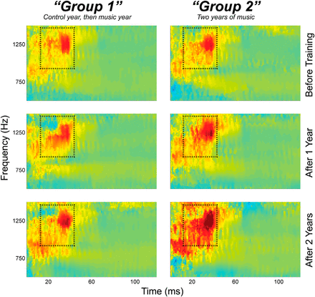

**viii Increases responsibility**

Playing an instrument comes with responsibilities. For example: maintenance and care of the instrument; procedures for keeping an instrument functioning properly; remembering music events and tasks; organising practice time.

**ix Exposure to cultural history**

Music often reflects the environment and times of its creation and learners will be exposed to a variety of music types and genres. Music itself is history and can often lead to an appreciation of other cultures

As part of the survey of instructors, this group reported a wide range of benefits achieved from the instrumental tuition service. This ranged from academic/musical skills gained through learning an instrument through to wider social/learning benefits. Feedback from instructors reflected the evidence from the literature that learning an instrument brings many transferrable life skills including improved social skills, increased self-esteem/confidence and team building skills. It was noted that it assisted in developing learning skills such as improved concentration, cognitive development and listening skills which support learning across other areas of the curriculum. Some instructors highlighted the importance of this type of learning for pupils with Additional Support Needs and the significant benefits learning an instrument had brought to a number of the pupils they had with some form of ASN.

Some instructors also reported that the benefits of the service in Highland were its inclusivity and affordability for all, whilst others noted the benefits for the young people at the higher learning end with regards group work and performances and the opportunity for learning from people beyond the Council area. The cultural benefits of the service were also highlighted in relation to sustaining musical learning within the Highlands and that the Council receives good publicity and acclaim for the quality of its teaching and the success of its pupils.

Teaching respondents were able to identify a range of benefits as a result of the instrumental tuition service. Many recognised the additional range of skills and learning that pupils benefit from as a result of learning an instrument. This was both from an emotional perspective and educational. Aligned with the feedback from instructors, teaching staff reported increased confidence and self-esteem, along with improved social and emotional wellbeing alongside wider learning benefits as a result of learning an instrument including improved mental and physical co-ordination, improved literacy and self-discipline as a result of independent learning. Many reported the high quality of teaching received as part of the service means that pupils are able to attain and achieve at a higher level than they would be able to without that provision. The instructors were noted as experts in their field and developing the pupils as musicians including the range of extra groups and bands. One teacher noted of the service:

*“It makes the school and community a richer place.”*

The parents of current users of the service were asked about the benefits they believed their child got from learning to play an instrument. Over 90% of respondents reported that music tuition:

* Gave them the skills of playing an instrument
* Created a sense of achievement
* Allowed them to be part of something
* Increased their confidence
* Improved their self esteem

In addition to the general question, parents had the opportunity to provide broader views. Some chose to highlight the range of additional social and emotional skills their children were gaining as a result of playing an instrument, whilst others noted the support it had provided in supporting other learning and extra-curricular activities. One parent noted that for their child, learning an instrument:

“….it’s made him look beyond his disability”.

**Objective 5 - Review relationships and partnership working with Council and other services**

The recommendations arising from this section are as follows:

**RECOMMENDATION**

A clearer vision and aims for the service that is linked to the wider aims of the organisation which would support closer links with schools and develop improved learning opportunities for all pupils.

Adopt a strategic approach to music instructor timetable management to free-up instructor time and ensure improved efficiency in time management.

Maintain and where possible develop the partnership with the Fèis network for delivering the YMI approach in all schools.

It is the view of the review team that the Friends group is a positive support to the regional groups and will continue to be a valuable partnership whichever delivery model is agreed by THC.

Ensure that the aims and objectives of the service include the benefits and learning opportunities for all young people, including those with additional support needs.

Introduce the service to all special schools in Highland.

Develop clear referral pathways to support the identification of pupils who would specifically benefit from this service.

Specific exemptions should be considered for Looked After Children and the opportunity should be promoted and young people encouraged to take this up.

This section of the report considers the feedback from discussions with other Local Authorities, with partner organisations and links to other Council service areas.

**Other Local Authorities**

As part of the review it was important to review the approaches taken by other Local Authorities to understand different delivery mechanisms. Discussions were held with the following Councils:.

* Aberdeenshire
* Dumfries & Galloway
* Dundee
* Perth & Kinross

There are broad similarities between the Highland Council Music Tuition service provision and provision in other areas and most of the differences are to do with relatively minor and practical ways of working. The key learning points from the way which other Councils deliver their services are that:

* There is a need develop a clearly articulated vision and strategic aims for the service which have a fit with the work of the Council and its community planning partners (the Council needs to know what it is paying for and why);
* There is a need to develop a performance management and monitoring framework which supports the delivery of the strategic aims of the service;
* There is scope to review the annual planning and delivery cycle so that services can be advertised in advance of each school year allowing greater efficiency;
* There is potential to develop a strategic approach to staff travel and timetabling to minimise travel costs and maximise tuition time.
* Councils which have lower costs deliver more of the service to groups than individuals and if this were to be applied in Highland it could allow lower charging, or differentiated charging for group and 1:1 tuition (Dundee City Council removed its charge altogether, its context being that only 20% of its customers were fee paying and there was, therefore very little income from derived from the service. This has allowed it to deliver to larger groups and has meant that its customer to instructor ratio is the highest in Scotland);
* There should be clearer and more formal links with schools, including better integration with school planning and development, communication with parents; parents evenings, etc.;
* Closer links with schools has enabled new and innovative approaches to be taken through whole class or whole school music learning, focused particularly on reducing the educational attainment gap;
* There is a need to review instructor timetables so that their work with area and regional groups can be built into their working week in a way which is sustainable;
* There is a need to use technology to improve booking and administration processes and at the same time improve the customer experience.

RECOMMENDATION

A clearer vision and aims for the service that is linked to the wider aims of the organisation which would support closer links with schools and develop improved learning opportunities for all pupils.

Develop a strategic approach to instructor timetable management to free-up instructor time and ensure improved efficiency in time management.

**Youth Music Initiative - Fèisean nan Gàidheal**

There is a partnership between the Council and Fèisean nan Gàidheal for the delivery of part of the Scottish Government/Creative Scotland funded Youth Music Initiative (YMI) which seeks to provide a music learning experience to all primary school pupils. In the Highlands particularly, and in Scotland as a whole, there exists a wide ranging Fèis, which covers traditional music, as well as wider cultural opportunities such as dance, song and drama. Fèis offers music and cultural integration to traditional roots.

The ethos of the Fèis is learning through individuals coming together to develop their skills in the Gaelic arts, including song, dance, drama, and traditional music on a wide range of instruments. Instrumental tuition focuses on traditional instruments such as fiddle, accordion, pipes and whistle, clarsach and guitar.

Fèis organisations bring people together a number of times a year to learn within a community based setting. A number of Fèis organisations also provide instrumental music tuition through after-school and evening classes to both children and adults. Some provide programmes for hiring instruments and others have hire to buy schemes.

A number of Fèis bodies have different programmes and projects that they deliver locally in Highland but also across Scotland. In Highland, there is a partnership with Fèisean nan Gàidheal to deliver part of the Youth Music initiative in primary schools. Fèisean nan Gàidheal pays self-employed music instructors to deliver the YMI programme and the local Fèisean to coordinate the provision in primary schools.

The review team met with Fèisean nan Gàidheal and Fèis Rois as delivery partners and to consider how they might contribute to the overall review. While they saw themselves as having a role to play in delivering the Youth Music Initiative and in traditional music, they did not see themselves as having a role in THC’s Music Tuition services given the broader musical range that this covers. There was agreement that whatever the delivery model was in future that partnership working to develop music provision in Highland would be important and that there could be opportunities to build on the already successful partnership.

RECOMMENDATION

Maintain and where possible develop the partnership with the Fèis network for delivering the YMI approach in all schools.

**Friends of Highland Young Musicians**

Friends of Highland Young Musicians are an independent charity. It describes itself as follows. Friends of Highland Young Musicians:

“represents and promotes the Regional Music Groups which are run as an extension to the work of the Instrumental Tuition Service in the Highland Council area.”

There is further information about Highland Young Musicians on its web site: <http://www.highland-young-musicians.com/>

As part of the review, two review team members met with the chair and some of the Friends of Highland Young Musicians committee members. The organisation is very committed to the regional music groups, the benefits group performance brings and more generally, the positive impact of music and music tuition in the Highlands at an individual and community level. It supports the service through fundraising for instruments, travel, prizes, the production of CDs etc. as well as having a representative function for participants and parents of participants (with the most recent change having been a reduction from two to one concert and six to four practices per year to make the Highland Young Musicians element of the service cost neutral to THC).

The Friends group expressed a desire to see music tuition fees reduced with there being a number of options for this such as larger tuition groups; people who want 1:1 tuition paying more; making introductory lessons cheaper; and increasing demand/promotion of music tuition.  They emphasised the importance of music tuition being accessible for all.  The availability of tuition and then the groups was important in Highland given the poor availability of private instructors and the same opportunities not being open to young people than those living in central Scotland.

The Friends group also expressed a desire to consider other ways in which it could further support Music Tuition services such as exploring external funding opportunities and developing local fundraising initiatives and exploring further sponsorship activities.  They also saw opportunities for Highland Council to seek sponsorship and promote the expertise of the groups and the service as a whole.

The Friends were concerned about the sustainability of the groups given the increase in costs and the reduction in number of events and stopping the residential element of Highland Young Musicians rehearsals.  They recognised that this was necessary to be able to continue but noted that the numbers had reduced and held the view that it was currently at ‘tipping point’.

RECOMMENDATION

It is the view of the review team that the Friends group is a positive support to the regional groups and will continue to be a valuable partnership whichever delivery model is agreed by THC.

**Additional Support Needs and Looked After Children**

A review of the supporting literature clearly identifies potential learning benefits associated with learning a musical instrument. Whilst there are wider learning benefits for all pupils, there have been clear benefits identified for individuals with additional support needs. These positive benefits have also been identified by instructors who were able to provide specific examples of pupils who have directly benefited as a result of learning an instrument.

Currently however, there is no formal arrangement to identify or refer individual pupils with additional support needs who would benefit from instrumental tuition. There is also no formal liaison mechanism in place between the instrumental service and the ASN team/schools to ensure learning practices and approaches are adapted to meet the needs of individuals.

At present there is no instrumental music tuition currently in place at any of the three special schools in Highland. The Youth Music Initiative is also not provided within these schools. Discussions with Head teachers from these premises indicates that there is, and would be, both interest and benefit to pupils located in these schools. Music is of key importance for the learning of pupils based in special schools. For some, the focus is on music therapy but for others, the learning of an instrument is both possible and would provide significant learning benefits and achievement. The delivery of any service to this group of pupils needs to be designed on an individual basis and reflect the needs of each child. Schools already have some external tuition being provided, either through volunteers, staff within the school or external tuition paid for by the school.

There is an understanding of the need to take account of THC’s wider social objectives at an individual instructor level, evidenced by feedback from instructors. However, there is the need to consider CPD for instructors around ASN, in order to ensure appropriate supports are provided to pupils. It has not been possible to quantify the number of participants from various target groups because there is currently no requirement to report any performance indicators other than participant numbers.

Highland Council has a corporate parenting responsibility for all Looked After Children (LAC) in Highland. At present there is no targeting or encouragement to learn an instrument to this group of young people and nor are there any specific exemptions in place regarding the fees for LAC. Given the known benefits of learning an instrument, it is recommended that this is an opportunity that the Council should be promoting to this group of young people which it has a parenting responsibility.

RECOMMENDATION

Ensure that the aims and objectives of the service include the benefits and learning opportunities for all young people, including those with additional support needs.

Introduce the service to all special schools in Highland.

Develop clear referral pathways to support the identification of pupils who would specifically benefit from this service.

Specific exemptions should be considered for Looked After Children and the opportunity should be promoted and young people encouraged to take this up.

**Objective 6 – Consider the Service Delivery Options**

The 10 options for service delivery are described in some more detail at Appendix 3.

Informed by various means such as the significant research and engagement undertaken including workshops with the Music Instructors, an overall view was formed of each option as to those that were realistic, practicable and also most likely meet the aims of Council Redesign.

The table below presents the findings.

|  |  |  |
| --- | --- | --- |
| OPTION | YES/NO | Reasons (if “NO”) |
| 1. In-house | YES |  |
| 1. In-sourcing | NO | Already in-house. |
| 1. Shared Services | NO | Not at this stage – the report recommendations do not preclude this as a future option. Would need to address time taken to implement, different operating principles etc. |
| 1. Outsourced Services to commercial provider | NO | Commercial sector partner does not exist and would therefore rely on individual contractors resulting in a fragmented service, with unequal access and significant management and administrative overhead. Market forces likely to result in increased charges. |
| 1. Partnership and/or integrated | YES |  |
| 1. ALEO | YES |  |
| 1. Commercial Opportunities | (YES) | As part of other options. |
| 1. Community-run | NO | A single community partner does not exist and would therefore rely on individual contractors resulting in a fragmented service, with unequal access and significant management and administrative overhead. |
| 1. Reducing demand | YES |  |
| 1. Reducing service standards |

**Objectives 7-9 - Provide detailed service delivery options appraisals of those most likely to deliver the greatest benefit in terms of affordability, efficiency and customer service across Highland**

A SWOT analysis (*Strengths, Weaknesses, Opportunities and Threats*) was undertaken in respect of the 4 possible options identified, again informed by various means including the significant research and engagement undertaken.

**In-house**

|  |  |
| --- | --- |
| STRENGTHS   * Experienced, committed and motivated staff. * Evidence of customer success. * Material investment (compared to other local authorities). * Considerable music expertise in the management. * Existing arrangements for staff pay, pensions etc. in place. * Understanding by instructors of social objectives. * Partnership arrangements could continue. * Technical leadership is strong. * Highland is recognised as a centre of excellence (regional groups). * Strong area and regional group structure. * Good relationships with some schools. * Team approach to regional groups. * Good range of instruments and styles. * Flexibility to vary delivery dependent on pupil needs. | WEAKNESSES   * Inefficient service delivery model with savings targets not being fully achieved. * Business, professional leadership and management of the service offer room for improvement. * Leadership/mgmt restructuring likely required * Lack of business planning. * Lack of strategic aims and objectives – e.g. lack of integration with the wider social objectives of the service and the Council. * Lack of performance management and quality assurance. * Lack of IT devices for staff. * Lack of investment in instruments, no inventory. * Not sufficiently inclusive at present * Lack of staff training and CPD. * Online/digital processes requiring design, testing and implementation to improve information sharing, and thereby administration. * Travel time to deliver the service. * Lack of effective marketing, promotion and communication with customers. * Lack of equity across Highland in terms of instrumental provision and choice. * Lack of culture within the MT service of taking a commercial approach to service delivery, financial & resource management etc. * Inconsistent relationship with schools. * Lack of prominence and visibility of music within the organisation. |
| OPPORTUNITIES   * Building on existing customer satisfaction. * Review & implement new leadership & management structures & delivery arrangements. * Explore new and more effective administrative & online systems. * Use skills within the wider Council to develop an effective marketing approach alongside a planned & consistent approach to recruitment of pupils. * Creative and commercial approach to pricing. * Build on existing service approaches to include pupils with ASN & other vulnerable young people. * Make better use of existing commercial arrangements. * Embed music tuition as integral part of service & business planning. * Take a digital approach to develop the service. * Potential to grow the business/customer base & generate more income. * Seek different approaches to instrument provision including sponsorship, procurement opportunities, lease, and rent-to-buy. * Shared CPD between instructors (using existing skills) e.g. instrument repairs in-house. | **THREATS**   * Current model cannot be sustained. * Some instructors consider themselves to be working at capacity. * Families on low incomes who don’t qualify for benefits potentially excluded (second highest fees in Scotland). * Price in danger of being perceived as poor value. * Staff perception of threat of change. * Lack of instruments and difficulty of maintaining them. * Reliance on goodwill in order to deliver after-school, area and regional groups. * Service disruption in a period of change. |

**Partnership and / or integrated**

|  |  |
| --- | --- |
| STRENGTHS   * Fèis organisations have a track record with after-school and community based music delivery. * Expertise in traditional music. * Staff protected by TUPE regulations. * Already delivering traditional music services in schools. * Established partner delivering YMI. * Customer focussed approach. * Developing and growing new projects and programmes for traditional music. * Charitable organisation. * Some Fèis organisations have established online booking systems. | WEAKNESSES   * Current delivery model does not include employment of music instructors. * No pensions admitted body status. * No expressed appetite for broadening beyond traditional/folk music. * A new model of employment of staff would be required. * Staff perception of not being part of “education”. * Fèis perceived by music instructors as a traditional music organisation. * New area of business. * No precedence for such a model in Scotland. * Inherited practices and pressure on instrument provision and budget. |
| . OPPORTUNITIES   * An enthusiastic and effective partner to deliver YMI. * Expanding market opportunities, e.g. summer programme, after-school, family learning. * Utilise existing administrative and online systems. * Effective marketing. * Creative and commercial approach to pricing * Customer view of Fèis as a charitable organisation. * Ability to attract sponsorship as a charity. * Be the first in Scotland. * Greater prominence and visibility of music within the organisation. * Ability to develop service delivery digitally.   Building on existing customer satisfaction. | **THREATS**   * Reduced identity for traditional/folk music. * Potential threat to organisational sustainability, and therefore also to the welfare of staff. * Could place undue financial liability on small organisations. * Potential loss of breadth of music-styles. * Service disruption in a period of change. * Previous union concerns about transfer of services out with the Council. |

**Arms-Length External Organisation (ALEO)**

|  |  |
| --- | --- |
| STRENGTHS   * Proven track record – commercially, of delivering efficiencies, financial & resource management and leadership. * Admitted body status * SLA in place with THC and HLH for staff pay, pensions etc. * Staff protected by TUPE regulations * Already delivering services in schools * Established partner, e.g. formal agreement between Youth Development staff and schools * Established service transfer process. * Customer contacts, e.g. 6 million visits/contacts * Customer focussed approach * Growing customer base * Diversifying services, e.g. after-schools * Understanding of social objectives * Charitable organisation. * Partnership arrangements could continue, e.g. Fèis Rois. * Digitally maturity * Increased job security | WEAKNESSES   * Staff perception of not being part of “education”. * HLH perceived by music instructors as a “leisure” organisation. * New area of business. * No precedence for such a model in Scotland. * Inherited practices and pressure on instrument provision and budget. |
| OPPORTUNITIES   * Leadership development awards * Frameworks in place (i.e. dance pathways) to offer inclusive activities and recognition * Expanding market opportunities, e.g. summer programme, after-school, family learning. * Utilise existing administrative and online systems * Effective marketing * Creative and commercial approach to pricing * Build on existing relationships to include pupils with ASN and other vulnerable young people. * Build on existing procurement and commercial arrangements. * Customer view of HLH as a charitable organisation. * Ability to attract sponsorship as a charity. * Be the first in Scotland * Greater prominence and visibility of music within the organisation. * Ability to develop service delivery digitally. * Building on existing customer satisfaction. | **THREATS**   * Previous union concerns about transfer of services out with the Council. * Possible service disruption in a period of change. * Staff perception of threat of change. |

**Ceasing / Reducing**

|  |  |
| --- | --- |
| STRENGTHS   * Budget saving from approx.18 months after cessation of service (to account for redundancy costs). (So would be 20/21 at the earliest before full savings could be achieved, based on cessation from 18/19). | WEAKNESSES   * Significant redundancy costs. * Full-year savings not deliverable until at least 20/21 * Economic impact including loss of good quality jobs located across Highland. * Reputational damage to the Council. * Loss of the financial benefits of MT. * Loss of non-financial benefits of MT, including:   + Increases memory capacity   + Refines time management and organisation skills   + Boosts team skills   + Teaches perseverance   + Enhances coordination   + Improves reading and comprehensions skills   + Improves speech   + Increases responsibility   + Exposure to cultural history * Poorer quality of life. * Missed opportunity to deliver the business in a more efficient and effective way. * Loss of access for customers including equity of access. * Loss of access for potential customers and those on the waiting lists. |
| OPPORTUNITIES   * Protects other Council services. | **THREATS**   * Local impact, including customer opinion and political, on areas across Highland. |

**SWOT Summary**

**Continuing the Service:**

Based on the evidence collated and the options appraisal undertaken, the recommendation of the Review Team is to continue the service. As the SWOT analysis demonstrates, there are significant disadvantages to ceasing or reducing the service, both to the organisation and to individual pupils.

To the organisation, there would be redundancy implications resulting from stopping the service and correspondingly, no savings realised until at least 19/20. There is also reputational risk to the organisation from ceasing the service. The service is recognised for its excellence and valued by parents, pupils, staff and former users. Any attempt to remove the service is likely to result in reputational damage to the organisation.

To individuals, the benefits of the service have been well documented in the report. These benefits are both from an educational perspective but also wider social and emotional benefits. The loss of the tuition service would result in many not having, or being able to afford, a similar opportunity.

There is considerable experience in the staff group currently operating in Highland, with significant commitment to the service and extra-curricular activities they provide voluntarily to pupils. There is also a strong school and area group structure operating providing additional learning benefits for young people.

**The need for change:**

Whilst the SWOTs demonstrated the value of retaining the service, they have also highlighted the need for change. There is a need to improve the current business, leadership and management of the service and a requirement to focus on business planning for the service. There is also a lack of a digital approach to administrative and recruitment processes.

There is a current lack of clear aims 0and objectives for the service resulting in a disconnect between the tuition service and the broader Care & Learning Service priorities. As a result the wider learning opportunities available to schools and to individuals, who could specifically benefit from this type of learning, have not been capitalised on.

There is also a lack of equity in the service across the Highland area. The availability of instrumental tuition is limited in rural parts of Highland, with a limited choice of instrument. There has also been a lack of diversification in instrumental provision although customers have highlighted there is interest in this area.

Whatever delivery model is selected also needs to consider the pricing approach going forward and the impact upon those on low incomes and that any pricing policy needs to balance between increase in costs and affordability.

**Opportunity for change:**

The SWOT also demonstrates that, whilst there are weaknesses in the current operation, there are opportunities to improve the efficiency of the business management of the service and in growing the business. The evidence collated suggests that there are:

* Opportunities for improved recruitment processes and marketing of the service
* Interest in parents to use the service
* Opportunities to expand the instrument tuition provided
* Opportunities to expand the service into after-school/evening and adult markets
* Developing a more commercial pricing strategy
* Improved digital administrative processes

The initial SWOT analysis highlighted that there were four potential delivery models: a partnership approach, delivering through High Life Highland as an arms-length organisation or continuing to deliver this in-house. The weaknesses highlighted would need to be addressed in whatever the delivery model selected.

**Partnership option:**

On considering the SWOT, the possibility of a Partnership approach was not considered an option. The only clear potential partner would be through Fèisean nan Gàidheal as they have coverage across Highland. Whilst they have clear strengths as an organisation, a strong track record of delivering music tuition and an existing partnership arrangement through the delivery of the Youth Music Initiative, this was not considered a viable option going forward. The organisation does not currently have a delivery model that would support the direct employment of staff and this could put undue financial liability on the organisation and potentially threaten their sustainability. The ethos of the Fèis movement is embedded within the traditional music scene and the delivery of this service would result in a change to this approach. Ultimately, whilst committed to continuing the existing partnership, there was no clear appetite from the organisation to broadening the scope of their service and providing this on behalf of the Council.

**Arms-length Organisation:**

The SWOT analysis of the option for delivering the service through an arms-length organisation identified that this was a viable option. With an existing ALEO in place, High Life Highland, many of the potential opportunities and benefits of this model were the proven track record and experience of the organisation. This was particularly in relation to the commercial approaches already identified by the business, the approach to financial and business management and the experience of growing the business. As an existing delivery partner, relationships already exist with schools and there are shared social objectives. The SWOT highlighted some potential weaknesses would be the perception that the service would no longer be part of education and that this would be a new area of business for HLH. Potential threats may also be a reluctance to transfer the service. On balance however, the review team identified that the strengths of HLH meant that it would be well placed to develop and grow the opportunities highlighted to make the service more efficient, effective and viable going forward.

**In-house:**

The option of continuing with delivering the tuition service in-house was also identified as a viable delivery model going forward. However, the current strategy of increasing prices is not achieving the necessary savings. As reported at page 4, customer numbers are down 9% in 16/17 and 5% in 17/18 whilst prices rose by 10% and 9.5%, respectively. The only alternative to deliver future savings under the current model is to reduce staff numbers.

Clear weaknesses in the existing system were identified, particularly with regards to the current structure and lack of business planning and processes in place. The service delivery model is inefficient and savings are not being fully achieved. All were identified as areas requiring change moving forward. There were strengths in the existing model particularly with regards the musical expertise within the management structure, the flexibility to vary the delivery model and the commitment and dedication of music instructors. The opportunities identified for growing the business could potentially be realised through an in-house approach: growth and diversification in customer base and services on offer, commercial pricing approaches and digital approaches to administrative processes. However, the analysis recognised that this was not an approach taken to date and would rely on a shift in culture and approach across the service.

**Conclusion:**

The conclusion of the review team was therefore that whilst many of the strengths of the delivery models are shared between HLH and an in-house approach, HLH are better placed and more experienced in order to provide the transformation required of the service to ensure that it is efficient, effective and sustainable going forward.

Further detailed analysis of the potential benefits on transfer to HLH are provided below:

**Financial benefits to THC of transferring Music Tuition Services to HLH**

The contractual arrangement between the Council and HLH requires HLH to make annual savings. If Music Tuition services were to be transferred to HLH there would be an annual saving to the Council of £80k per annum comprising savings from the reduction in the HLH Services Fee (as per the agreement in the Service Delivery Contract) and THC not having to provide inflationary increases for salaries etc.

In addition to that, if THC were to retain the service in-house, it would be faced with the need to provide additional funding to maintain the current service levels and increased cost of pay awards and increments etc.

The graph below compares the increased costs to THC should it continue to deliver Music Tuition Services in-house based on the current approach, with the savings which will be made if the service were to be transferred to HLH. As can be seen, the avoided additional costs and savings to THC in the second year of the transfer is £150k and in five years’ time, the combination of avoided costs for THC and savings delivered would amount to £670k.

Previous transfers from THC to HLH have been based on actual income and expenditure transferring rather than the budgeted amounts and this would have to apply to Music Tuition Services for any transfer to be agreed by the HLH board. This means that a transfer would be cost neutral to THC during the year of transfer with savings to the Council being accrued in future years through the budget savings required of HLH.

The review team considered a budget reduction at the point of transfer and this is not considered to be practical because it would not allow HLH to take a planned approach to savings necessitating either:

* a price increase, which is the approach THC has taken which resulted in a 15% decrease in customers over the past two years and would be counter-productive; or
* The need for staff redundancies and a cut in the service which would again, be counterproductive and lead to negative publicity surrounding the transfer.

Because neither of these options would be affordable to HLH, a transfer on an amount less than the current cost to THC would not be accepted by HLH.

A transfer on the current cost to THC would be a way of achieving a long-term, sustainable saving and providing assurance to THC of this. The track record of HLH is important. 79% of HLH’s funding came from the Council when it was established in 2011 and now, council funding is 54% of its budget. Taking account of the additional work which THC has asked HLH to deliver over the past six years, its actual funding has reduced (excluding the £1.8m rates savings which it makes) by £4m, giving a total year on year saving of £6m to THC. While making savings, the quality of service provision has improved as is evidenced by, for example: the increase in customer numbers from just over £2m when it was established to just under 6M (excl. Inverness Leisure) last year; and libraries having achieved the customer service excellence standard.

Should Music Tuition services be transferred to HLH, it will be included in HLH’s business planning processes treated in the same way as its other services where service delivery is protected through:

* Assessing opportunities to earn more income;
* Delivery efficiencies; and
* Only considering service reductions where absolutely necessary and ensuring that the customer impact of these is minimised.

**Non-Financial Benefits to Transferring Music Tuition Services to HLH**

There are opportunities for HLH to grow the music tuition customer base in a similar way to what it has achieved with its other services and this includes delivering services to more school pupils (there are waiting lists for music tuition services) and also by developing more commercial music tuition services to new, non-school customers including adult and family lessons.

Within its business planning framework, HLH has taken a local approach to service delivery which reflects local circumstances such as the facilities available and other local resources/services. This is particularly important for Music Tuition services where within each school, the availability of space in which to deliver the service, its history and school population is different.

Should Music Tuition transfer to HLH, it would gain an individual identity as a Music Tuition service in the same way as the other HLH Services (e.g. Libraries; Youth Work; Museums; etc.). It would also benefit from having an HLH identity which has become a trusted customer brand in the Highland Council area. This would allow an improved customer profile for music tuition and along with the clear setting of aims and objectives potentially strengthening the position of Music Tuition services.

HLH already has customer booking systems in place which could be adopted for use for music tuition. Experience has shown that simplifying customer booking processes through providing on-line bookings, linking this with social media advertising and enabling a wider range of staff (in e.g. libraries and leisure facilities) to take bookings reduces cost and helps to increase customer numbers. It also improves customer satisfaction ratings.

There are a number of developments and opportunities which could be considered by HLH should a transfer be agreed, such as:

* Youth work and music staff could work together to support young people who might not otherwise participate in music programmes or develop targeted music programmes;
* Opportunity to develop a volunteering programmes around music as part of, or similar to, the HLH Leadership Award, dance leadership or the High Voltage Libraries volunteering programme.
* Opportunity to consider new models of service delivery and associated pricing structures;
* Opportunity to change staffing over time to allow more flexibility to deliver music tuition out-with school times and settings;
* Opportunity to link Music Tuition services and other HLH Services such as Youth Work to improve targeting (e.g. to make the service more accessible to disadvantaged young people);
* Opportunity to market Music Tuition Services to the existing HLH customer base and work with other HLH services to deliver joint projects;
* Opportunity to introduce operating efficiencies over time to contribute to savings targets;
* Opportunity to identify new projects to increase income;
* Opportunity to strengthen the relationship between Music Tuition services and individual schools through formal partnership agreements with schools (as is done for youth work).

In making recommendations on pricing, there is evidence based on customer behaviour that the price is possibly approaching a ceiling for some customers (there has been a fifteen percent reduction in customer numbers over the past two years). Surveys of customers, however, has suggested that the price is reasonable with some reporting that they would be prepared to pay more for the service.

Should the service be transferred to HLH, it would be inappropriate for THC to specify charging levels (because this would undermine HLH’s charitable status) but the Service Delivery Contract between THC and HLH requires HLH to maintain price increases within the inflation levels set by THC unless there is specific agreement to do otherwise and in setting charges, HLH is required to take account of the following principles:

1. Ensuring affordable access to all sections of the community to encourage participation;
2. Fostering social inclusion for those who are economically and socially vulnerable;
3. Developing opportunities across a broad range of activities for an increasing range of participants;
4. Reflecting differing local priorities and size, quality and design of facilities;
5. Raising income;
6. Maintaining free use of school facilities for school and youth work activity, while allowing charging for additional facility management costs incurred;
7. Maintaining free access to outdoor facilities to host events delivered directly by the Inverness Festivals Working Group.

The development of Music Tuition services going forward would be overseen by the HLH board.

1. **LIST OF RECOMMENDATIONS**

**Recommend the preferred option, including direction for further business planning**

**RECOMMENDATIONS**

1. Music Tuition services should transfer from The Highland Council (THC) to High Life Highland (HLH) with effect from 1st April 2018. *(this will require Committee/Council approval)*

*(Recommendations to be progressed operationally)*

1. A Project/Change Manager is appointed from within existing resources in THC and HLH to manage this change. It is anticipated that this post would be required from January-April 2018.
2. The Project/Change Manager reports to the Principal Project Manager (Corporate Resources) and will work closely with the Care & Learning Service and HLH.
3. As service delivery provider, HLH shall implement the following recommendations –

4.1 Develop a clear set of aims and objectives for Music Tuition services with stakeholders for music tuition which take account of the strategic objectives of the Council and that those objectives:

* 1. Take account of the social objectives of the Council
  2. Clearly describe the customer pathway from introduction through to the regional (Highland Young Musicians) groups;
  3. Set the principles for charging, including concessions/free provision;
  4. Set out the approach which will be taken to service improvements and efficiency;
  5. Set out the approach which will be taken with partners including schools and where appropriate, other providers; and
  6. Set out the approach which will be taken to measuring and reporting performance.
  7. Link to the wider aims of the organisation which would support closer links with schools and develop improved learning opportunities for all pupils.
  8. Include the benefits and learning opportunities for all young people, including those with additional support needs.
  9. Design and maintain business plan, linked to the Service Plan.
  10. Undertake a comprehensive review of the Pricing Strategy linking to all other business strategies such as a Business Growth Strategy.
  11. Design and maintain a Waiting List which should be used proactively as part of the overall management of the service and relevant strategies such as Growth.

4.5 Maximise the size of groups wherever possible and practicable. This may require investment in more instruments.

4.6 Prices charged from April 2018 should be at least 10% higher than 16/17 as approved by Members.

4.7 The use of negative budgets should be avoided; proper budget across all cost and income budget headings should be provided and reflected on the Council’s financial system (Integra).

4.8 The service provider should create and maintain a stock of musical instruments.

4.9 Design and maintain a clear business strategy for equipment and maintenance, hiring and purchase. This should be linked to the Pricing Strategy and close working with the Shared Procurement Service.

4.10 Proactively and assertively seek sponsorship opportunities and funding.

4.11 The “special exemption” qualifying category should be removed with effect from 1 April 2018 (to enable advance notification of this change).

4.12 A review into the price exemption category of SQA should be undertaken.

4.13 The Pricing Strategy should consider the introduction of sibling discounts.

4.14 Direct Debit or on-line payments should be the default methods of payment.

4.15 Non-payment should result in withdrawal of service until the debt has been cleared.

4.16 Sufficient management time and urgency should be given to the financial management of debt/bad debt.

4.17 Design and maintain a clear and transparent refunds policy.

4.18 The delivery model should explore providing capacity or appropriate mechanisms for absence cover in order to mitigate against the number of lessons missed due to staff absence.

4.19 Pricing / charging policies must be adhered to at all times.

4.20 Deliver improvements in financial management including accurate budget preparation and costings, utilising management information such as customer take-up, and close links to other business strategies including Price and Growth.

4.21 Design long term plan and strategic approach for possible future reductions in external funding.

4.22 Undertake Forward Business Planning linking to other business strategies such as Budget Management, Price and Growth.

4.23 The service delivery model needs to deliver a higher pupil/instructor ratio whilst at the same time supporting the Music Instructors to do this so that the service can be delivered within affordability levels.

4.24 Blended delivery of Music Tuition (a mix of face-to-face, video-conferencing/video tutorials) should be considered.

4.25 Music Tuition requires to be effectively marketed. This includes promotions and full use of the web to increase transparency and the benefits.

4.26 Design and maintain a Performance Management Framework for Music Tuition services including a suite of KPIs.

4.27 Greater attention and priority requires to be afforded to Continuous Professional Development (CPD), including annual ERDs being undertaken.

4.28 An IT solution is implemented urgently to ensure staff have the necessary devices to undertake their role effectively, efficiently and securely; this is likely to be the provision of laptops.

4.29 All staff undertake the online Information Management course by 31st March 2018.

4.30 The process requires review including the principle forms/application process should be electronic as standard.

4.31 Develop a strategic approach to music instructor timetable management to free-up instructor time and ensure improved efficiency in time management.

4.32 Maintain and where possible develop the partnership with the Fèis network for delivering the Youth Music Initiative approach in all schools.

4.33 Note that the Friends of Highland Young Musicians are a positive support to the regional groups and will continue to be a valuable partner.

4.34 Introduce the Music tuition service to all special schools in Highland.

4.36 Develop clear referral pathways to support the identification of pupils who would specifically benefit from this service.

4.37 Specific exemptions should be considered for Looked After Children and the opportunity should be promoted and young people encouraged to take this up.

**Implications**

Resource:

* Resource implications are detailed in the report.

Legal:

* There are no legal implications. TUPE transfer would apply.

Community (Equality, Poverty, Rural):

* There have been equality and rural implications identified with the operation of the current service. There are equality implications because the service is not provided in all special schools, therefore not providing some disabled pupils access to the service. There are rural implications as a number of the schools in rural communities do have the service provided. Going forward, the service delivery model proposed will seek to adopt working practices to increase accessibility and access to the service in order to address the implications identified. Should transfer be agreed, High Life Highland would undertake equality, poverty and rural impact assessments of the business plan and approach proposed.

Climate Change/Carbon Clever:

* The service delivery model going forward proposes to seek more effective ways of delivering the service across a wide geographical area and reduce the travel times and distances for instructors wherever practicable.

Risk:

* The current service is not sustainable in its current form and therefore change is required.

Gaelic:

* There are no Gaelic implications.

**Designation:** Head of Revenues & Customer Services / Review Team Leader

**Date:** 13 December 2017

**Authors:**  Allan Gunn, Head of Revenues & Customer Services

Alison Clark, Acting Head of Policy

Douglas Wilby, Head of Performance, HLH

Lucy Lallah, Technical Business Analyst

Norman Bolton, Music Development Officer

1. **APPENDICES**

|  |  |
| --- | --- |
| Appendices | Page |
| 6. Appendices ………………………………………………………………… | 56 |
| Appendix 1 Press releases and examples of successes.……… | 56 |
| Appendix 2 SQA Results…………………………………………… | 60 |
| Appendix 3 Redesign options……………………………………… | 61 |
| Appendix 4 Price & take-up ………………………………………… | 56 |
| Appendix 5 Hiring of instruments ………………………………… | 63 |
| Appendix 6 Sponsorship …………………………………………… | 66 |
| Appendix 7 Pupil numbers………………………………………… | 68 |
| Appendix 8 Administrative process………………………………… | 69 |
|  |  |

**APPENDIX 1 – Press releases & examples of successes**

(Source Corporate Communications, The Highland Council website, The Highland Council Facebook feed)

**Press Release: World Champion RACPADS pipes and drums to parade Alness**

A huge treat is in store this weekend for anyone visiting Alness when World and European champions Ross and Cromarty Pipes & Drums School (RACPADS) will perform on Saturday 2 September at 2pm on Alness High Street.

Councillor Carolyn Wilson said: “We are so proud of our young pipers and drummers and hope there will be a great turnout on Saturday so that everyone can show their support and congratulate the band members and instructors on their fantastic achievements.”

The band is tutored by Highland Council Music Instructors working for the Council's Instrumental Tuition Service and Music Development Officer.

Norman Bolton, Highland Council’s Music Development Officer said: "Come to Alness and hear for yourself how the hard work at weekly lessons and band practices has paid off when results like this are achieved. Learning to play a musical instrument gives young people so many additional skills and complements their broader education.” 29 August 2017

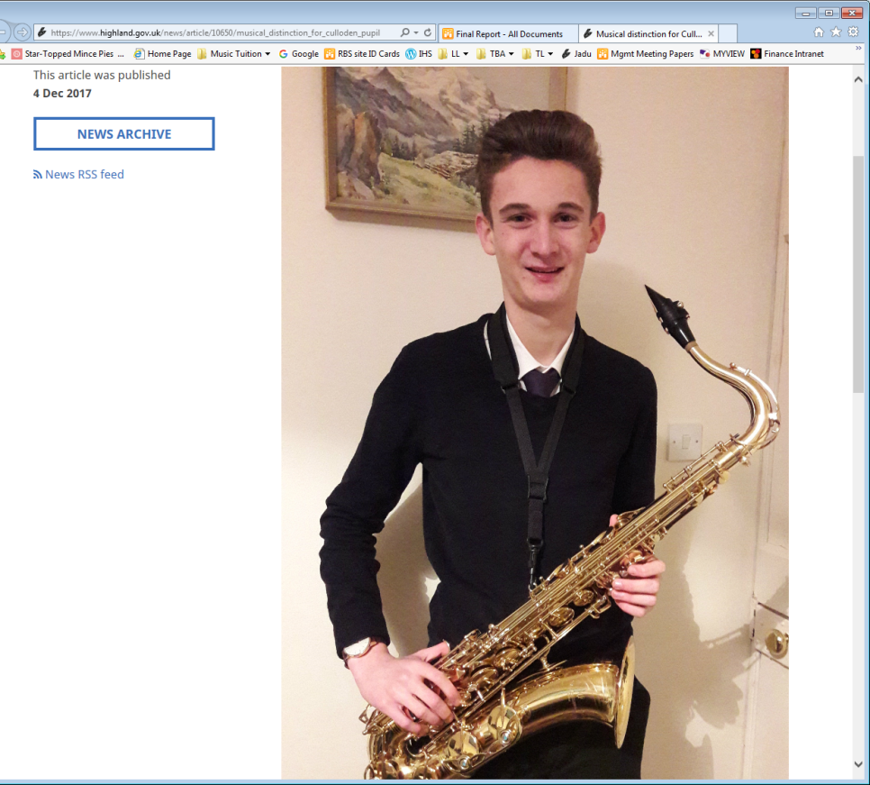**Press release: Musical distinction for Culloden pupil**

Culloden Academy pupil Ruairidh Jones is pictured following his recent success in achieving Grade 8 Trinity College Jazz Saxophone, with Distinction.

Ruairidh started playing soprano saxophone 9 years ago when he was 8 years old and progressed to alto and tenor as he grew. His lessons have mostly been delivered by the Highland Council Instrumental Music Service and through time he became a member of Highland Schools Wind Band for 3 years. For the last 4 years he has been in Highland Youth Big Band on either alto or tenor - currently as lead tenor. He has also been to the NYJOS (National Youth Jazz Orchestra of Scotland) summer school for 3 years and in 2017 was 2nd tenor in the NYJOS Access Orchestra.

Ruairidh is hoping to go on and study Jazz Performance at either the Royal Birmingham Conservatoire or Leeds College of Music.

The Highland Council’s Music Development Officer, Norman Bolton, said: “It’s fantastic to have been able to follow Ruairidh’s progress as a musician from his early days with Highland Young Musicians groups.  He has always been a motivated and loyal student and we hope his ambitions will come to fruition with the continued support of his parents and Council staff.” 4 Dec 2017

**Facebook – various examples:**

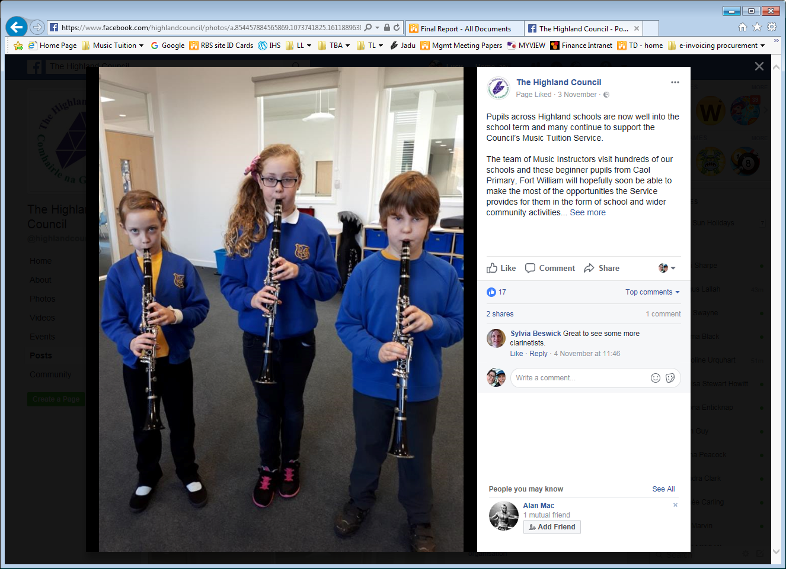

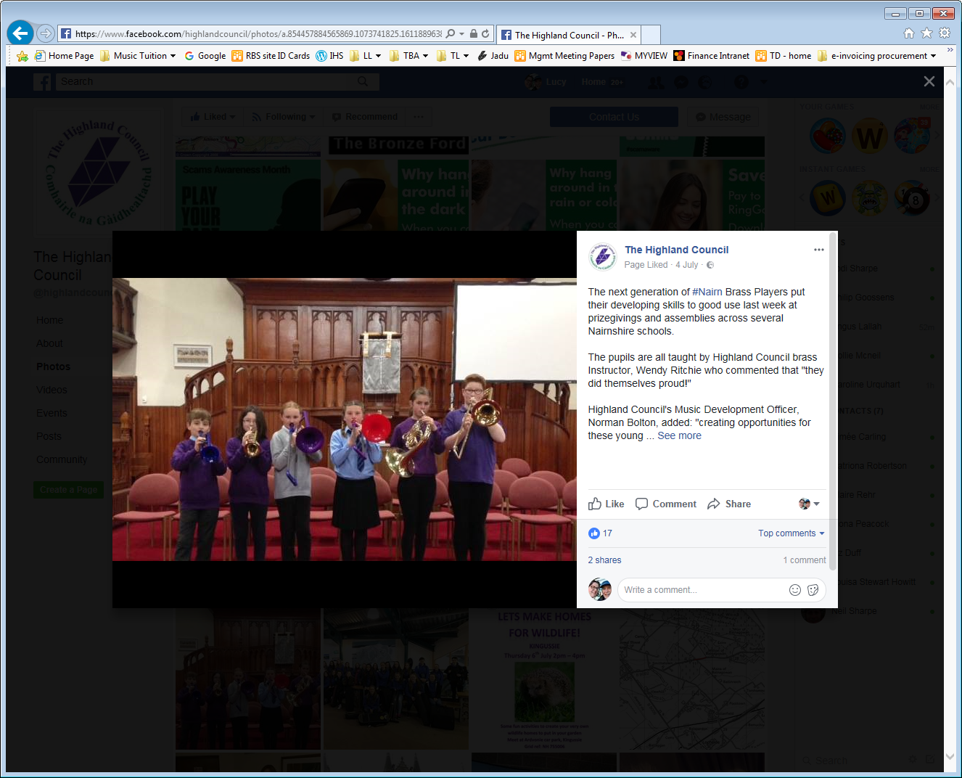

**Facebook – various examples:**

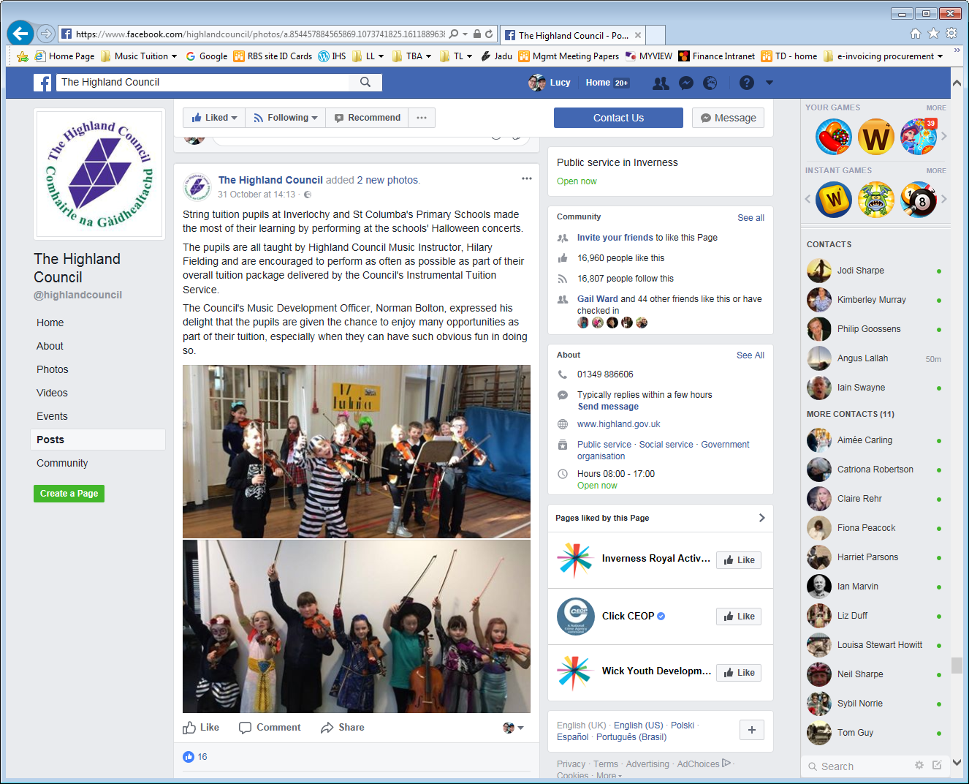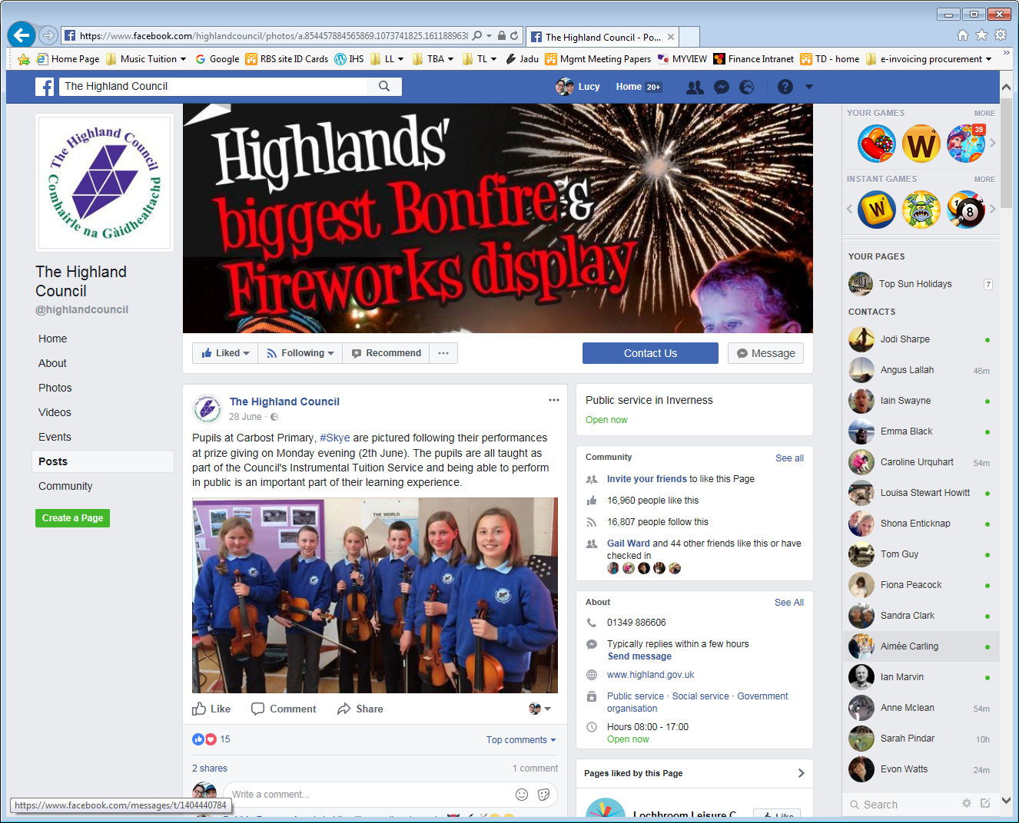

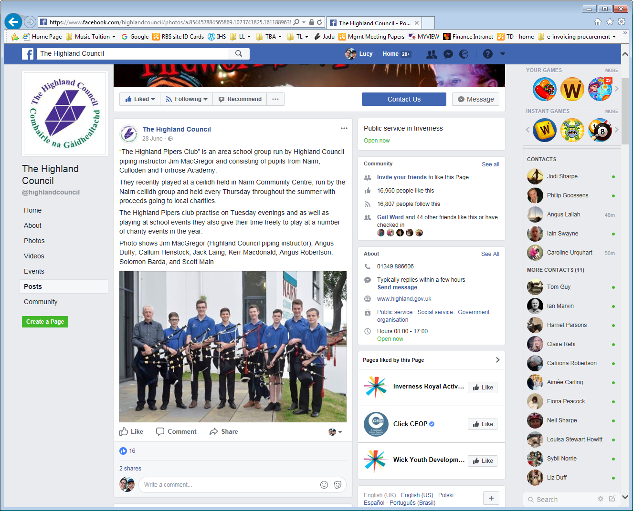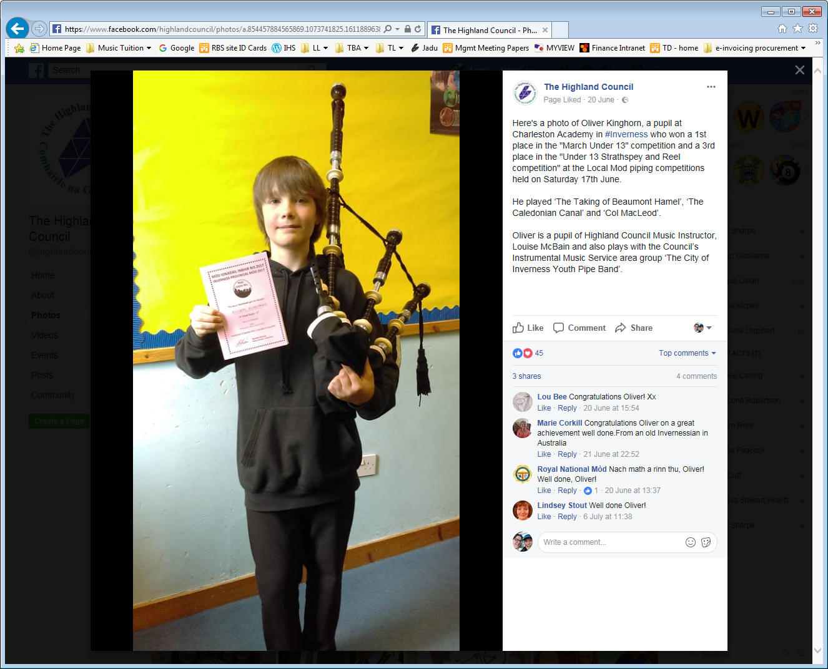

**APPENDIX 2 - SQA Results**

|  |  |  |  |  |  |  |  |  |  |  |  |  |  |
| --- | --- | --- | --- | --- | --- | --- | --- | --- | --- | --- | --- | --- | --- |
| **SQA MUSIC  2017** | **2017** | | | | | | | | | | | | |
| **A** | | **A - B** | | **A - C** | | **PASS** | | **A - D** | | **No Award** | | **Entries** |
| **No.** | **%** | **No.** | **%** | **No.** | **%** | **No.** | **%** | **No.** | **%** | **No.** | **%** |
| SCOTLAND: National 3 |  |  |  |  |  |  | 210 | 79.5% |  |  |  |  | 264 |
| Highland |  |  |  |  |  |  | 9 | 56.3% |  |  | 7 | **43.8%** | 16 |
|  |  |  |  |  |  |  |  |  |  |  |  |  |  |
| SCOTLAND: National 4 |  |  |  |  |  |  | 1,082 | 84.3% |  |  |  |  | 1,284 |
| Highland |  |  |  |  |  |  | 26 | 78.8% |  |  | 7 | **21.2%** | 33 |
|  |  |  |  |  |  |  |  |  |  |  |  |  |  |
| SCOTLAND: National 5 | 4,569 | 62.2% | 6,124 | 83.4% | 6,924 | 94.3% |  |  | 7,105 | 96.7% | 239 | 3.3% | 7,344 |
| Highland | 205 | **67.9%** | 257 | **85.1%** | 278 | 92.1% |  |  | 286 | 94.7% | 16 | **5.3%** | 302 |
|  |  |  |  |  |  |  |  |  |  |  |  |  |  |
| SCOTLAND: Higher | 2,963 | 57.4% | 4,323 | 83.7% | 4,938 | 95.7% |  |  | 5,060 | 98.0% | 102 | 2.0% | 5,162 |
| Highland | 130 | **58.6%** | 198 | **89.2%** | 215 | **96.8%** |  |  | 218 | **98.2%** | 4 | 1.8% | 222 |
|  |  |  |  |  |  |  |  |  |  |  |  |  |  |
| SCOTLAND: Adv. Higher | 1,116 | 67.2% | 1,435 | 86.4% | 1,590 | 95.7% |  |  | 1,624 | 97.8% | 37 | 2.2% | 1,661 |
| Highland | 32 | **69.6%** | 41 | 89.1% | 43 | 93.5% |  |  | 43 | 93.5% | 3 | **6.5%** | 46 |

**APPENDIX 3 – Peer Review 10 options**

**10 Options for Service Delivery**

Peer reviews will consider the following options for service delivery:

1. **In-house services** – running these better, more efficiently and identifying where a Lean Review should be undertaken.
2. **In-sourcing** of services currently contracted out.
3. **Shared services** – both provided by us and provided for us.
4. **Outsourced services** – see if a different approach is needed e.g. commissioning by outcomes, payment by results, and a shared or coordinated approach.
5. Services delivered in **partnership and/or integrated** with others, this could be place-specific.
6. **Arms-Length External Organisation** or other Council owned or created organisation to enable freed up, commercial or more sustainable practice.
7. **Commercial opportunities** within the service. By generating more income we can off-set grant reductions and support services and jobs across the region.
8. Transferring to a **community-run** service. This could be place specific.
9. **Reducing demand** for the service or more preventative approaches.
10. **Reducing service standards** (re-setting these with affordability in mind) **or stopping services**.

**APPENDIX 4 - Pricing and take-up 16/17**

The table below indicates the price and number of pupils (as per IS 2017)

|  |  |  |  |  |  |  |
| --- | --- | --- | --- | --- | --- | --- |
| Local Authority: | PUPIL NUMBERS 16/17 | % of pupils | **Fees - individual | Ranking - Indiv | **Fees - groups | Ranking - Groups |
| Moray | 815 | 7% | 378.00 | 1 | 264.00 | 4 |
| Aberdeen City | 3371 | 15% | 340.00 | 2 | 272.00 | 3 |
| Highland | 3100 | 10% | 318.00 | 3 | 318.00 | 1 |
| Aberdeenshire | 3060 | 9% | 316.00 | 4 | 216.00 | 11 |
| East Renfrewshire | 1732 | 10% | 300.00 | 5 | 300.00 | 2 |
| Clackmannanshire | 392 | 6% | 258.50 | 6 | 258.50 | 5 |
| Stirling | 950 | 8% | 258.00 | 7 | 258.00 | 6 |
| Perth & Kinross | 1762 | 10% | 245.85 | 8 | 245.85 | 7 |
| Argyll & Bute | 1141 | 11% | 232.98 | 9 | 232.98 | 8 |
| Angus | 932 | 6% | 231.00 | 10 | 231.00 | 9 |
| Fife | 4434 | 9% | 220.00 | 11 | 220.00 | 10 |
| South Lanarkshire | 2990 | 7% | 210.00 | 12 | 210.00 | 12 |
| Dumfries & Galloway | 1166 | 6% | 200.00 | 13 | 200.00 | 13 |
| Shetland | 685 | 21% | 190.00 | 14 | 140.00 | 19 |
| East Ayrshire | 1242 | 8% | 180.00 | 15 | 180.00 | 14 |
| North Ayrshire | 1,555 | 8% | 180.00 | 16 | 180.00 | 15 |
| East Dunbartonshire | 1382 | 8% | 170.00 | 17 | 170.00 | 16 |
| Falkirk | 2057 | 9% | 156.00 | 18 | 156.00 | 17 |
| North Lanarkshire | 3409 | 7% | 150.00 | 19 | 150.00 | 18 |
| Scottish Borders | 906 | 6% | 140.00 | 20 | 140.00 | 20 |
| Inverclyde | 958 | 10% | 117.00 | 21 | 117.00 | 21 |
| East Lothian | 1341 | 10% | 0.00 | 22 | 0.00 | 22 |
| Dundee City | 3677 | 20% | 0.00 | 22 | 0.00 | 22 |
| Renfrewshire | 1532 | 7% | 150.00 | 22 | 150.00 | 22 |
| Edinburgh City | 5089 | 10% | 0.00 | 22 | 0.00 | 22 |
| Eilean Siar | 540 | 16% | 0.00 | 22 | 0.00 | 22 |
| Glasgow City | 4919 | 7% | 0.00 | 22 | 0.00 | 22 |
| Midlothian | 1302 | 11% | 0.00 | 22 | 0.00 | 22 |
| Orkney Islands | 646 | 24% | 0.00 | 22 | 0.00 | 22 |
| South Ayrshire | 1,266 | 9% | 0.00 | 22 | 0.00 | 22 |
| West Dunbartonshire | 1034 | 8% | 0.00 | 22 | 0.00 | 22 |
| West Lothian | 2194 | 8% | 0.00 | 22 | 0.00 | 22 |
| SCOTLAND total/ave.* | **1879** | **9%** | **228.16** |  | **212.35** |  |

*Average fees based on the average of those that charge, and average pupil numbers based on numbers per authority.

**Fees for groups/individuals may show as the same figures if the local authority doesn’t have a different fee, such as ourselves in 16/17.

**APPENDIX 5 - Hiring of musical instruments**

|  |  |  |
| --- | --- | --- |
| Local Authority | Hiring Policies, 2016/17 | Summary |
| Aberdeen City | Instrument hire is included in the price of the instrumental music lesson for the duration of study | Included |
| Aberdeenshire | Aberdeenshire’s Instrumental Music Service has a limited stock of musical instruments to loan to pupils receiving instrumental tuition in schools. Allocation of instruments is subject to availability and need. Only in exceptional circumstances are pupils able to borrow certain instruments; e.g. Piano, Guitar, Drum Kit.  There is no charge for the loan of instruments.  Pupils may borrow an instrument as long as they attend school; however, senior and/or more advanced pupils will generally be encouraged to purchase their own instrument. | mixed |
| Angus | There is a £30 hire charge per pupil, per year. All instrumental music pupils are eligible to hire until they leave school in S6. | Hire |
| Argyll & Bute | Pupils can borrow an instrument for 1 year.  The service does not have a hiring policy. At times the Service may be short of instruments. | time bound |
| Clackmannan-shire | The service has a stock of most instruments available for music pupils to loan.  The service recommend that the loan period should be around 2 years and encourage pupils to purchase their own instrument at this stage, but cases are treated individually especially with the more expensive instruments.  No pupil will be excluded because they can’t provide an instrument.  If a pupil opts to play an instrument which is unavailable, then they would have to hire/loan from elsewhere. There is no extra cost to borrow an instrument from the council. | time bound |
| Dumfries & Galloway | Instruments are available for hire for £49.00 per year. These are available for the duration of tuition. Drum kits and Guitars are not available to hire. | hire |
| Dundee | Dundee City Council provides an optional instrument hire policy for a charge of £83 per year.  For children who live in households with an income of less than £15,800 this fee is waived.  For those paying there is the option to pay by direct debit over the course of the year.  Pupils studying SQA pay no fee for instrument hire. | hire |
| East Ayrshire | Instruments are provided on loan free of charge for the first year. East Ayrshire Council has a free instrument loan policy - there is no 'hire' facility.  Parents are encouraged to invest in an instrument for their child after the first year of tuition to allow the Instrumental Music Service to continue to offer the same opportunity to the next upcoming year group. | time bound |
| East Dunbartonshire | Instruments are loaned to beginner pupils if available. There are no hire procedures in place within the Instrumental Music Service. | time bound |
| East Lothian | The Instrumental Music Service and some schools in the authority have a number of instruments that are loaned to pupils. There is no hiring scheme. The length of time is flexible. | time bound |
| East Renfrewshire | All Monday-Friday pupils are loaned an instrument for the first two terms free of charge, then they are encouraged to purchase their own instrument. Pupils receiving lessons on larger or more expensive instruments are loaned instruments on a long-term basis for the duration of their tuition – on the understanding that they must play in an authority ensemble when at the required standard. Pupils eligible for free school meals are loaned an instrument, as much as possible, for the duration of their tuition.  The service does not have the resources to loan instruments to Saturday Music Centre pupils - they are encouraged to hire instruments from local stockists, before going on to purchase their own. | Time bound |
| Edinburgh | No hire charges | Included |
| Eilean Siar | The Instrumental Music Service buys instruments for pupils to borrow for the whole duration required.  There is no charging policy for instruments but some young people choose to buy their own instruments. The pupil can use instruments purchased by the authority throughout their entire schooling. The Service might have to purchase more instruments this session. | Included |
| Falkirk | Free instrument hire for one year, after this pupils are encouraged to purchase their own. However, if pupils are unable to afford this, in particular for those playing more expensive instruments, then they will continue to receive free hire. | Time bound |
| Fife | Where appropriate, an instrument will be loaned and available for pupils to take home. For larger instruments such as piano, double bass, orchestral percussion etc. practice facilities are made available in school. The use of an instrument is included in the charge for instrumental instruction. There is no additional instrument hire charge. | Included |
| Glasgow | Glasgow City Council’s Instrumental Music Service provides instruments for loan to children & young people receiving instrumental lessons. | Included |
| Highland | Council instruments are available for as long as a pupil requires them - no charge. | Included |
| Inverclyde | Inverclyde provide instruments without charge | Included |
| Midlothian | The majority of instrumental music pupils in Midlothian are offered instruments on loan. These are offered subject to availability.  Staff will help arrange discounted lease-hire of instruments for pupils. External lease-hire arrangements vary from company to company. Staff will assist with tax-exempt instrument purchase for pupils. | mixed |
| Moray | There is no hiring policy as pupils are loaned instruments as part of the overall annual lesson charge. | Included |
| North Ayrshire | Instruments are provided free of charge | Included |
| North Lanarkshire | North Lanarkshire’s Instrumental Music Service (IMS) does not operate an instrument hire service for pupils. However, it does provide instruments for pupils who play larger, more expensive, instruments such as French Horns, tuba, Baritone saxophones, etc.  Schools have also been encouraged to purchase their own stock of instruments to allow first access for pupils. The IMS provide the staffing for schools; it is the responsibility of individual schools and parents/carers to provide the instruments for tuition to take place. | mixed |
| Orkney | All instruments provided free of charge with no maximum length of time for pupils to keep instrument. | Included |
| Perth & Kinross | An Instrument is available for all pupils learning within the Perth & Kinross Instrumental Music Service and this is included in the cost of £245.85.  Pupils are encouraged to purchase their own instrument at a later stage. This can be carried out through the P&K Instrument Purchase Scheme. | Included |
| Renfrewshire | Free loan of an instrument to pupils for at least first year of tuition.  No hire charge in place if young person is using an Authority instrument. | Time bound |
| Scottish Borders | Cost of hire is included in the annual fee.  Any pupil taking music in S4 and above who does not own their own instrument can hire an instrument from Scottish Borders Council for £68 for the year. | mixed |
| Shetland | If a pupil borrows an instrument, there is no extra cost for this. All pupils are entitled to borrow an instrument where suitable. There is no set timescale for this but we advise parents/guardians to provide their own instrument after the first free term. | mixed |
| South Ayrshire | All instruments, repairs and maintenance are provided free of charge. There are no costs incurred by learners in South Ayrshire. | Included |
| South Lanarkshire | South Lanarkshire Council holds a relatively small supply/inventory of musical instruments. In general, parents/service users enter into independent hiring or purchase arrangements with musical instrument retailers or suppliers.  The Instrumental Music Service does not offer any hire or loan facility in relation to musical instrument provision, however, individual schools hold a small supply of instrument resources for pupil use. A selection of larger and more costly musical instruments are centrally provided and distributed to schools by the Instrumental Music Service, these include: oboes, bassoons, baritone saxophones, tubas, trombones, drum kits, timpani and large orchestral percussion instruments etc. | mixed |
| Stirling | Pupils can borrow an instrument with no charge. In most case pupils are expected to provide their own instruments after a few years. More expensive instruments will be provided for the duration of the pupils’ tuition. String pupils will be provided with a council instrument until they reach full sized instruments then they should provide their own.  There are always exceptions and no pupil will be excluded from tuition because they cannot provide an instrument. | mixed |
| West Dunbartonshire | All instrumental music pupils are loaned an instrument free of charge from when they start lessons until they leave school. | Included |
| West Lothian | It is recommended that each school has enough instruments available for new start pupils to be able to complete a trial period of lessons. These instruments are provided free of charge. Those pupils who then continue with the instrumental music programme are encouraged to rent or buy an instrument wherever possible and where it is not possible they may continue to use the school instrument free of charge. | mixed |

**APPENDIX 6 - Sponsorship**

|  |  |
| --- | --- |
| Local Authority | Hiring Policies, 2016/17 |
| Aberdeenshire | The Scottish Schools Pipes and Drums Trust (SSPDT) match funded the positions of two music instructors for a Pipe Band project based in Banff. The funding agreement is for a period of 2 years, after which the positions will be integrated with the core instrumental provision. |
| Argyll & Bute | Argyll Piping Trust fund 0.7 fte for a piping tutor in Old Argyll as well as 0.1 to cover travel to provide tuition in Mull. |
| Clackmannan-shire | Hillfoots Music For Youth is run as a not for profit organisation by an Executive Parents Committee, all income is generated from concerts and fundraising. |
| Dundee | Dundee City Council’s Instrumental Music Service has recently entered into a partnership arrangement with Travel Dundee to provide a number of free transport passes annually to be issued to pupils who otherwise would be unable to attend central Music Centre activities. |
| East Ayrshire | Virgin Money, SSPDT. |
| East Dunbartonshire | No sponsorship but a parent group raise money to help fund some groups – FIMEDS  Grants have been cut this year |
| East Lothian | The Scottish Schools Pipes and Drums Trust (formerly East Lothian Pipes and Drums Trust) provides tuition in one of the clusters |
| East Renfrewshire | The Friends of East Renfrewshire Schools Music are dedicated to promoting instrumental and choral music in schools across the areas, focussed through the Saturday morning Music School at Williamwood High School.  The Friends raise funds for additional activities and facilities to enrich the learning experience, and to enable as many children as possible, from all backgrounds, to have the opportunity to learn instruments, join choirs, and showcase their talents. They provide additional instruments and sheet music, subsidise residential trips and tours and provide hardship funding for children from disadvantaged backgrounds to participate in trips.  Contributions have included providing instruments to help establish East Renfrewshire Schools Pipe and Drums band, the first East Renfrewshire county pipe band, and to stage a choral/orchestral West End Gala Concert. |
| Eilean Siar | The Scottish Schools Pipes and Drums Trust: 15K over 3 years for Drumming lessons  Macaulay Trust 2K Grant to enable Pipe Band to perform at National event and to attend workshop run by the National Youth Pipe Band of Scotland. |
| Fife | For Additional Activities:  Fife Youth Music Activities Charitable Trust offers support and encouragement to Fife Music Activities, the programme of group and ensemble music making organised by the Instrumental Music Service in Fife.  FYMA aims to support learning through the availability of music opportunities for youth groups in Fife, to supplement Education Service provision and to minimise any barriers to participation. While financial support is provided to Fife Music Activities, other groups encompassing youth music making in Fife also benefit viz. Fife Festival of Music and Kirkcaldy Orchestral Society's Youth work.  FYMA funds have been disbursed in a variety of ways including providing assistance where the cost of participating would otherwise prevent a pupil's involvement. |
| Midlothian | We do not have any private sponsorship as such; however, we are in receipt of circa £112k from YMI which allows us to do additional work in primaries, and with children with additional needs. |
| Moray | £500 business donation from Grigor & Young Estate Agents and Solicitors toward the self-funding Moray Schools Youth Orchestra the first week of the summer holidays.  £750 private sponsorship donation from a benefactor toward the self-funding Moray Schools Youth Orchestra the first week of the summer holidays. |
| North Ayrshire | North Ayrshire IMS receive £2,500 from the Rhona Reid Trust to sponsor Young Musician Events. This session we also received funding (£1,400) from the local community to purchase new drums for the Pipes Band. |
| North Lanarkshire | For Additional Activities:  A small number of companies provide approximately £3000 worth of sponsorship towards the running costs of North Lanarkshire’s music groups activities |
| Orkney | Youth Music Initiative (YMI)  Stagecoach Orkney provide free bus passes to help pupils travel to and from rehearsals |
| Perth & Kinross | Perth & Kinross Music Foundation - Young Musicians’ Parents’ Association support lessons, central groups and music camp.  Perth Youth Orchestra is supported by the Gannochy Trust |
| Renfrewshire | Renfrewshire’s YMI piping programme receives matched funding from SSPDT |
| Scottish Borders | Borders Young Musicians support extra-curricular activities |
| South Ayrshire | Our partnership continues with the Scottish Schools Piping and Drumming Trust (SSPDT) and William Grant Foundation. This funds a piping and drumming project in the Girvan Area until 2019. |

**APPENDIX 7 - Number of pupils for each authority 12/13 to 16/17**

|  |  |  |  |  |  |  |
| --- | --- | --- | --- | --- | --- | --- |
| **Local Authority** | **Number of IMS pupils** | | | | | |
| **Year** | **12/13** | **13/14** | **14/15** | **15/16** | **16/17** | **% diff 2012-2017** |
| **Aberdeen City** | 2760 | 2642 | 2255 | 2500 | 3371 | 22.1 |
| **Aberdeenshire** | 3389 | 3025 | 2955 | 2576 | 3060 | -9.7 |
| **Angus** | 1500 | 1200 | 1434 | 1146 | 932 | -37.9 |
| **Argyll & Bute** | 1258 | 1435 | 1334 | 1226 | 1141 | -9.3 |
| **Clackmannanshire** | 432 | 448 | 345 | 444 | 392 | -9.3 |
| **Dumfries & Galloway** | 1210 | 1317 | 1552 | 1294 | 1166 | -3.6 |
| **Dundee City** | 2200 | 2669 | 2938 | 3538 | 3677 | 67.1 |
| **East Ayrshire** | 1147 | 783 | 823 | 1002 | 1242 | 8.3 |
| **East Dunbartonshire** | 1301 | 1600 | 1410 | 1586 | 1382 | 6.2 |
| **East Lothian** | 1284 | 1318 | 1327 | 1331 | 1341 | 4.4 |
| **East Renfrewshire** | 1942 | 1938 | 1904 | 2010 | 1732 | -10.8 |
| **Edinburgh** | 4758 | 4912 | 5215 | 5100 | 5089 | 7.0 |
| **Eilean Siar** | 360 | 500 | 500 | 766 | 540 | 50.0 |
| **Falkirk** | 1142 | 965 | 1376 | 1950 | 2057 | 80.1 |
| **Fife** | 3494 | 3161 | 3332 | 4415 | 4434 | 26.9 |
| **Glasgow** | 4538 | 4551 | 4573 | 4597 | 4919 | 8.4 |
| **Highland** | 3100 | 3200 | 3400 | 3450 | 3100 | 0.0 |
| **Inverclyde** | 1015 | 1350 | 1677 | 1,388 | 958 | -5.6 |
| **Midlothian** | 1100 | 1100 | 1221 | 1312 | 1302 | 18.4 |
| **Moray** | 850 | 850 | 893 | 910 | 815 | -4.1 |
| **North Ayrshire** | 1570 | 1627 | 1554 | 1,487 | 1,555 | -1.0 |
| **North Lanarkshire** | 3853 | 3670 | 3685 | 3599 | 3409 | -11.5 |
| **Orkney** | 498 | 500 | 531 | 581 | 646 | 29.7 |
| **Perth & Kinross** | 1590 | 1605 | 1690 | 1711 | 1762 | 10.8 |
| **Renfrewshire** | 1050 | 1280 | 1534 | 1546 | 1532 | 45.9 |
| **Scottish Borders** | 716 | 862 | 895 | 995 | 906 | 26.5 |
| **Shetland Islands** | 662 | 561 | 570 | 724 | 685 | 3.5 |
| **South Ayrshire** | 1222 | 1319 | 1240 | 1,126 | 1,266 | 3.6 |
| **South Lanarkshire** | 2957 | 3029 | 3035 | 3050 | 2990 | 1.1 |
| **Stirling** | 810 | 844 | 844 | 898 | 950 | 17.3 |
| **West Dunbartonshire** | 964 | 891 | 941 | 926 | 1034 | 7.3 |
| **West Lothian** | 2448 | 2395 | 2468 | 2397 | 2194 | -10.4 |

**APPENDIX 8 - A brief overview of the “As Is” (administration) process**

1. Expressions of interest are provided to the instructor by the parent/child.
2. The instructor considers such request and decides if there is a place available.
3. If there is a place available, the instructor gives the child a registration form/pack to take home for completion.
4. The completed forms, including DD mandate, are returned to the administrative staff in Dingwall.
5. On receipt of these completed forms the administrative staff log the forms, including updating the relevant data fields on SEEMiS (school database of pupils).