Redesign Board - Performance Briefing Note
Accounts Commission - Best Value Assurance Reports
Report by Corporate Audit & Performance Manager
13 February 2018
1. | Background
1.1 | The Redesign Board’s remit and work plan were agreed at Council on 7 September 2017 and these included an action that the Board would be briefed on the new approach to Best Value Assurance Reviews for local authorities by Audit Scotland and consider how the work of the Board is contributing to strengthening the Council’s approach to Best Value.
1.2 | The Council has a statutory duty under Best Value and the Accounts Commission has had a process of Best Value reviews of Councils in place for some time. The last Best Value Audit of the Council was in 2009. The Accounts Commission has just started implementing a new approach to Best Value (BV) through Best Value Assurance Reports (BVAR). The definition of BV under the Local Government Scotland Act 2003 places specific duties to: ‘make arrangements which secure Best Value’ which is about ensuring that there is good governance and effective management of resources, with a focus on improvement, to deliver the best possible outcomes for the public.
1.3 | A Best Value audit is a significant assessment for any local authority and a poor result will be damaging to the Council’s reputation through public reporting of the results. There is also the potential for enforcement action from taking over management of the Council to additional scrutiny burdens as external audit seek on-going assurance that improvement is being driven strategically. The Council’s last audit in 2009 was very positive but given the new regime and the more difficult operating environment the Council finds itself in there is no room for complacency.
2. | Auditing of Best Value – new approach
2.1 | Audit Scotland (AS) is currently reviewing its approach to Best Value Audits and some underpinning issues have been identified by AS which put some context around the potential approach:  - 14 Councils had not has a BV report in the past five years (applies to HC);  - 15 current Chief Executive have not had a BV audit (applies to HC);  - Concern there is a perception a BV indicates a poor or failing Council;  - Concern Councils are coasting;  - Identified a need for more frequent assurance;  - Need for greater focus on impact of BV arrangements and on improvement;  - Consider the potential of bringing Local Government audit work together to provide a more collective views and judgements.
2.2 | While guidance is under development internally within AS some key principles are taking shape:  - BV remains critically important but guidance needs strengthened and refreshed;  - Pace, depth and continuity of improvement needs to increase in local government and driving this core of BV audit process;  - Continued proportionate and risk bases approach but more frequent assurance on BV across all 32 Councils;  - Better experience for Councils through more integration of processes and responsibilities;  - Strong focus on quality of service experienced by the public and outcomes achieved for communities including demonstrating contributions to partnership working;  - Clear focus on improvement and the outcomes Council’s achieve as a result of arrangement to secure BV and not on the arrangements themselves;  - More regular engagement between auditors and Councils to discuss progress, risks and challenges. Linking this to existing risk and audit assessments which determine local audit plans and timing, potential for elements of continuous assessment;  - Expectation Councils will have clear improvement plans that are informed by effective performance management and service reviews, progress is accurately monitored and reported;  - New audit appointments starting in 2016/17 (new HC Auditors Grant Thornton) and BV reporting will be over the 5 year cycle of the external audit appointment;
3.  3.1 | Current position on BVAR  A report to Council on our Local Scrutiny Plan by external audit in May 2016 stated that the Council was recommended for some early Best Value scrutiny. Early indications now are this may be either thematic or a focused risk based approach rather than a full Council BV and will link to ongoing work of our external auditors. However the structure of the first tranche of BVAR report during 2017/18 have been consistent and while the focus and evidence gathered will differ they have all covered:  - Does the Council have a clear strategic direction?  - How well is the Council performing?  - Is the Council using its resources effectively?  - Is the Council working well with its partners?  - Is the Council demonstrating continuous improvement?
3.2 | BV guidance is being refreshed but this is in parallel to the first tranche of Councils being audited under existing guidance and the process is being described as evolutionary. Attached below is a timeline on previous BVs and currently this is being followed with oldest taken first. The National Performance Forum will enable a watching brief to be kept on the 1st and now 2nd tranche of BVARs announced.
3.3 | Links have also been made in the new direction to Best Value with the Statutory Performance Indicator (SPi) guidance stating that incorporating the assessment of Council’s Public Performance Reporting (PPR) is an integral element of the new approach to BV rather than a separate process. It also highlights that compliance with Local Government Benchmarking Framework (LGBF) is not sufficient and evidence is needed on how benchmarking is used to improve performance.
4.  4.1 | Redesign Contribution to BVAR  The Redesign Board has a crucial role in supporting a positive outcome for the Council through our BVAR. The overall approach and options appraisal methodology used for Redesign is now providing a consistent approach for the Council to review functions and services with a drive continuous improvement and value for money. All the key areas being covered by BVAR as outlined in paragraph 3.1 are the core work of the Redesign Board as such the work of the Board provides crucial direction for the Council and will provide core evidence for the BVAR. Overall the approach to Redesign is now intrinsic to delivering Best Value and is also being viewed very positively by external audit.
Author: Evelyn Johnston, Corporate Audit & Performance Manager 23.01.18

Appendix 1 – BVAR timeline
Appendix 2 – List of benchmark SPIs (LGBF)

Appendix 1

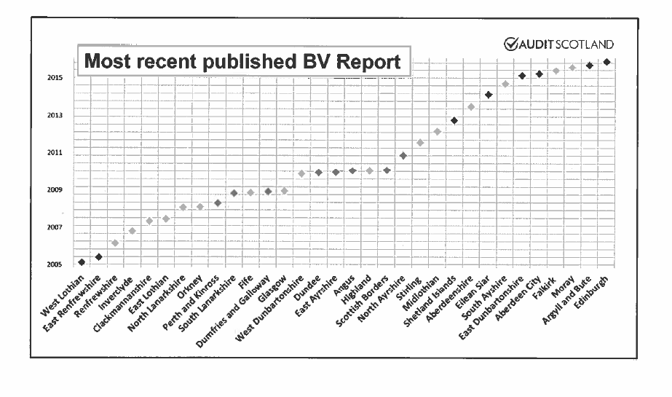

Appendix 2
Children’s Services
CHN01 - Cost per primary school pupil
CHN02 - Cost per secondary school pupil
CHN03 - Cost per pre-school education registration
CHN8a - Gross cost per bed/week Children’s Residential Units
CHN8b - Cost of LAC per child per week - community
CHN10 - % adults satisfied - schools [3 year rolled averages]
CHN17 - % of children meeting developmental milestones
CHN18 - % of funded early years provision which is graded good/better
CHN21 - % Participation rate for 16-19 year olds
CHN22 - % of child protection re-registrations within 18 months
CHN04 - SCQF Level 5 attainment by all children
CHN05 - SCQF Level 6 attainment by all children
CHN06 - SCQF Level 5 attainment by children from deprived backgrounds
CHN07 - SCQF Level 6 attainment by children from deprived backgrounds
CHN09 - % of Looked After Children in the community
CHN11 - Pupils entering positive destinations
CHN12a - Overall Average Total Tariff (S4-S6)
CHN12b - Average Total Tariff SIMD Quintile 1
CHN12c - Average Total Tariff SIMD Quintile 2
CHN12d - Average Total Tariff SIMD Quintile 3
CHN12e - Average Total Tariff SIMD Quintile 4
CHN12f - Average Total Tariff SIMD Quintile 5
CHN19a - School attendance rates (per 100 pupils)
CHN19b - School attendance rates (per 100 looked after children)
CHN20a - School exclusion Rates (per 1000 pupils)
CHN20b - School exclusion rates (per 1000 looked after children)
CHN23 - % LAC with more than 1 placement in the last year (Aug-July)
Corporate Assets
CAST1 - Asset Management – Suitability for use
CAST2 - Asset Management - Condition
Corporate Services
Corp1 - Central Support Services as a proportion of running costs
Corp3b - Women managers in top 5% of earners
Corp3c - Gender Pay Gap
Corp4 - Council Tax Collection cost per dwelling
Corp6a - Sickness absence days per teacher
Corp6b - Sickness absence days per employee (non-teacher)
Corp7 - Council Tax - Annual % received
Corp8 - Invoices Payment within 30 days
Culture and Leisure Services
C&L1a – Cost per attendance at Sports facilities
C&L2a - NET cost per visit to libraries
C&L3a - NET cost per museum visit
C&L4a - NET cost of parks & open spaces per 1,000 population
C&L5a - % adults satisfied - libraries [3 year rolled averages]
C&L5b - % adults satisfied - parks & open spaces [3 year rolled averages]
C&L5c - % adults satisfied - museums & galleries [3 year rolled averages]
C&L5d - % adults satisfied leisure facilities [3 year rolled averages]
Economic Development
ECON1 - Percentage of Unemployed People Assisted into work
ECON2 - Cost per planning application
ECON 3 - Average Time (weeks) Per Planning Application
ECON4-Total direct spend with Highland small and medium sized enterprises
ECON 5 - No of business gateway start-ups per 10,000 population
Environmental Services
ENV1a - Net cost of Waste collection per premises
ENV2a - Net cost per Waste disposal per premises
ENV3a - Net cost of street cleaning per 1,000 population
ENV 3c - Street Cleanliness Score
ENV4a - Cost of maintenance per km of roads
ENV4b - Road network - A Class
ENV4c - Road network - B Class
ENV4d - Road network - C Class
ENV4e - Road Network - U Class
ENV5a - Cost of Trading Standards, Money Advice, and Citizen Advice per 1000 population
ENV5b - Cost of Environmental Health per 1000 population
ENV7a - % adults satisfied - refuse collection
ENV7b - % adults satisfied - street cleaning
ENV6 - % Household waste recycled and composted CY
Housing Services
HSN1/SHR31 - Gross rent arrears as % of rent due
HSN2/SHR34 - % rent loss through voids
HSN3/SHR7 - SHQS - % total meeting SHQS
HSN4b/SHR12 - Average time to complete non-emergency repairs [days]
HSN5/SHR8 - % properties at or above National Home Energy Rating or Standard Assessment Procedure ratings
Social Work Services
SW1 - Adult Home Care costs per hour aged 65 and over
SW2 - Direct payments spend on aged 18+ adults
SW3 - % of aged 65+ with intensive needs receiving care at home
SW4a - % of adults receiving any care or support who rate it as excellent or good [3 year average]
SW4b - % of adults supported at home who agree the services and support had an impact in improving or maintaining their quality of life
SW5 - Net Residential Costs per week Older Adults 65+

