CB4b: Environment

Wipro’s Plan to help the Authority to minimise waste in ICT
A plan which describes your approach will minimise waste in accordance with 5.6.1;
Wipro is ISO140001 certified and has strict policies to reduce waste and promote recycling of products, packaging and refreshed infrastructure. We are constantly working with our supply chain to identify opportunities and agreements to participate in own waste prevention plans, which is in-line with the Scottish Government’s zero waste plan.
We will deliver the services in compliance to WEEE standards to minimise waste in terms of both, WEEE and packaging. In line with the Council’s Carbon Clever initiative and Scottish Government’s zero waste plan, Wipro has chosen Stone Computers as our recycling partners for all refreshed infrastructure. Stone Computer is AATF accredited and are obliged to report all in the UK Government national system that reports to the European Agencies.
We are aiming for zero landfill by recycling all ICT infrastructure that is refreshed by Wipro as part of the Authority’s Transformation Project requirements. These projects include (Transformation Project 2) full back-office infrastructure centre refresh of over 600 servers hosted in Schools, Incumbent data centres and Council offices, (Transformation Project 3 and 4) end user device refresh for Corporate and Curriculum and (Transformation Project 6) rollout of Chromebooks for Curriculum.
We will develop refreshed infrastructure database as part of the transformation project, to track the data purge as well the recycling approach for each refreshed device. This data will be maintained by Stone Computers and audited by Wipro to ensure our commitments are met.
- Following receipt all equipment is inspected and tested to ascertain its potential for reuse, equipment deemed suitable will also then be graded and cleaned; then be assigned to re saleable stock.
- Recycling service for redundant IT equipment & associated peripherals; with primary aim of placing all viable equipment back into reuse.
- Equipment which cannot be re used is processed for the recovery of constituent materials; through processing at Stone and downstream recycling partners. The process ensures that all redundant equipment is returned to Stone and therefore not despatched to landfill.
All packaging will be recycled as per the Council’s Waste guidance using certified recycling suppliers.

A plan which describes how your approach to the delivery of the Services will result in an auditable landfill minimisation in accordance with 5.6.2;
Wipro has set a target to achieve zero landfill for all refreshed infrastructure. We will deliver this through our WEEE compliant, ISO IEC 140001 certified recycling partner, Stone Computers. Stone Computer is AATF accredited and are obliged to report all in the UK Government national system that reports to the European Agencies.
Our approach to recycling to minimise the landfill:
- All Authority data will be purged from the devices using Blancco tool.
- Blancco tools to purge Authority data from digital media. Blancco is approved by CESG and UK Government as a data purge tool for all HMG infrastructure
- WEEE compliant processes, ISO:IEC:140001 facilities and certified partners (Stone Computers), vetted by our Supply Chain management Group
- Wipro as defined target of zero landfill for all refreshed infrastructure to minimise waste and reduce CO2 impact as per the Authority’s requirements.
- At least 10% of the infrastructure, that is considered re-usable and is able to perform on the supported operating systems such as Microsoft Windows 7 or 8 will be made available to the charities and volunteer groups.
Following receipt all equipment is inspected and tested to ascertain its potential for reuse, equipment deemed suitable will also then be graded and cleaned; then be assigned to re saleable stock. Equipment which cannot be re used is processed for the recovery of constituent materials; through processing downstream at recycling partners, who will use it for spares. This ensures the Authority is reducing waste.
The Authority staff will have the opportunity to choose the refreshed desktops / laptops for home use (including for family and friends) through a user friendly portal, accessible through our Service Desk self-help portal.
We will utilise at-least 10% of the refreshed equipment to support our Community Benefits programme, through donating the suitable desktop and server infrastructure to citizens across the Highland Council area.
Wipro will use the social schemes through our Charity– WiproCares and GetOnline@Home (http://www.getonlineathome.org/) to donate the equipment that is fit for purpose before it is recycled.
Wipro will provide a certificate verifying their contribution in supporting such donations to the charities.
Our recycling approach that includes all redundant IT equipment & associated peripherals; has a primary aim of placing all viable equipment back into reuse.

Reporting and Certification
All recycled equipment will contribute towards the UK efforts in meeting the European Union level waste management targets. Unlike many recyclers, Stone Computer hold AATF status with the Environments Agency and therefore is obliged to report the receipts of all WEEE into the UK national system. Disposals of WEEE with unregulated providers results in these quantities not being reported or monitored.
Wipro will provide certificates of destruction for data and compliance with WEEE Directive. Asset reports detailing refreshed items and copies of all relevant & completed waste documentation will be provided to the Authority through the Decommissioning project. Where deemed necessary, we will support the Authority’s requirement for physical audit visits to the recycling site.
Wipro’s approach to recycling provides full audit of our recycling initiatives and is aimed to achieve overall reduction in the Authority’s carbon footprint.

Measuring the CO2 and other emissions of our Service
A plan which describes how your approach to the delivery of the Services will result in measurable CO² and other emissions reduction in accordance with 5.6.3;
Wipro will use the Greenhouse Gas Protocol (GHG Protocol) tool to understand, quantify, and manage greenhouse gas emissions as part of the ICT Services. The GHG Protocol is result of a decade-long partnership between the World Resources Institute (WRI) and the World Business Council for Sustainable Development (WBCSD). It works with businesses, governments, and environmental groups around the world to build a new generation of credible and effective programs for tackling climate change. The methodology covers:
- Business Unit, e.g. per user per location
- PUE – Power usage effectiveness - the ratio of total amount of energy used by a computer data center facility to the energy delivered to computing equipment
- Boundary Definitions e.g. Service Type and Location scopes
- Service Boundary for Green House Gas emissions
- Embodied Emissions; i.e. calculation of C02 incurred in the manufacturing process
- Regional Emissions Factors where ICT is deployed
- Trivial emissions sources and how they should be treated in the calculations
- Vendor-supplied data for equipment energy consumption: in-use and ‘embodied’
- Extrapolation of acceptable data in the most cost-effective way
- Apportionment of energy use and carbon emissions for shared infrastructure or services
The cradle to grave life-cycle of an IT equipment (desktop, server, storage, network component) is shown below:
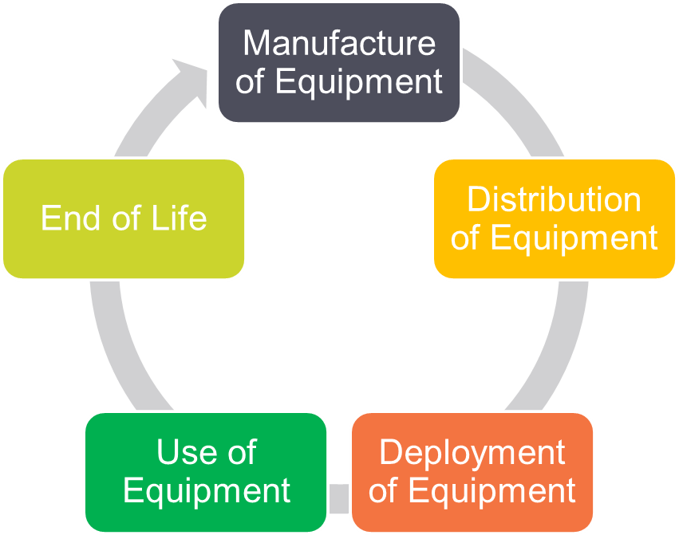
Figure 1 – Cradle to grave life-cycle of an IT equipment is assessed to review the impact on CO²
The equipment undergoes six phases in its lifecycle, starting from manufacturing of equipment to the point equipment is refreshed. We have an approach for measuring the CO2 emissions at every phase and minimise the CO2 impact as part of our service delivery:
Manufacturing Equipment: Measure the values shared by original equipment manufacturer, these specifications are also available in the public forums.
Equipment Distribution: CO2 measurements is mostly insignificant; this involves following key contributors to CO2 emissions
- Emissions due to the electricity consumption of the assets
- Emissions due to transportation of equipment from the factory to end location
- Effort and resources deployed to co-ordinate and manage the logistics
- Waste generated due to change of hands in the logistics process.
Deployment of Equipment: Wipro has considerable influence over the waste generated and CO2 emissions that are beyond the normal specifications
- Engineering visiting assumptions – emissions related to staff movements, most impact by car
- Clarity around scalability on size and geographies (for different emissions factors)
- Any impact of hardware refresh for instance (if the life/length of service is not intrinsically linked to the life of the equipment supported)
Use of Equipment: This phase will be measured on the equipment usage and measures taken to improve efficiencies in the deployment model across the data centre and distributed sites.
- Frequency of use of hands and feet support, travel associated with this support.
- Tickets per user (based on stable estate, e.g. 0.7 ticket per user per month)
- Emissions factor on medium use of Servers/storage/network/Desktop/Laptop in a time period, for example 10 hours a day,
- Impact on supporting infrastructure and associated emissions / timings
End of Life: The end-of-life stage begins when the used product is discarded by the consumer and ends when the product is returned to nature or allocated to another product’s life cycle. Depending on the circumstances specific to the Desktop Managed Service and local legislation on decommissioning of services/collection & disposal of relevant ICT equipment, there will be a placeholder covering:
- Collection of Equipment
- Recycling of Equipment
- Disposal of Equipment
Wipro has a comprehensive Ecological Sustainability Programme Management System that is compliant with the EN ISO14001:2004 standard for the Environmental Management Systems.
The figure below describes Wipro’s approach to deliver the Services that will result in reduced CO² and other emissions.
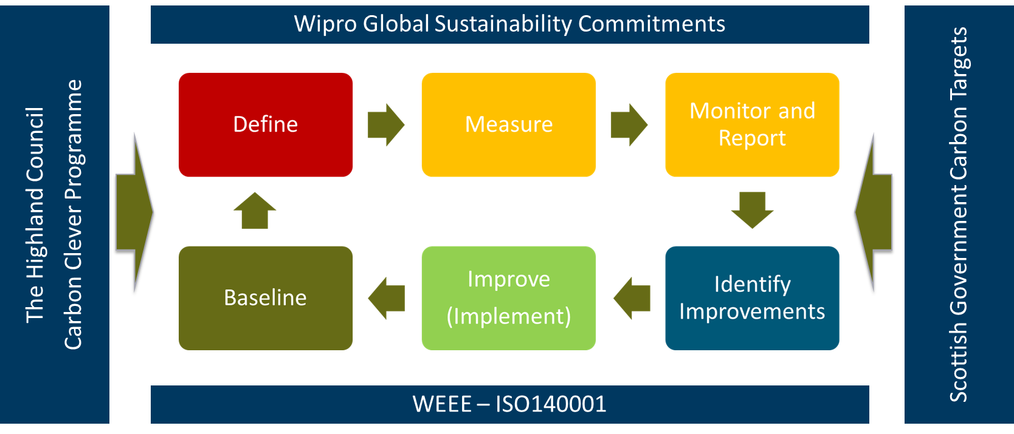
Figure 2 - Wipro’s approach to deliver the Services that will result in reduced CO²
The key stages that form Wipro’s approach to deliver the Services with reduced CO2 emissions are:
- Define – Define the solution for the services in scope. Wipro will baseline the current energy consumption based on the services in scope. This will help us monitor the progress and report the savings based on our transformation plan.
- Measure – We will measure the CO2 and energy consumption at the Key Milestones. These will be mapped to the Transformation Projects, for example Transformation Project 2 – Data Centre Transformation, Transformation Project 3 and 4 related to End User Compute Refresh.
- Monitor and Report – Wipro will measure the energy consumption and CO2 emissions in our data centres for the hosted services. These will be reported to the Council on the Service Management Dashboard on the monthly basis. We will also report the monthly CO2 emissions to the Council Executive Board through a display in the Council’s head office ( in agreement with the Council) to demonstrate the ICT Service is contributing to the Council’s commitments to wards 3% year on year reduction.
- Identify Improvements – Ongoing project to identify opportunities to support the Council to reduce the energy consumption and CO2 through continuous innovation project. Our Continuous Innovation Project stream will have the KPI’s to identify opportunities of CO2 reduction across our service as well as working with the Council, Authority Suppliers and our sub-contractors to support the Council with 3% year on year savings.
- Improve – Wipro will implement the projects in agreement with the Authority, which will result in over 50% reduction in energy consumption and CO2 consumption. These are described in the section below.
- Baseline – Define the new baseline as per results achieved. Post baseline we will work with the Authority through the Define phase to identify the scope of services where the energy savings can be achieved that will result in reduced CO2.
- Wipro will reduce the energy consumption by over 50% through the transformation projects as part of our Service delivery. This project will be implemented as part of the Core Contract. The details are provided in our response to 5.6.4 (5.6.4) below.
- We will recycle all refreshed infrastructure through our 140001 certified Recycling Partners.

Plan for reducing the Authority’s ICT related Energy Consumption
A plan which describes how your approach to the delivery of the Services will result in minimised energy use in accordance with 5.6.4;
Wipro recognises that 60-70% of emission is contributed directly by electricity consumption. Wipro has an effective mechanism to track, which also helps us in minimising our consumption. At Wipro EcoEnergy, we provide intelligent and sustainable solutions for enterprise-wide energy operations and efficiency management. We have built analytical models and correlation logics to deliver energy efficient solutions. We work to reduce the carbon footprint, energy wastage, and recover your energy losses. Our approach is switching to results.
Squeezing savings from matured operations with years of focus on efficiency requires new and innovative ways. Data plays an important role in the same. The new world of smart meters, smart grids, and enhanced customer relationship management systems has already started to generate massive data sets that utility companies are keen to analyse.
Our approach is four fold – D.E.T.A (Data, Energy, Technology and Analytics), which we will bring to the Authority.
- Data - We handle large and complex data for energy analytics. The challenges include data acquisition, validation, storage, search, analysis and visualization of data from multiple sources, locations and frequency. The trend to larger data sets is due to the additional information derived from analysis of a single set of related data. This enables correlations to spot trends in business and operations, having implications on energy usage.
- Energy - The backbone of our energy management services is our unique Energy Management Platform. The Platform interfaces with your assets and facilities to continuously collect consumption data at the system or even device level. The Platform leverages meters and sub-meters for consumption measurement and uses sensors for temperature, humidity, light-level, occupancy, run hours of equipment, flow, quality and any other parameters that impact energy consumption.
- Technology - Wipro’s Energy Management Platform is technology-agnostic and can integrate with almost all Building Management Systems (BMS), SCADA and other data aggregation layers to collect device-level information.
- Analytics - Using Analytics for Benchmarking is the tip of the ice-berg. We do much more. We believe that energy management can be carried out effectively through continuous co-relation and analysis of various variables that affect energy consumption such as type of facility, asset, process, weather data, etc. Our team of analysts, supported by technical experts, leverages our Energy Management Platform to gather device-level energy data and provide useful insights for energy optimisation
The figure below describes the integrated architecture of our EcoEnergy Solutions that is helping us reduce energy consumption to our clients.
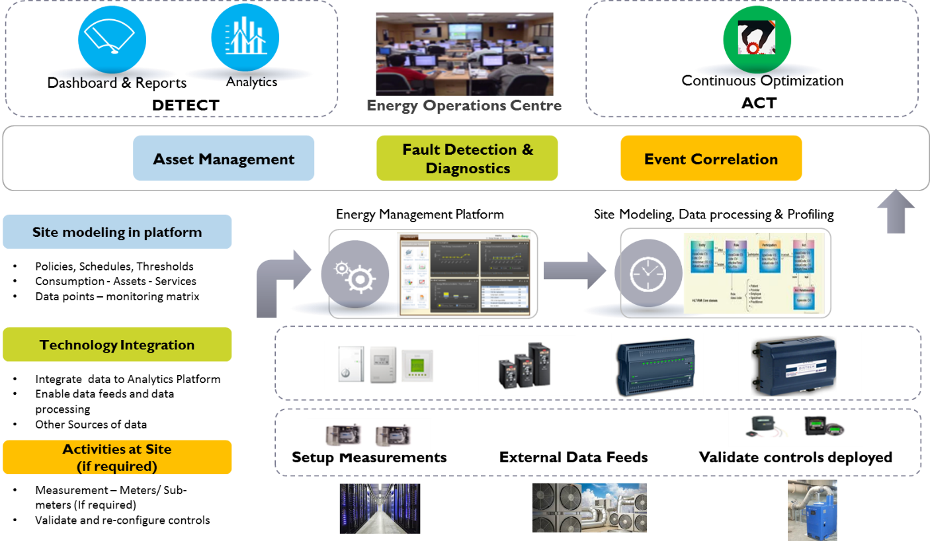
Figure 3 - Wipro's EcoEnergy Architecture that will be available to the Authority
Wipro EcoEnergy divides the real estate into addressable zones such as Computing, Lighting, HVAC and common areas. Post energy profiling Wipro carries out two activities –
- Outlier Management
- Deviation Management
- Outlier Management - Wipro looks for outliers from the expected performances and try to identify the root cause of the same. Based on the root cause, Wipro carries out a short term or medium term intervention. Wipro follows a 20:80 approach where Wipro looks for 20% of the scope to extract 80% gain.
- Deviation Management – Wipro follows here a 1:3 approach. Wipro finds out the deviation from the policies such as temperature, PUE and lux policies and helps in aligning them to the expected policies. By quick detection of the deviation Wipro helps in accelerating the recovery of lost savings opportunity. Thus instead of waiting for 3 months Wipro helps in carrying out an actionable intelligence within a month.
We commit to saving for your business. We deliver effective cost savings ranging from 6% – 18% through reduced consumption, optimized operations, monitoring and maintenance. We engage with you on outcome-based models assuring performance and savings targets for a multi-year engagement. So deep is our conviction, we link our earnings to your gains.
Wipro has defined Infrastructure Transformation Programme that will deliver the Authority’s vision of service excellence and contribute to the continuous improvement of the Council. Our proposal enables business change, transition and transformation whilst driving forward the strategic deployment of ICT. It delivers the Authority’s strategy to reduce energy consumption and carbon emissions by enabling the Target Operating Model for Schools and Corporate ICT. We will do that through green, efficient and environment friendly technology solution that uses the modern approaches and solutions such as virtualisation, consolidation and scalable architectures build on commodity infrastructure.
The figure below describes Wipro’s approach to reduce energy consumption through choice of suitable technology components and service delivery model.

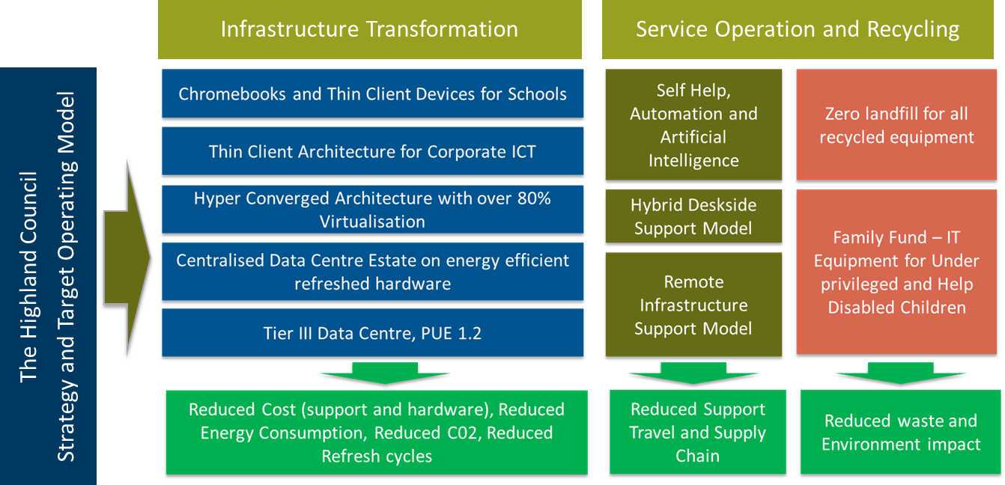
Figure 4 - Wipro's Solution delivers the Authority's Infrastructure Target Operating Model that delivers service excellence, best value for money and supports the Council in meeting its Carbon commitments
Wipro’s solution includes the following technical components that will deliver the reduction in energy usage:

- TIER III Data Centre with PUE 1.2 – Wipro will host Authority’s infrastructure in Uptime Institute certified TIER III data centre in Scotland. The PUE 1.2 rating accorded to the brightsolid data centre for effecient power delivery is closest to ideal state in the industry.
- Centralised Infrastructure – Wipro will centralise the Authority Infrastructure for Corporate and Curriculum environments. This reduces physical footprint of servers in the distributed sites substantially thereby improving the CO2 emissions in the overall estate
The figure below describes proposed Infrastructure Architecture that will reduce the Energy Consumption by over 50% from Service Effective Date.
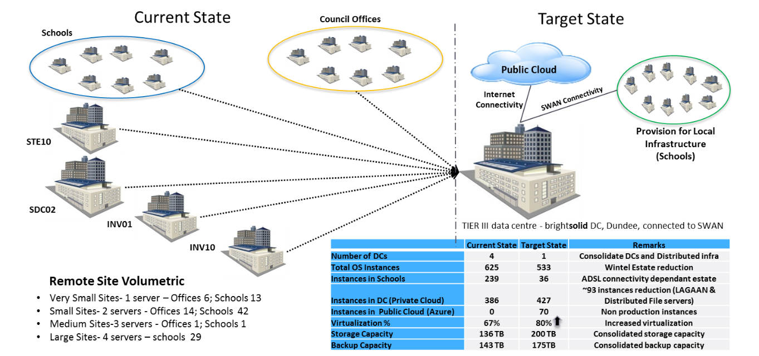
Figure 5 - Wipro's centralised architecture will reduce the energy consumption by over 50% by the end of transformation within 2 years from contract award.
- Hyper-Converged Infrastructure Architecture – Wipro has designed green, virtualised infrastructure architecture for Authority’s back-office systems and end user compute (thin client) platform We will use Hyper-Converged Architecture for the Authority’s Infrastructure Services. Hyper-converged systems are modular systems designed to scale out by adding additional modules. These systems are mainly designed around storage and compute on a single x86 server chassis interconnected by 10 GB Ethernet. The differences between a hyper-converged system and servers with a bunch of disks are engineering and software ( Authority’s current Infrastructure solution) is as follows :
  - Hyper-converged solutions leverage improvements at the storage controller software layer to allow these systems to scale out.
  - As more appliances are added, performance and capacity increases. However, instead of scaling up by adding more drives, memory, or CPUs, we can scale out by adding more appliance modules. This reduces the cost or expensive re-architecture and future refresh, as there is no vendor lock-in, thus reducing the cost or future refreshes and dependency on any specific hardware vendor or product.
  - In addition to the simplified architecture, the hyper-converged systems are managed via "a single pane of glass." Instead of having a set of applications and a team to manage the Authority’s storage array, a team to manage virtualisation, and a team to manage the server hardware, one team (or in some environments one person) can manage the complete hyper-converged stack. This approach reduces the cost for the Authority.
- Wipro will increase the current virtualisation ratio of 63% to over 80%. We are confident this ratio can be increased even further as we build our understanding of Authority’s applications. Our global delivery experience, which includes mix of Retail, Finance, Travel, Education systems is over 92% virtualisation. Virtualisation reduces the need to buy physical hardware.
- Thin Client Desktop (Corporate and Curriculum) – Wipro will deliver full desktop transformation for Corporate and Curriculum ICT by Novermber 2019, as per the Authority’s timetable. During this period we will also replace 12,000 thick desktop units by low enery Chromebooks, as per the Authority’s Chromebook Rollout project. Similar to Chromebooks, Thin client devices consume very low power, circa 5W power per hour as compared to 75W per hour power consumption by typical desktop and laptops. The figure below describes the power consumption savings as result of Wipro’s solution:
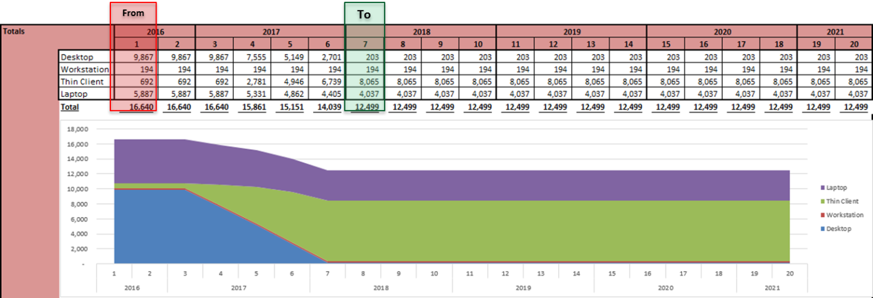
Figure 6 - Energy reduction over the term as a result of Wipro's rollout of new desktop solution
- Reduced Centrally Managed Desktop Devices to support the Authority’s Locally Managed Devices – Wipro will rollout Chromebooks
Wipro’s solution includes the following Service components that will deliver the reduction in energy usage:
- Remote Infrastructure Services (Desktop and Data Centre)
- Hybrid Deskside (Field Engineering) Support Services
- Self-Help, Automation and Artificial Intelligence

Wipro’s Target for reducing the Authority ICT related Energy Consumption
Wipro’s solution will reduce the Authority’s ICT related energy consumption in the data centre by over 50% within the 2 years of contract award.
The figure below describes reduction in energy consumption as a result of Wipro’s proposed Infrastructure Solution in the data centre. Note: The calculation does not take into account the reduction in carbon emission as a result of our Remote Infrastructure Service and Dispatch Model for the thin client. The below graph demonstrates the power consumption comparison in the current estate and the end state
The top (red) line denotes existing power utilisation and the consumption forecast of the same over next 5 years with the distributed architecture and thick client estate.
The bottom (blue) line denotes power consumption for the services Wipro will deliver with energy efficient, standardised, consolidated data centre infrastructure. The step wise reduction in power consumption is achieved with phased roll out of centralised VDI, thin client and minimal thick client environment.
.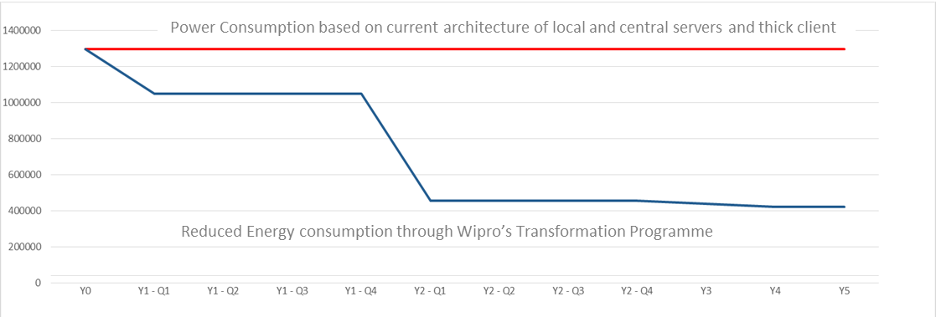
Figure 7- Net power consumption comparison against current state

Transformation Timeline to Reduce the Energy Consumption
Figure below describes Wipro’s high level Transition and Transformation Plan that will enable the reduction of energy usage as described above. We have defined the Key Milestones and Contract Performance Points (CPP), which enables the Authority to recover the savings from the dates defined in our implementation plan.

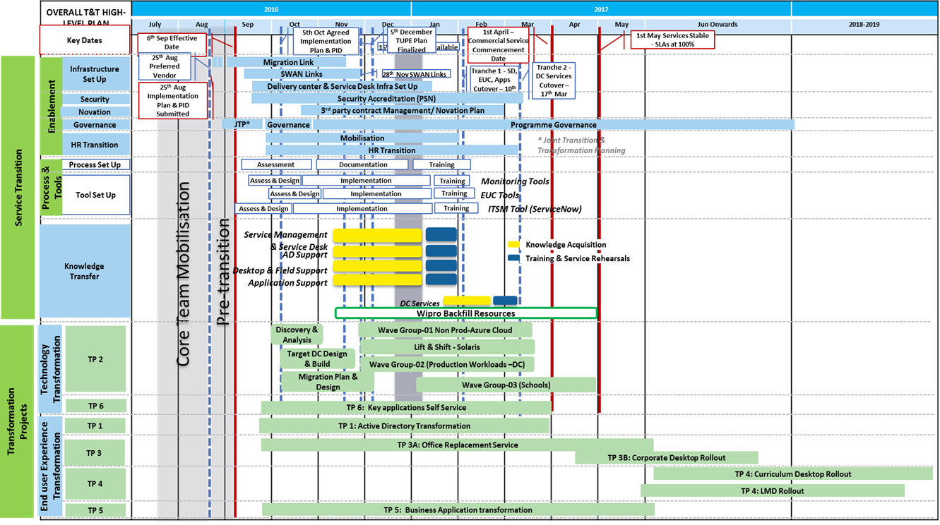
Figure 8 Wipro's Integrated Transition and Transformation Plan

Auditable Recycling and Compliance to Data Protection
Wipro’s solution includes the following solution for recycling of refreshed infrastructure (desktops and servers) components:
Any e-waste disposal in Wipro is carried out to in compliance with WEEE obligations. We will recycle the Authority’s decommissioned infrastructure at the recycling facilities provided by our SME partner - Stone Computers. The following list describes our approach to recycling:
- Blancco tools to purge Authority data from digital media. Blancco is approved by CESG and UK Government as a data purge tool for all HMG infrastructure
- WEEE compliant processes, ISO:IEC:140001 facilities and certified partners (Stone Computers), vetted by our Supply Chain management Group
- Recycling service for redundant IT equipment & associated peripherals; which has a primary aim of placing all viable equipment back into reuse. Equipment which cannot be re used is processed for the recovery of constituent materials; through processing downstream at recycling partners. The process operated ensures that all redundant equipment returned to Wipro is therefore not despatched to landfill. This ensures the Authority is reducing waste. Following receipt all equipment is inspected and tested to ascertain its potential for reuse, equipment deemed suitable will also then be graded and cleaned; then be assigned to re saleable stock. For example, during 2015, of the 1,823 tonnes was received, 75% was returned into reuse in secondary markets. Remaining was donated for charities, in the UK as well as South Africa.
- Wipro as defined target of zero landfill for all refreshed infrastructure to minimise waste and reduce CO2 impact as per the Authority’s requirements.
- At least 10% of the infrastructure, that is considered re-usable and is able to perform on the supported operating systems such as Microsoft Windows 7 or 8 will be made available to the charities and volunteer groups.
A plan which describes how your approach to the delivery of the Services will minimise supply chains which will result in measurable CO² and other emissions reduction in accordance with 5.6.5;
Wipro has minimised the sub-contractors to optimise the cost of delivery while ensuring our proposal meets the Authority’s agenda of SME and promote local businesses as per our commitment to deliver maximum benefits to the Economic Benefits requirements. The figure below describes our Supply Chain and Partners we will work with to deliver the services to the Authority as per Economic Benefits requirements.
- Data Centre – brightsolid, a Scottish business with its headquarters in Aberdeen and established TIER III data centres in Dundee and Aberdeen will host the Authority infrastructure. The choice of data centre is based on the TIER III accreditation and PUE 1.2, which will deliver an energy efficient data centre. The contract will exist for the Term of Wipro’s contract, with flexibility to the Authority to novate the Hosting Services if required.
- Device Recycle and Decommissioning – Stone Computers, 140001 certified, WEEE compliant, SME business to decommission and recycle the refreshed IT equipment. This requirement only exists duration of the transformation project.
- End User Compute Services – Phoenix, Scotland will deliver the field engineering services to Corporate and Curriculum users. Note: We are currently in discussion with two other suppliers for provision of field engineering services. The final decision of supplier will be made based on our evaluation criteria that best meets the Authority’s requirement. This services provided through this contract will contribute to the ongoing carbon emissions as a result of deskside support engineers need to travel to the end user to fix repair the broken devices.
The figure below describes our supply chain partners to deliver the services to the Authority.
Figure 9 - Wipro will include SME's in delivery of services as per the UK Government SME agenda

Transformation to Reduce the Energy Consumption
Wipro’s high level Transition and Transformation Plan included in our response to requirement 5.5.5 (5.6.5) above will enable the reduction of energy usage as described above. We have defined the Key Milestones and Contract Performance Points (CPP), which enables the Authority to recover the savings from the dates defined in our implementation plan.

A plan which describes how your approach to the delivery of the Services will minimise the requirements for staff travel in accordance with 5.6.6;
Wipro will deliver the Authority’s Target Operating Model through the combination of thin client devices for process workers, few desktops and workstations for power users and laptops for the mobile users. Our choice of energy efficient thin client devices, will:
- Reduce the energy consumption (less than 5W per hour energy consumption against over 75W per hour of a typical thick client device)
- Reduce cost of future refresh by avoiding at least one refresh cycle. Thin client devices have low mean time failure rate and life expectancy of between 7 to 10 years, which is more than twice in comparison to a typical thick client device that has life expectancy of between 3 to 5 years. By avoiding a refresh cycle, the Authority’s Carbon emission related to disposal of devices, manufacturing of devices, setup and rollout activities will be removed, thus delivering the outcomes of Carbon Clever Programme.
- Thin client devices will be swapped through technical courier, which reduces the cost of support as well as need for a dedicated engineer to travel. Considering the 18,000 sq. mile of the Highland Council area, this will reduce the in carbon emission by over 100,000 tonnes over the Term of the contract.
Wipro has designed a mixture of local and remote support through courier / dispatch model to minimise the carbon emissions for deskside support and field engineering support services. The figure below describes our solution to deliver the deskside support to the Authority that reduces the carbon emission through channel shift and leveraging the shared services from our supply chain, such as technical courier delivery model.
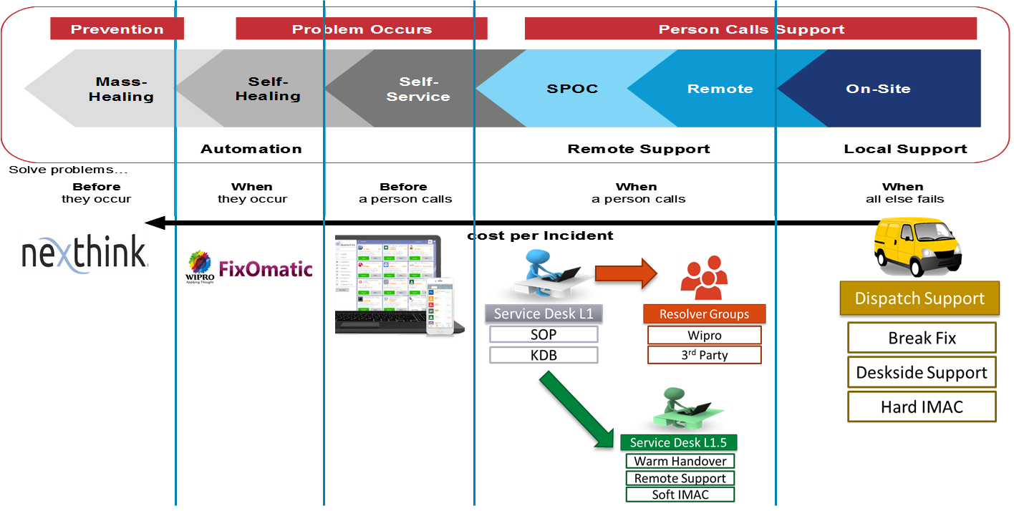
Figure 10 - Channel Shift and First Time Fix Strategy will be adopted by Wipro to reduce the energy consumption as well as travel related CO2 of our service staff.

Use of Current IT Technicians
Wipro recognises the Authority will have IT technical capability in the curriculum environment as a result of Locally Managed Device Support model. We will explore the opportunities to integrate the Locally Managed Device Support team as part of our resolver group in the subsequent stages of our dialogue. This has the potential to reduce the cost and carbon emissions to Authority. It is however essential to understand the workload on the Locally Managed Device support teams to assess their ability to be part of the Centrally Managed Device resolver groups.
A plan which describes the auditable recycling initiatives proposed in the provision of the Services and the extent to which they will result in a reduction in the Authority’s carbon footprint in accordance with 5.6.7;
Wipro has set a target to achieve zero landfill for all refreshed infrastructure. All Authority data will be purged from the decommissioned equipment using CESG approved Blancco tool before it is processed for recycling. We will recycle the refreshed infrastructure through our WEEE compliant, ISO IEC 140001 certified recycling partner, Stone Computers. Stone Computer is AATF accredited and are obliged to report all in the UK Government national system that reports to the European Agencies.
Our approach to recycling will is described in our response to 5.6.2 (5.6.2) above. It ensures that all redundant IT equipment & associated peripherals; has a primary aim of placing all viable equipment back into reuse.
Following receipt all equipment is inspected and tested to ascertain its potential for reuse, equipment deemed suitable will also then be graded and cleaned; then be assigned to re saleable stock. For example, during 2015, of the 1,823 tonnes was received, 75% was returned into reuse in secondary markets. Remaining was donated for charities, in the UK as well as South Africa. This has resulted in avoiding the landfill and reduction in the e-waste and associated carbon emissions.
Equipment which cannot be re used is processed for the recovery of constituent materials; through processing downstream at recycling partners, who will use it for spares. This ensures the Authority is reducing waste.

Donating Equipment for Charitable causes
The Authority staff will have the opportunity to choose the refreshed desktops / laptops for home use (including for family and friends) through a user friendly portal, accessible through our Service Desk self-help portal.
We will utilise at-least 10% of the refreshed equipment to support our Community Benefits programme, through donating the suitable desktop and server infrastructure to citizens across the Highland Council area. We will promote the donation scheme through local media such as newspapers and volunteering groups across the Highlands. The equipment will be made available to the registered interested citizens through community groups. We will organise specific drop in events for the citizens to collect the equipment across the Highlands Council area. Assistance will be available to the Citizens at such events to understand more about the usage of the equipment and IT. We will also use these opportunities to promote the Apprenticeships and Internships available at the Council ICT Service through our contract.
Wipro will use the social schemes through our Charity– WiproCares and GetOnline@Home (http://www.getonlineathome.org/) to donate the equipment that is fit for purpose before it is recycled.
Wipro will provide a certificate verifying their contribution in supporting such donations to the charities.

Reporting and Certification
All recycled equipment will contribute towards the UK efforts in meeting the European Union level waste management targets. Unlike many recyclers, Stone Computer hold AATF status with the Environments Agency and therefore is obliged to report the receipts of all WEEE into the UK national system. Disposals of WEEE with unregulated providers results in these quantities not being reported or monitored.
Wipro will provide certificates of destruction for data and compliance with WEEE Directive. Asset reports detailing refreshed items and copies of all relevant & completed waste documentation will be provided to the Authority through the Decommissioning project. Where deemed necessary, we will support the Authority’s requirement for physical audit visits to the recycling site.
Wipro’s approach to recycling provides full audit of our recycling initiatives and is aimed to achieve overall reduction in the Authority’s carbon footprint.

A plan which describes your approach to the achievement of sustainable procurement in your supply chain in accordance with 5.6.8.
Wipro has multi-faceted approach to ensure sustainability – our own as well as our suppliers. As a responsible business, we minimise our own energy consumption and carbon emissions. Our corporate procurement policies endorse sustainable procurement for our own supply chains and for our customers. The implementation of this policy is carefully monitored to ensure our compliance to Wipro Board and its Trustees, WiproCares, a charitable organisation that has over 39% of stake in Wipro.
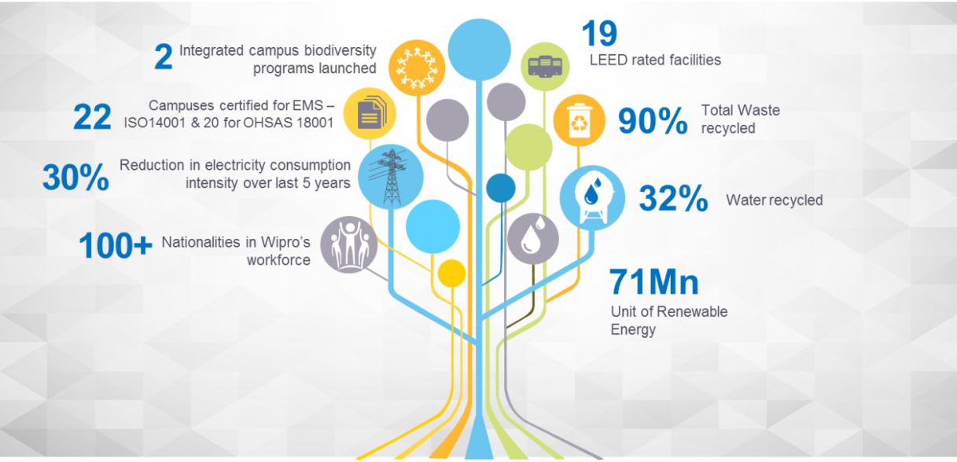
Figure 11 - Wipro's multi-dimensional focus on sustainability and Board level visibility demonstrates our commitment to the nature
Wipro’s Sourcing Management Framework (described in our response to CB2 – Economic Benefits), has clearly defined lifecycles, in-depth best-practice processes and work-aids, flexible process selection capability and alignment with industry standard models such as eSCM CL/SL, IVI-IT CMF, SEI CMMI and ISACA - COBIT 5. Our Sourcing Management Framework ensures fair and ethical purchasing, ethics and sustainability as well promotes local supply chains where possible. We take a life cycle view while seeking opportunities to reduce the environmental impact our services. It includes the burden incurred throughout the supply chain. Therefore, it is essential to use suppliers who both share our environmental aims and, as much as possible, are able to provide us with reliable and accurate data on the environmental characteristics of the products and services they supply, e.g. energy consumption of infrastructure as well as the emissions incurred in the service delivery and operations.
We regularly monitor our suppliers against sustainability related criteria which enables us to gather appropriate information from our suppliers to ensure we make fully informed sourcing decisions as part of suppliers Corporate Responsibility. The results of this assessment along with business continuity planning, delivery performance, operational performance measures and customer satisfaction scorecards are used qualify, measure and compare our supply chain. The table below describes the typical sustainability related information we seek from suppliers:

Area | Information Requested
Corporate Environmental Policy | Organisations Environment Policy.  - Current Goals  - Achievement against goals  - Remediation Plans  - Audit reports
Environmental Supply Chain Management | Details of Supply Chain Management Frameworks  - Code of Conduct  - Evidence of inclusion of environmental considerations in procurement or purchasing decisions  - Annual Report of Supplier performance demonstrating Suppliers sustainability achievements and performance against plans
Environmental Management | Certification against ISO 140001 or equivalent standards  - Current Certification  - Plans to achieve certification ( or re-certification)
Compliance | Compliance reports against environmental legislation  - Certificates of compliance  - Details of prosecutions in last 5 years  - Report of Outstanding prosecutions or enforcements  - Compliance reports for last 3 years
Reporting | Latest Environmental reports or statements produced
Emissions Reduction | Goals for C02 / Energy reductions  - Current Goals  - Measures implemented  - Remediation Plans  - Future Plans  - Compare against industry benchmarking

Wipro will use this information from our supply chain when measuring, and seeking opportunities to reduce, the environmental impact of the services provided to the Authority.
The enclosed attachment (Wipro Supplier Code of Conduct v1.0) is our Supplier Code of Conduct to ensure fairness, prohibition of child labour, equal employment opportunity, freedom of association, working hours, fair pay and ensure environment health and safety are provided for as part of the standard service delivery requirement. Where the Suppliers do not meet the code of conduct, they will be excluded from joining our Supply Chain community through the SupplierConnect portal.

Delivering our Commitments and Formal Governance Process
Wipro offers a variety of business commercial models and engages with customers on a long term model based on actual energy savings realization, where the energy savings projected are committed to the customer. The financials are crafted depending on the quantum of savings potential identified while also ensuring that the investment made is recovered from savings achieved within the engagement period.

Further, in almost every engagement so far, Wipro’s customers are experiencing a positive cash flow right from the start. The typical energy savings that we deliver range from 5% to 18%, depending on the infrastructure and nature of operations. On an average per site Wipro is delivering £40,000 annual savings

Section | Area of Commitment | Wipro’s Proposed Commitment
5.6.1 | Minimise waste | Wipro will ensure zero landfill of all recycled infrastructure as part of our transformation project
5.6.2 | Auditable landfill minimisation | All infrastructure refreshed as a result of our Transformation projects, which includes end user desktop devices and Authority hosted data centre devices will be recycled for spares and available for charitable donations.
5.6.3 | Measurable CO2 | Wipro will adapt Greenhouse Wipro will reduce the energy consumption by over 50% through the transformation projects as part of our Service delivery. This project will be implemented as part of the Core Contract.
5.6.4 | Target for reducing ICT related CO² | Wipro’s solution will reduce the Authority’s ICT related energy consumption in the data centre by over 50% within the 2 years of contract award.  Thin client devices will be swapped through technical courier, which reduces the cost of support as well as need for a dedicated engineer to travel. Considering the 18,000 sq. mile of the Highland Council area, this will reduce the in carbon emission by over 100,000 tonnes over the Term of the contract
5.6.5 | Minimise supply chains which will result in measurable CO2 and | Wipro will review the provision of recycled desktop devices as thin client devices where appropriate, in agreement with the Authority. This will remove the need to buy new hardware, thus substantially reducing the manufacturing, supply chain and packaging recycling as well as decommissioning and recycling CO2.  Reduce cost of future refresh by avoiding at least one refresh cycle. Thin client devices have low mean time failure rate and life expectancy of between 7 to 10 years, which is more than twice in comparison to a typical thick client device that has life expectancy of between 3 to 5 years. By avoiding a refresh cycle, the Authority’s Carbon emission related to disposal of devices, manufacturing of devices, setup and rollout activities will be removed, thus delivering the outcomes of Carbon Clever Programme  Wipro will implement ServiceNXT framework for delivering single pane of glass, which provides remote infrastructure management capabilities. It reduces the need for travel as the infrastructure can be supported remotely.
5.6.6 | Reduced Staff travel  Remote provisioning of support services  Use of local staff where appropriate | Wipro will implement ServiceNXT framework for delivering single pane of glass, which provides remote infrastructure management capabilities. It reduces the need for travel as the infrastructure can be supported remotely.  Wipro will replace over 95% desktop devices with thin clients as per the Authority’s requirements. The thin client devices have over 7-year lifespan and consume less than 5W of power as compared to just over 36 – 48 months’ life for a typical desktop device that consumes over 75W.  The thin client devices will be swapped using a courier model, where the device is replaced by our technical courier, rather than a dedicated field engineering support, who are more expensive and only support highly technical break-fix issues, thus limiting the number of customers they can support. Wipro will implement this service model as part of the desktop rollout programme.  Thin client devices and school server infrastructure will be managed and monitored remotely, due to the centralised nature of the architecture. This will reduce the travel related CO² of our support organisation  Wipro recognises the Authority will have IT technical capability in the curriculum environment as a result of Locally Managed Device Support model. We will explore the opportunities to integrate the Locally Managed Device Support team as part of our resolver group in the subsequent stages of our dialogue. This has the potential to reduce the cost and carbon emissions to Authority. It is however essential to understand the workload on the Locally Managed Device support teams to assess their ability to be part of the Centrally Managed Device resolver groups
5.6.7 | Auditable recycling | All recycled equipment will contribute towards the UK efforts in meeting the European Union level waste management targets. Unlike many recyclers, Stone Computer hold AATF status with the Environments Agency and therefore is obliged to report the receipts of all WEEE into the UK national system. Disposals of WEEE with unregulated providers results in these quantities not being reported or monitored.  We will produce a quarterly report during the transformation project and annually thereafter (as the volume of device refresh will be substantially reduced thereafter)
5.6.8 | Sustainable procurement | Wipro is committed to SME involvement and supporting the Authority in carbon reduction. We have featured in Dow Jones Sustainability Index (DJSI), World for the sixth time in a row. We work with our Supply chain to help and support them as well as report the Sustainability figures of our organisation as well as our suppliers.  We will partner with Scottish SME – brightsolid to provide a secure and green TIER III certified data centre with PUE 1.2.  Power usage effectiveness (PUE) - is the ratio of total amount of energy used by a computer data centre facility to the energy delivered to computing equipment. PUE 1.2 is one of the lowest CO²and greenest data centre credential.

Wipro’s Community Benefits Officer will be responsible for implementation of our Community Benefits Plan. We aim to fulfil this role through secondment of a suitable Council staff for 1st year of the contract. At the end of 9 months, the role will transition to a suitable individual, preferably chosen from the candidates within the Corporate Parenting Programme. This approach will help us develop a strong link between the Highland communities, Wipro and Wipro Care, our CSR organisation.
In order to effectively manage the reporting and monitoring of progress regarding the delivery of our Economic Benefits commitments we will report the achievements and progress on quarterly basis through the formal Community Benefits Board as part of the Authority’s Schedule 8.1 – Governance. The figure below describes the alignment of our service delivery with the Authority’s Governance Boards as described in Schedule 8.1.
Wipro’s Community Benefits Officer will be responsible for implementation of our Community Benefits Plan. We aim to fulfil this role through secondment of a suitable Council staff for 1st year of the contract. At the end of 9 months, the role will transition to a suitable individual, preferably chosen from the candidates within the Corporate Parenting Programme. This approach will help us develop a strong link between the Highland communities, Wipro and Wipro Care, our CSR organisation.
In order to effectively manage the reporting and monitoring of progress regarding the delivery of our Economic Benefits commitments we will report the achievements and progress on quarterly basis through the formal Community Benefits Board as part of the Authority’s Schedule 8.1 – Governance. The figure below describes the alignment of our service delivery with the Authority’s Governance Boards as described in Schedule 8.1.
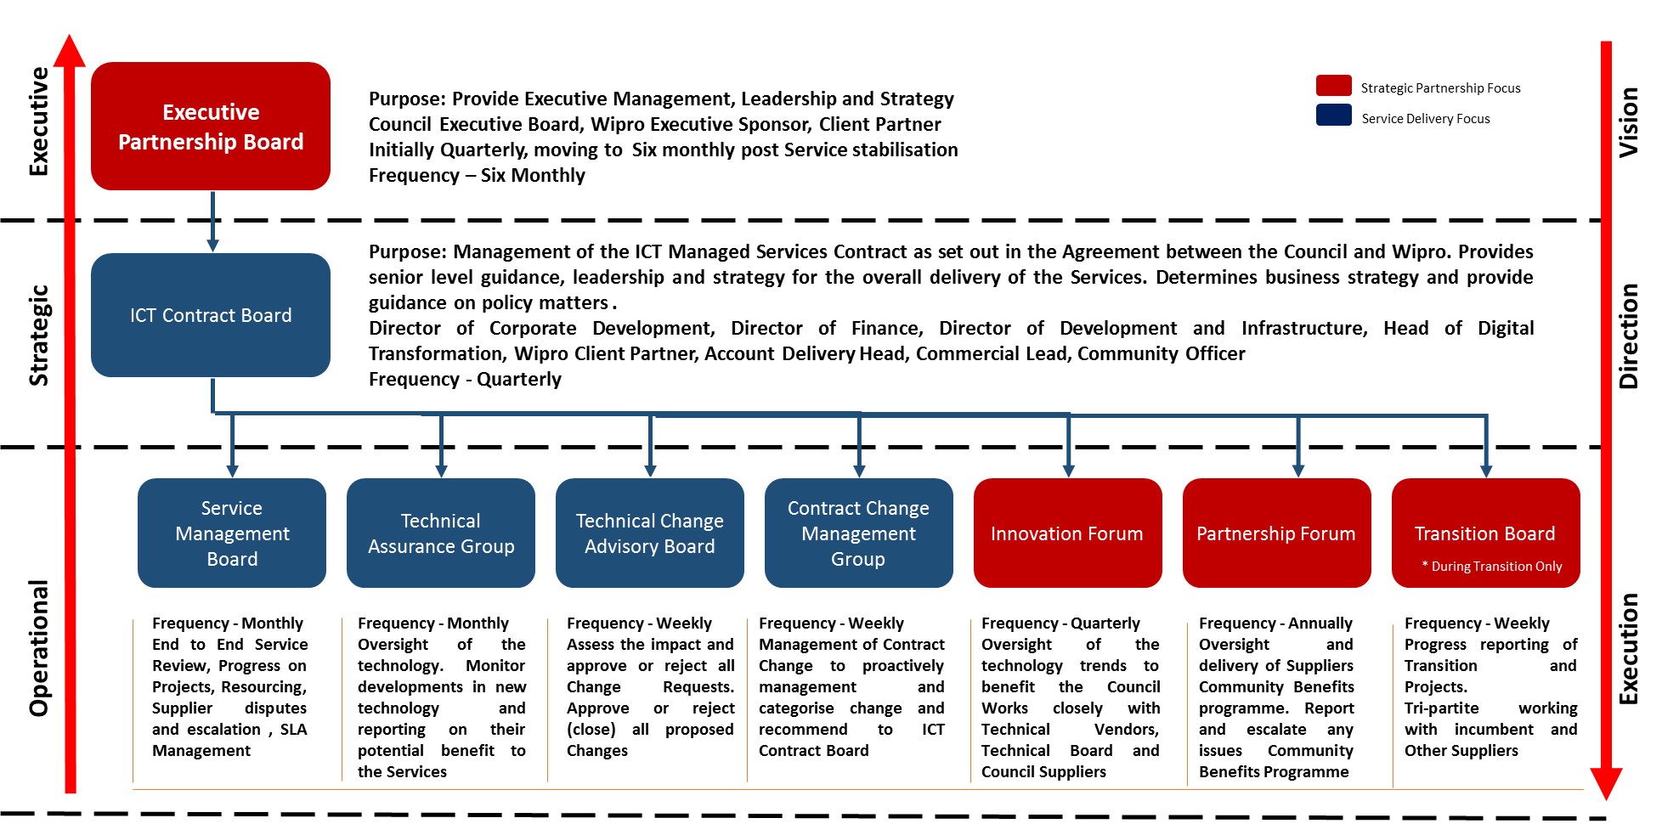
Figure 12 - Wipro will report the Community Plan to ICT Contract Board and Service Management Board through the Authority's Community Benefits Board
We will produce an annual report to report the progress against our commitments on the Community Benefits. The figure below describes our organisation structure and responsibilities and attendance to various Governance Boards.
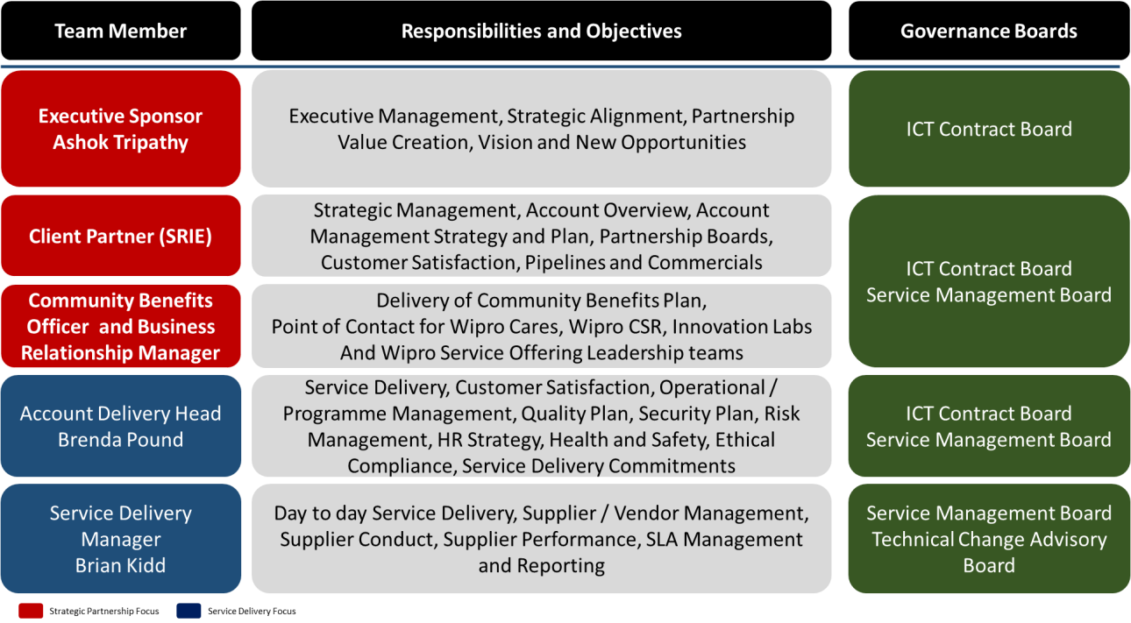

Figure 13 - Wipro's organisation structure maps with the Authority's Governance Model

