CB1b: Workforce Matters
Wipro’s Community Benefits Plan sets out our committed plans and proposals for successfully delivering ethical workforce practices in our organisation as well as through our supply chains. The key objective of the plan is to promote ICT as a career option and provide work experience through training and apprenticeships to school leavers, apprentice and graduates. It aspires to support the young people in Highlands to get ready for jobs. We and our sub-contractors will offer the jobs where possible to build our workforces from locally sourced resource pool, trained with us. The figure below describes the overview of our proposal to deliver the requirements specified at 5.2 of Schedule 11 (Workforce Matters) of the Contract.
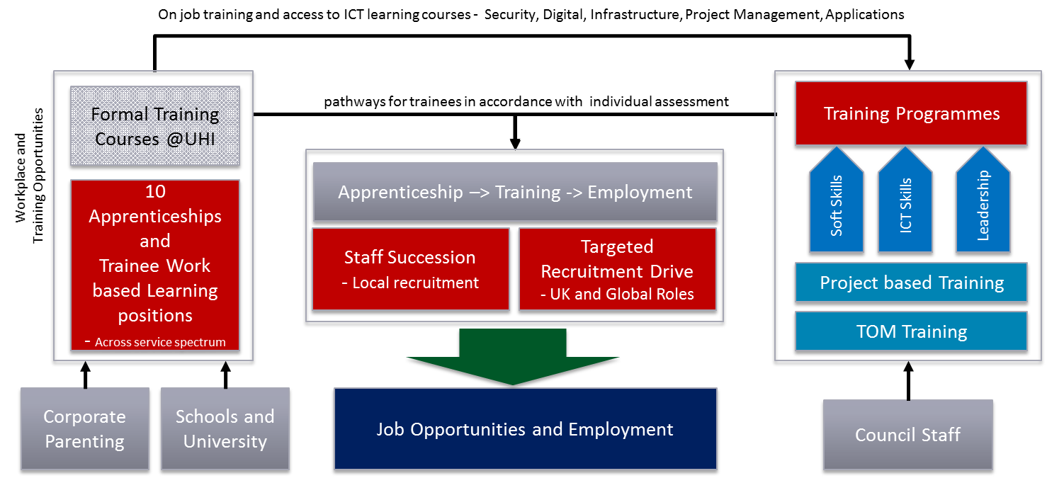
Figure 1 - Wipro's Community Plan has set SMART objectives that echo our philosophy of community care and investment in education based on culture that originates from Wipro Cares
Wipro’s people practices are shaped by the Spirit of Wipro values, our Tenets, Code of Business Conduct and Ethics (COBC), as well as principles of the U.N. Global Compact, U.N. Universal Declaration of Human Rights and International Labour Organization’s declaration on Fundamental Principles & Rights at Work (1998). While these provide the guidelines and direction for responsible business conduct at a global level, our policies are shaped and customized by local regulations and law of land. Wipro COBC imbibes our commitment for human rights and zero tolerance for discrimination at all stages of the employee lifecycle - Protect-Respect-Remedy of UN principles.
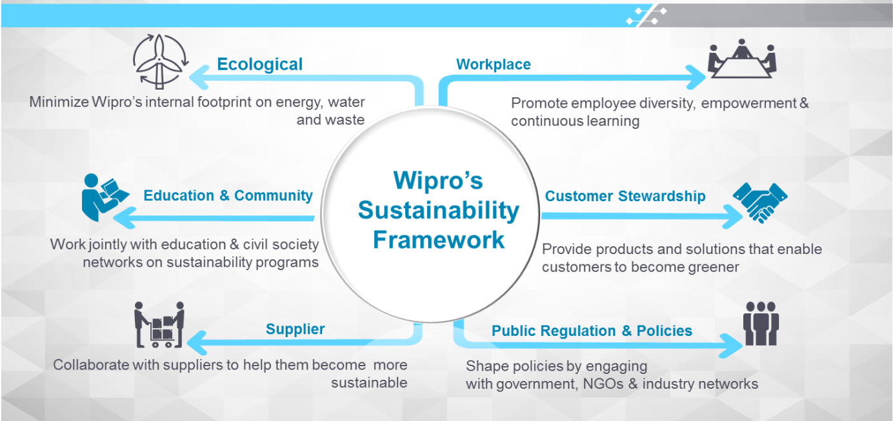
Figure 2 - At the heart of our culture is our multifaceted framework of engaging with local communities and ensuring ecological impact is minimised. We are rated “A” for the sixth successive instance by DNV AS and SGS, reassuring of maximum level of disclosure
A plan which sets out the number of trainees envisaged, their job title, and a description of the envisaged career path, including qualifications attained into permanent employment in accordance with point 5.2.1;

We will offer 5 trainee positions per annum under the Apprenticeship and Internship scheme employed by Wipro and its sub-contractors to deliver the services to the Highland Council. The trainee positions will be available in the following areas of Service delivery, currently based on the scope of services we will deliver under the ICT Re-Provision contract to the Authority.

Career Paths
We will use our Talent Management Framework to support the trainees and apprentices through the term of their training and employment with Wipro. The framework is designed to support our trainees and staff to develop soft skills, technical skills and certifications as well as specific programmes targeted to develop the leadership qualities. The figure below describes the Career Pathway portal that can be used by the school leavers, apprentices, graduates and existing employees to understand the career pathways, training and development needs and benchmarked salaries for each role.
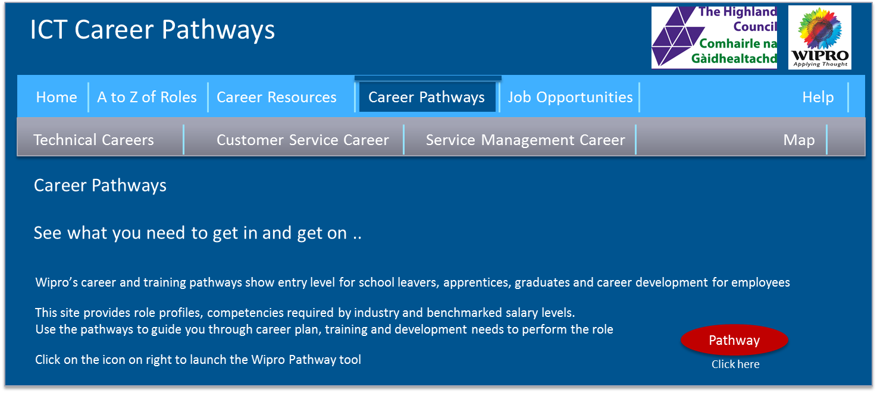
Figure 1 - Wipro's Career Pathway Portal will provide a single window access to Career Resources, Career Pathways and Job Opportunities to individuals and businessess.
The table below lists the service areas, job title, envisaged career path along with the qualifications that will be achieved while progressing on the career path for the trainees and apprentices.
Service Area | Job Title | Envisaged Career Path | Qualifications attained
Customer Service – Service Desk | Trainee Customer Service Analyst | Trainee Customer Service Analyst -> Service Analyst –> Service Desk Team Lead –> Cross Functional Specialist -> Major Incident Manager -> Service Delivery Manager -> Account Manager -> Customer Relationship Manager | Lean, Six Sigma, Customer Relationship Management, Escalation Management, Customer Communications, Problem Solving, Customer Support
Customer Service – Desktop Support Engineer | Trainee Desktop Support Technician | Desktop Technician –> Desktop Designer -> Desktop Architect | Desktop Support, Desktop Management, Desktop Technician, Microsoft Windows
Project Management – Project Management Office | Trainee Project Co-ordinator | Project Co-ordinator -> Project Manager -> Programme Manager -> Service Delivery Manager -> Account Manager -> Customer Relationship Manager | Project Management, Customer Communications, Lean, Six Sigma, Customer Relationship Management, Project Reporting, Change Management, Release Management, Co-ordination
Technical Solution – Application Developer | Trainee – Developer | Trainee Software Engineer -> Application Developer -> Designer -> Architect -> Application Development Manager -> Service Delivery Manager -> Programme Manager -> Account Manager | Microsoft / .NET Development SDK, Oracle / Java SDK, Agile, Source Code Control, Lean, Six Sigma, Team Work, Development Process and Methodologies
Technical Solution – Infrastructure Developer | Trainee – Developer | Trainee Engineer -> Infrastructure Developer -> Infrastructure Architect -> Service delivery Manager -> Programme Manager -> Customer Relationship Manager | Microsoft / .NET Development SDK, Oracle / Java SDK, Agile, Source Code Control, Lean, Six Sigma, Team Work, Development Process and Methodologies
Service Management – Service Reporting | Trainee – Service Associate | Service Associate -> ITIL Expert -> ITIL Consultant -> Service Delivery Manager -> Account Manager -> Customer Relationship Manager | ITIL, Service Management, Customer Relationship Management, Project Reporting, Change Management, Release Management, Co-ordination
Service Management – Vendor Management | Trainee – Supplier Manager | Supplier Manager -> Vendor Manager -> Category Manager -> Commercial Manager -> Account Manager | ITIL, Service Management, Supplier Relationship Management, customer Relationship Management, Supplier Connect, ISO Standards, Project Reporting, Change Management, Release Management, Co-ordination
Service Management – Escalation Management | Trainee – Customer Relationship Associate | Customer Relationship Manager -> Service Delivery Manager -> Account Manager -> Customer Relationship Manager -> Programme Manager | ITIL, Service Management, Customer Relationship Management, Project Reporting, Incident Management, Problem Management, Change Management, Release Management, Co-ordination
Service Management – Incident Management | Trainee – Service Incident Associate | Service Associate -> ITIL Expert -> ITIL Consultant -> Service Delivery Manager -> Account Manager -> Customer Relationship Manager | ITIL, Service Management, Customer Relationship Management, Project Reporting, Change Management, Release Management, Incident Management, Triage, Problem Management, Co-ordination

The figure below describes the career path for Trainee Customer Service Analyst. Similar pathways will be published for all roles on Wipro Highland Council Account Portal accessible to the trainees and apprentices.
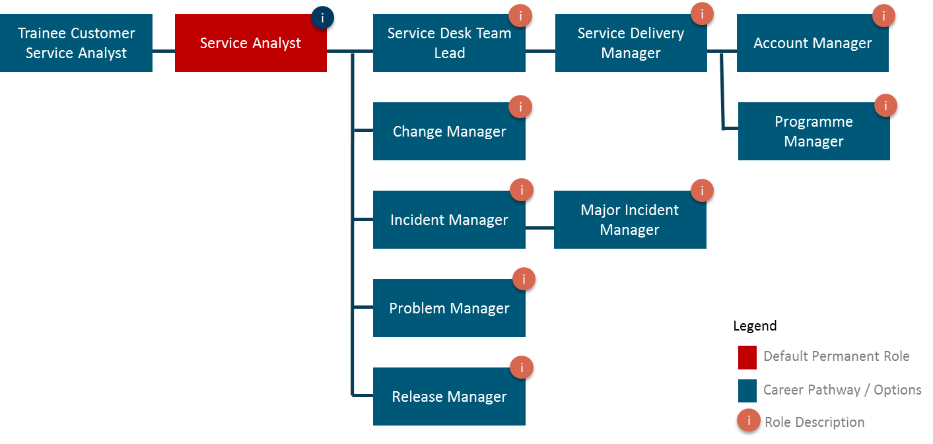
Figure 2 - Career Pathways along with Role descriptions, entry criteria, training requirements and available training will be available on Wipro's Highland Council Account Portal.
All trainee and apprenticeship roles will be advertised locally in the Council anniversary of the Service Effective Date. We will a define fair candidate evaluation criteria, which we will agree with the Authority. The apprentices will be exposed to different areas of the service delivery during the first month. They will have an assigned mentor who will work with them through this period to support and guide them. They will undergo regular assessment with the mentor so that we can support the development plan. At the end of 3 months’ cycle, the apprentices will have an opportunity to select the service area they would want to spend the remaining 3 months of the apprenticeship period. They will get the support from mentors and industry experts throughout the apprenticeship period.
We will reserve 20% of the apprenticeship roles for the candidates from Corporate Parenting background, which will be available to other candidates where suitable candidates are not available.
The figure below describes our Talent Management Framework, which uses regular assessment based approach and mentoring support to ensure the trainees and staff are supported to develop their chosen Career Path. It will be used at our service.

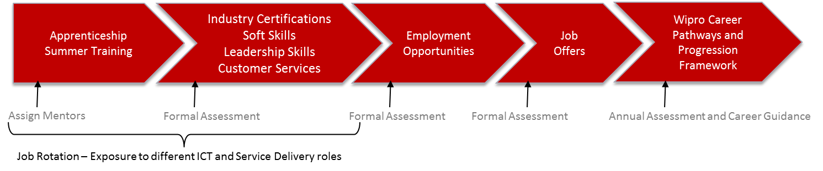
Figure 3 - Our Talent Management Framework uses regular assessment based approach and mentoring support to ensure the trainees and staff are supported to develop their chosen Career Path
Wipro’s Career framework provides the ability to translate business strategy to talent needs. It encourages our organisational agility by focusing on depth and breadth of knowledge and skills. We are able to establish consistency and equity in our processes and thus can be more transparent. This also helps us lay the foundation of different aspects of talent management like- hiring, performance management, development etc. The figure below describes Career Banding framework within Wipro.
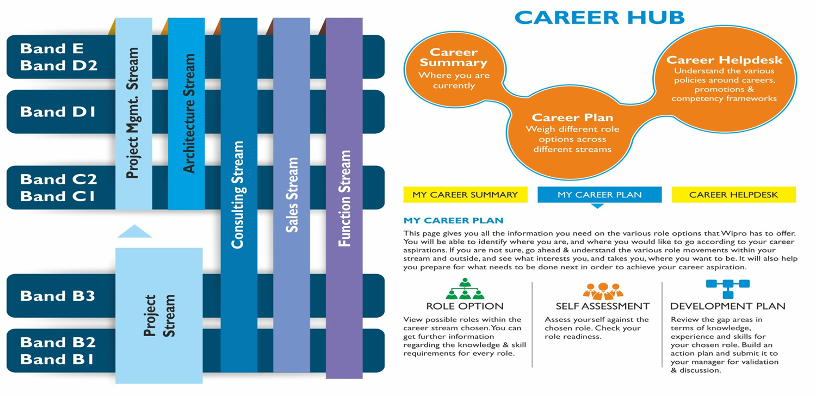
Figure 4 - Wipro Career hub is available to all employees
Banding is the process by which a range of jobs are clustered on the basis of job size into a few representative job groups. The difference between job bands is significant in terms of responsibility and accountability, therefore the competency requirements from the role holders are significantly differentiated across career bands. Our rational behind doing a Career banding is to address the professional & personal growth needs of the individual. Employees see a more transparent growth path. This framework ensures that growth of individuals is meaningful and role & performance based rather than time bound and hierarchical. The emphasis is on continuous learning and development of competencies with a wider variety of assignments that are made available.
In addition, our career banding also identifies a separate career path for those who wish to specialise on the technology side as a Specialist. Such individuals based on business requirements and their technical expertise can grow and contribute as a technical expert.
All representative roles in Wipro have been classified under 6 Career Streams.
- Project stream: The Project Stream is the grooming ground for building careers that are further specialised (post Band B3) with Project Management Expertise; Technology & Architecture; Consulting or Sales. Employees tagged to the Project Stream typically work in delivery projects (application development, maintenance, testing, infrastructure etc.)
- Project Management stream: Employees tagged to the Project Management Stream typically implement & monitor successful delivery of projects. Indicative Roles within Project Management Stream are - Project Manager, Delivery Manager, Account Delivery Head, VDH, SDH, Program Manager, Program Director, etc. These roles develop strong people, process, and customer management and delivery capabilities.
- Architecture Stream: Employees belonging to the Architecture Stream typically are technology experts, involved in design of technical solutions and system solutions which meets the needs of the customer.
- Consulting Stream: The employees in this stream are largely client facing roles and are responsible for delivery of solutions to business and technical issues for clients by using domain, technology or functional know-how and expertise.
- Sales Stream: These roles are client facing roles who are seeking opportunities for Wipro in the market. These roles include hunting & farming responsibilities, presales support and expanding in new geographies.
- Function Stream: The employees in this stream are functional experts in areas such as HR, Finance, Quality, Marketing etc. and own the function grown charter which is tightly aligned with overall business strategy.
Each band in a stream has a set of applicable titles/designations. Some of the titles/designations may overlap across bands and streams, but there are also titles/designations that are only in a specific band.
The Career Banding Framework is a global system relating to job size and scope, therefore employee’s Band will not be impacted in case of movement from one project to another.

Linkage of HR systems to Bands
The Banding Framework has linkage to the Performance Management and Career Management Systems. The movement from one Band to another is linked to employee’s roles and responsibilities and competencies. Evaluation on employee’s performance will help determine his/her readiness for different job roles and also provide direction in areas that need development so that he/she can work on them to address employee’s career aspirations. When employees transfer to Wipro part of the due diligence process is understanding the existing incumbent structure and how they align grades/levels to their roles within Wipro. We would undertake an initial mapping into our career framework for the roles in-scope for transfer. After 3 months this is then followed up with another job mapping process to ensure that we have all the transferring employees existing knowledge and experience.
Employees transferring to Wipro would be assigned an initial banding level based on our initial career framework mapping and output from the HR and Technical one to one meetings. These meetings would be held with the employees on an individual basis during the transition period where Wipro would have the opportunity to gain a better understanding of their role, day to day activities, their skills and knowledge.

Plan for staff succession planning linked to career development pathways
A plan which describes how your organisation proposes to deliver staff succession planning linked to career development pathways for trainees in accordance with 5.2.2;
Succession planning in Wipro is a regular process of identifying and developing potential future leaders or senior managers, as well as individuals to fill other business-critical positions, either in the short- or the long-term. In addition to training and development activities, Wipro will deliver our succession planning programmes for the Authority and typically include the provision of practical, tailored work experience relevant for future senior or key roles.
Wipro categories Talent management into 2 streams: -
- Talent consists of those individuals who can make a difference to organisational performance either through their immediate contribution or, in the longer-term, by demonstrating the highest levels of potential both for the authority and Wipro.
- Talent management is the systematic attraction, identification, development, engagement, retention and deployment of those individuals who are of particular value to an organisation, either in view of their ‘high potential’ for the future or because they are fulfilling business/operation-critical roles
The figure below describes our 3 step process for succession planning that will be adapted to develop and maintain the succession planning. The trainees and apprentices will form part of the resource pool that we will consider to identify staff for succession planning.
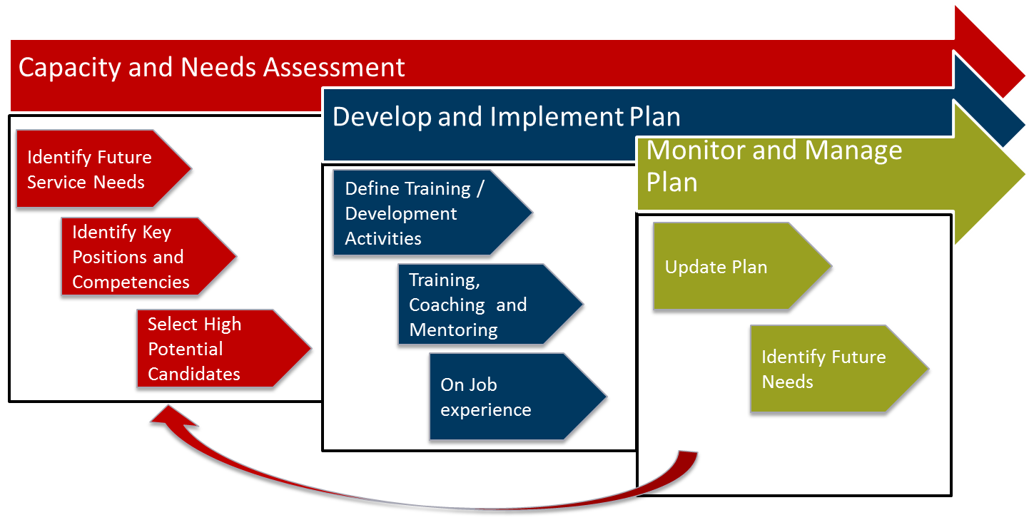
Figure 5 - We will implement 3 step succession planning process for all key positions. Trainees and Apprentices will form part of the high potential candidate resource pool for future resource leading to career development.
All key roles and service delivery positions involved in delivering the ICT services to the Authority will be included in the succession plan. Wipro’s approach to succession planning for all roles will ensure the skill and experience is nurtured in the Highlands and support the Council’s objective of retaining the knowledge within the area. Our Talent Sourcing and Management processes will focus on sourcing skills from local market and offering the opportunities of growth, where possible as part of our service delivery organisation. The plan will include a combination of training and developing existing staff, trainees and apprentices who demonstrate potential and willingness to be part of the team.
Wipro’s Account Delivery Head will be responsible for ensuring a succession plan is in place for all key positions in our service delivery organisation for the Authority. Succession Planning will form part of the terms of reference and staff at key positions will have to maintain succession plan which will be reviewed annually as part of Wipro’s Annual Appraisal Process. We will discuss the succession plan of our Key Personnel with the Authority on annual basis. This will provide the Authority the required visibility on changes in tour delivery organisation. The table below describes our proposed Succession Planning Template that will be used for all key roles.
Name |  |  | Date
Reviewed With
(Supervisor Role)

Department | Job Title | Certification and Accreditation required | Reason for this position | Change Eligibility Date | Location
We will work with the Council to act upon the feedback on the proposed succession planning candidates. Wipro’s appraisal process is outlined below:
Wipro’s online performance management process enables a consistent approach of managing performance throughout the company. The process is in place to ensure employees receive regular feedback in order to grow and express their true potential. Employees who transfer into Wipro (TUPE staff from incumbents as part of outsourcing arrangements) or those who join Wipro via new employee’s process are set goals and objectives within 30 days of joining Wipro. By setting goals and objectives during the induction and on boarding phase of the transition helps provide transferring employees from Fujitsu employees with clarity and a sense of direction to focus on the deliverables for the forthcoming performance management and appraisal period.
Our annual performance appraisal is April – March, with an interim review appraisal in October. This date will be communicated with the Authority employees as part of the HR communication and transition plan. The process and planning approach taken to evaluate the performance of each employee is highlighted below:
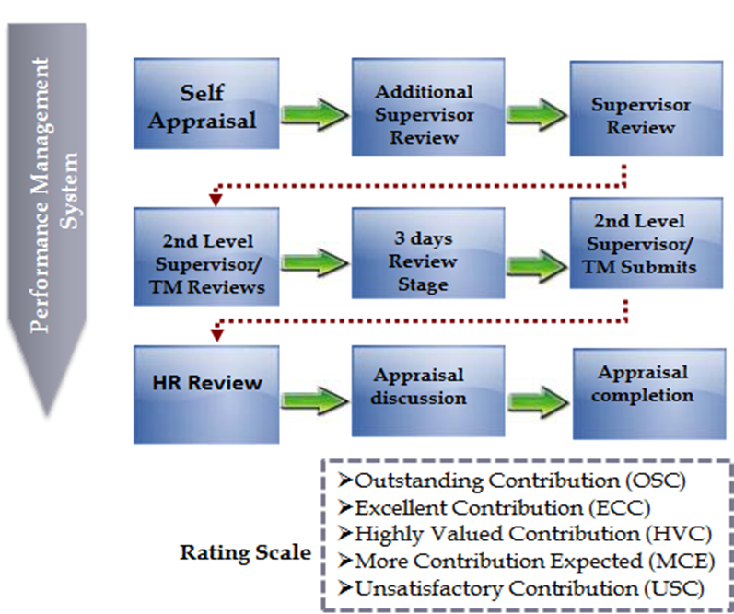
Figure 6 – We encourage our employees to provide evidence on how they’ve achieved their goals and objectives and collate feedback from customers, stakeholders or colleagues on their performance to support the overall appraisal rating.

Job Rotations
Wipro encourages internal role movements for all employees. When employees transfer into Wipro they would need to remain on the account for 12 months as a minimum then they are free to apply for job rotation. Wipro has a view of being transparent with respect to all internal opportunities, all internal job openings are posted in the My Opportunities portal. It is the one-stop-shop for an employee to view, search and apply for roles within the company and is available to all employees of Wipro IT business. This providing challenging job opportunities as per employee expectations, competencies and preferences is a priority for Wipro as an employer of choice. The focus of the organization is to match roles to individuals and enable employees to take charge of their career. It is critical that open job opportunities and roles within the organization are made available to our internal talent pool i.e., the employees and are fulfilled internally to the maximum extent possible. Keeping this in mind My Opportunities provides an opportunity to an employee to view and apply for roles across all open job opportunities in Wipro IT Business.

Talent Review &Planning
Linked with the Authority, Wipro has a strong Talent Review & Planning Process (TRP) that covers strategic talent needs, succession planning, tracking and development of key talent. The process assesses the readiness of key talent and charts out growth plan for them. Adherence is ensured through clear owners & timelines & the same is monitored periodically. The Top management invests significant time on this process.

Role Based Assessments
Working on the account Wipro would introduce some role based assessments to strengthen the capability building framework for key roles in the project management and architect streams. These assessments are designed for understanding the proficiency level that employees possess with respect to the specific skills, experiences and competencies required to successfully play the role. Assessments at Wipro have the following linkages:
- Individual Development plan basis the gaps identified in the role based assessment.
- Role fitment for all existing role holders and role aspirants, including progressions would be subject to clearing the role assessment.
We have a portal for role based assessment which is a one-stop-shop for all employees to take up the relevant assessment as per eligibility and also view details of various assessment processes. The portal helps the employee to either self-nominate or get nominated by his/her Supervisor or HR for the concerned assessment as well as view his/her feedback or outcome records for the assessments completed.
Two kinds of assessments we have are:
- Role Aspirant: These assessments are for employees who are aspiring to move into a role and hence are potential candidates for the role. Potential assessments can be for a lateral movement (e.g. Senior. Project Manager in Band C2 to Delivery Manager in band C2), or for the next role in hierarchy (e.g. Delivery Manager in Band C2 to Senior Delivery Manager in Band D1).
- Existing Role holder: These assessments are for employees who are already playing the role, but have not been assessed yet. (e.g. Program Manager in Band C2 takes up the Program Manager L1 assessment if not already assessed)
The figure below describes our proposed staff succession planning linked to career development pathways for trainees in accordance with 5.2.2;
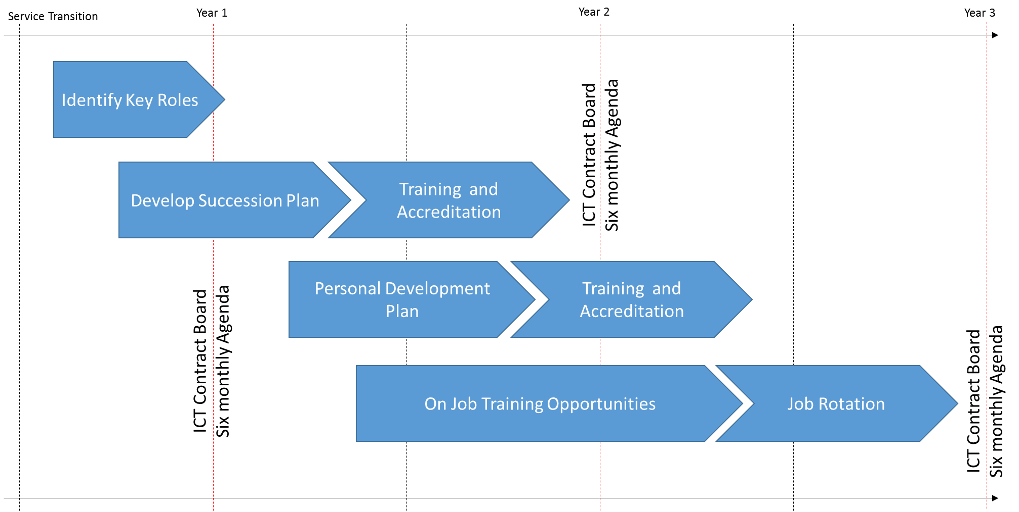
A plan which describes how your organisation proposes to support the Authority’s commitments to corporate parenting in accordance with 5.2.3;
Wipro recognises the care leavers are far less likely to go on to a positive destination than other school leavers, with over a quarter becoming unemployed. They may be unwilling to disclose their status and in addition some may have more complex support needs. As part of our Apprenticeship programme, we will hire a Modern Apprentice (MA), and businesses get the skills and talent they need. At the same time, the apprentice gets their career of to a roaring start – with industry-recognised qualifications based on highly structured training, usually delivered by a training provider. Wipro will pay the Modern Apprentice’s wages.
We will reserve at-least 1 Apprenticeship for a care leaver from the Highlands Council area.

Development of Employability Workshops:
We will undertake a one-day workshop for up-to 10 young people to support development of employability skills and ultimately facilitate entry to Modern Apprenticeship programmes, every six months. This will include barrier removal, specialised support and will be followed by 1-week work experience with Wipro. Target groups will be disability, care leavers and young carers.
These candidates will receive future opportunities as part of our Apprenticeship and Internship Programme.

Teaching Assistance (TA) Training
We believe teachers are crucial for the development of next generations. It is equally crucial to develop and support the next generation of teachers. We support the development and training programmes for teachers through our activities in the education sector in India, South Africa and America.
We recognise the shortage of trained teachers in remote areas of Highlands, through our competitive dialogue as well as our discussions with the University of Highlands and Islands. Wipro will offer additional training support for Teaching Assistance training programme for schools that will take candidates from Corporate Parenting background in the Highlands Council area. Wipro will partner with the Teaching Assistant College to offer a resource pack based self-learning and training solution for schools in the Highland Council area. Ongoing professional development has a high impact on teaching and learning. The training resource packs will provide classroom assistants with the tools they need to provide exceptional support every day. The classroom assistant training resource files have been written to enable schools to deliver valuable training without spending hours developing their own materials. Each file contains all the materials needed to deliver informative and interactive training including guidance notes, PowerPoints on CD Rom, handouts, group activities, case studies & thought provoking reflection for delivery of over 50 hours of great training by any of your teachers, senior manager or a Lead TA or Early Years Practitioner.
Two types of resource packs are available targeted to primary or secondary schools:
- Early Years Training Resource File
- Effective Classroom Assistant Training File
The packs are most applicable to schools with 5 or more classroom assistants due to the group nature of the learning process. Once a school is licensed for a resource pack it is available for use by all current and future classroom assistants in that school.
Wipro is funding the resource packs in total for 10 schools per year in the Highlands Council area over 3 years, meaning 30 schools in total will benefit from this development, as described in our commitment for CB3b – Community Benefits. The schools will be selected through a fair selection procedure, in agreement with the Council and preference will be given to those who provide teaching assistance to candidates with Corporate Parenting background.

Skills development and Training
A plan which describes your proposals for skills development and training for Authority staff in accordance with 5.2.4. Your plan should set out the envisaged quantity and the proposed scope of any training proposed;
Wipro recognises the importance that the Council places in providing high quality, relevant IT training to its staff. Provision of such services is vital to achieving successful transformations and delivering the business benefits of change projects. Wipro will provide the training on transformed ICT Services and on demand training services through flexible and cost effective Service Catalogue. Wipro will gather data to support the ICT training needs, perform analysis from management information produced from our service desk tools where user training trends or issues will be highlighted. We will work closely with the Council’s HR team to identify specific ICT training requirements that may have been identified through the Councils own appraisal process.

Training as part of Wipro’s Transformation Projects
Wipro’s solution includes a series of transformation projects to deliver Authority’s vision of Service Excellence through transformation to enable the Target Operating Model. Wipro’s solution will support and enable business change as per the Highland Council’s strategic business objectives. The main programmes we will deliver to the Authority as part of our transformation include:
- Rollout of Office 365 Productivity Platform
- End User Device Refresh
- Virtual Desktop Architecture that will deliver combination of Thick Client in the form of Desktop and Laptops as well as Thin Client Devices

Wipro will provide Microsoft Office 365, a Cloud productivity through the familiar Office desktop suite and Cloud based versions of its next-generation communications and collaboration services: Exchange Online, SharePoint Online and Lync Online. We deliver a series of 1 hour workshops to provide the Highland Council staff (Corporate and Curriculum) with an understanding of the key Office 365 technologies and explain how the transition from the current Exchange 2010 and Office 2010 to Office 365 would take place.
Through these workshop we will help the staff to understand
- Understand the Office 365 technologies
- Understand the Microsoft transition road-map to Office 365
- Identify what actions they would need to take to successfully undertake transition
These interactive workshops will enable the users to gain:
- A deeper understanding of the Microsoft Office 365 Technologies
- An explanation of Wipro’s Office 365 Transition Plans and Processes
- What actions to do next in order to transition successfully to Office 365
- An understanding of the role Wipro and the Council would play in the ‘transition weekends’
- Guidance on Pre Transition Planning activities
- Guidance on Post Transition Activities including Mobile Device Configuration and Administrative Activities
- A look at a successfully completed transition, demonstrated via a Transition Scenario
Wipro will provide training material to the Authority staff (Corporate and Curriculum) to prepare for the change. The training material in the form of online CBT courses and fliers will be available on the Council Intranet. As part of our rollout project we will provide floor walkthroughs and onsite training support on the day of rollout. Drop in zones will be available to the Council staff for help / guidance and clarification of specific topics. Service desk will be provided with training materials and self-help guides that can be emailed for the staff. Knowledgebase and FAQ’s will be published on the Service Desk Portal so that staff can access the knowledgebase as per their own convenience.
Wipro will use a range of communication channels to send across the message. These would be emails, focus groups sessions, standees, posters, webinars, road shows and other media to send the message to the end user. The final list of the media would depend upon the results of the communications assessment.

The communications content will be designed to bring an awareness on the benefits of the Programme, next steps for the users, roll out schedule, upcoming events, highlighting the do’s and don’ts and things users are likely to lose as a result of migration (if any). The communication channels mostly used are – emails, poster campaigns at major sites, newsletters, yammer, presence at manager’s brief, dedicated Programme Portal page on the intranet.

The communications manager will be responsible for designing and developing content for Posters, Standees, handouts, FAQ docs and other media as decided by the team. Implement the plan / monitor feedback / expectations management. As we move ahead in the project Wipro’s communication plan will constantly evolve and we will take on board the user feedback. We will build in a feedback mechanism that helps us to understand the awareness / concern / support levels of our target audience across Corporate and Curriculum.
The communications collateral will be designed to bring an awareness on the benefits of the Programme, next steps for the users, roll out schedule, upcoming events, highlighting the do’s and don’ts and things users are likely to lose as a result of migration (if any). The communication channels mostly used are – emails, poster campaigns at major sites, newsletters, yammer, presence at manager’s brief, dedicated.
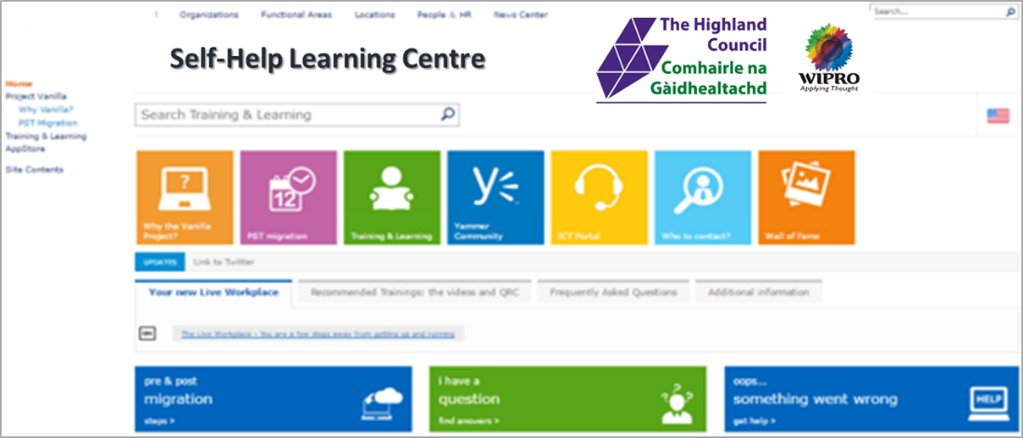
Figure 7 - Wipro will implement Self-Help Learning Centre accessible from our Service Desk Portal

The table below describes communication plan based on our methodology that has been developed for the Authority.

User group/segment | Device types | Apps  Usage  Summary | Typical work pattern | Proposed deployment approach | Hot spots/ key considerations/  special interests | Initial Training  Needs | Communication and engagement
Executive Board and Members | iPad, Laptop, Mobile phone | Full Office version  (E3) | Any time anywhere secure access, Self-service Portal | One to One  Of Group session | Minimize disruption  Tailored to individual | Class room approach | Via Change Champion  Personalized
Teachers | Laptops | Full office version  (E3) | Flexibility to work from Home  Self-service Portal | Laptop clinic | Minimize disruption,  Tailored based on the user profiles | CBT’s floor walkthroughs and drop-in sessions | Via Change Champion  Communication Plan
Corporate Standard Users | Workstation, Laptops, Desktops and Thin client | Full office version (E3) | Flexibility to work Self-service Portal | Site wise device refresh, Thin client rollout | Minimize disruption,  Tailored to profile based desktop refresh | CBT’s floor walkthroughs and drop-in sessions | Via Change Champion  Communication Plan

Curriculum Device Rollout Project
Wipro recognises the importance of Authority’s plan to provide Chromebooks for the Curriculum environment. We have dialogued the shortfall of trained resources and training material within the Authority’s team to support the schools to adopt the Chromebooks and new ways of learning. The delay to this project could have a material impact on the Council’s transformation timetable resulting in the delay to the Authority’s savings.
Wipro are providing 5 man months’ effort for developing training material and providing training to the Authority’s Curriculum staff and Council IT staff as part of our commitment to the Council for the Chromebook rollout project. Our staff will work with the Authority staff as part of the Authority’s Chromebooks project during this period.
Wipro will provide training material and dedicated one stop page for the Authority’s Chromebook Programme to help the LMD administrators with FAQ’s, Self Help and help the Authority and Curriculum in creating a Yammer social community to support the schools. We will participate in those community discussions and bring our technical know-how to help the Curriculum environment. We will provide:
- A dedicated page on the portal/ Authority’s intranet will be developed and maintained throughout the programme lifecycle. The portal will be one-stop destination for any information users may need about the Programme.
- A sample of the Programme Portal Page, demonstrating various options available for the users to choose from the Portal Landing Page is described in the figure below.
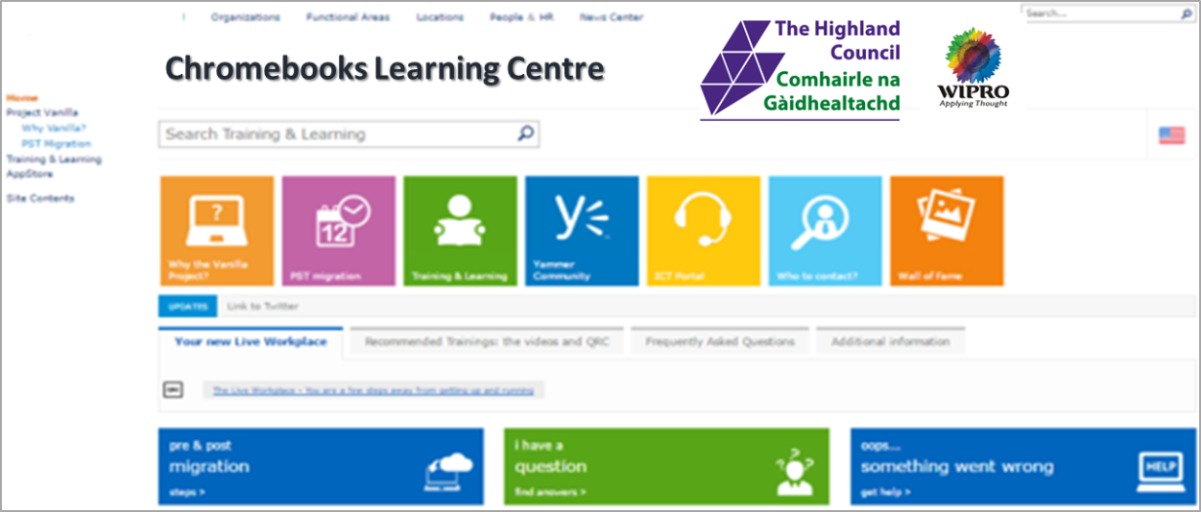
Figure 9 - An Example Landing Page for the Chromebook Learning Centre
- Recommended Training section for the Locally Managed Devices Support Staff
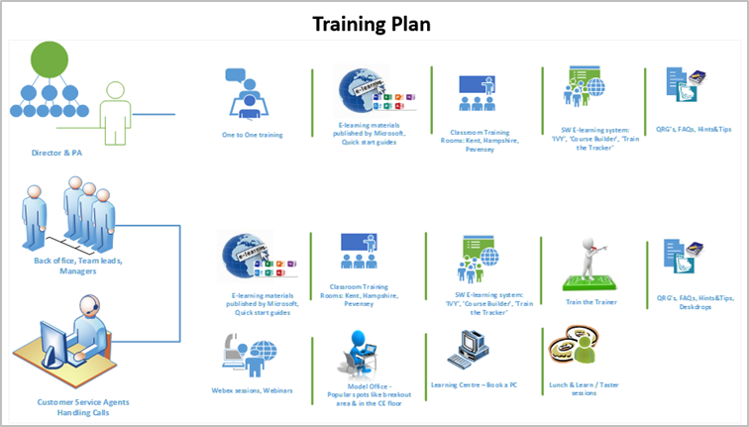
Figure 10 - An example training and learning centre for the LMD Support Staff and TA's in school

Service Catalogue based training
In addition, Wipro will engage external training specialists such as QA and University of Highlands and Islands to provide a broader pool of training resources for specialist courses as required by the Council. Our Service Catalogue will include a range of virtual learning courses designed to recreate a classroom experience online, enabling full interactions with the learning professional leading the course. We have chosen QA’s Virtual Learning Platform (QA365), which will allow the Council staff to access the learning session from anywhere (requires internet access), thus saving travel costs and allow users to get trained at the time of their convenience and comfort, download course recordings and view new content that is routinely added by QA’s learning professionals.
We recognise the need for development themes that will be central to its Council’s goals. By aligning training courses to these themes we will be able to support the learning to support the strategic development of the Council’s workforce.
A list of some of the popular courses that are available in virtual learning environment:
- ITIL® - ITIL® Foundation - Virtual learning
- PRINCE2® - PRINCE2® Foundation and Practitioner - Virtual learning
- Information Security and Assurance
- Data Protection Act (DPA) Foundation
- Business Continuity and Organisational Resilience Information Risk Management
- Customer Service - Covering the full spectrum of requirements from front line interaction, specialist customer contact, locality working and community engagement
- Management and Leadership Development - Covering wide spectrum of requirements from leadership, soft skills and front-line supervision
- Life Skills - To support front line staff as their jobs require greater flexibility and ability to utilise ICT and to record information and communicate with end customers
- Service Innovation - Enhancing the management skills required to deliver change and transformation, supporting professional development in the areas of: procurement, contract management, working in partnerships
- New Ways of Working - Developing new ways to harness technology, working outside of traditional office environments, supporting cultural change
The list of courses will be designed by working with the Council HR and Training Management team.

Business Transformation and Digital Awareness
Wipro’s Digital Architect Academy (DAA) provides a platform to our technology leaders and transformation architects abreast with the next generation technologies. Our DAA team has developed a learning eco-system for Digital Architects. This eco-system includes a set of programs on emerging technology landscape, digital architecture principles, developing proof of concepts etc. that enable these professionals to build an all-round competency for “Digital” and proactively design solutions to address customer needs. Digital Architect Academy will be accessible to Authority’s Business Transformation leadership team to develop the new ways of working and transformational ideas to support the Highland Council Business Transformation Plans.
We are exploring the opportunities of joint working with the University of Highlands and Islands through STEM programme in this specific area as described in CB3 – Community Development response.

Enabling Secondment Opportunities
Wipro has deep experience in secondments to cover situation whereby an employee or a group of employees are assigned on a temporary basis to work for Wipro from another organisation or a different part of the organisation of the Authority or another vendor, current employer. Typically, this has occurred during outsourced deals and linked to key members of the retained organisation or key employees that will be required to return to the customer as some pre-arranged point.
Wipro would agree with the Authority the scope and duration of the secondment and any key deliverables that would be mutually beneficial to both parties. Wipro would use seconded methods for key employees that are crucial to Authority or other vendors and would be retained to help with knowledge transfer of any legacy applications or key SME’s areas. Wipro would be amenable to other options for secondment within the authority in the following occurrences: -
- The career development of that particular individual
- The chance for that individual to gain some new skills or gain some experience
- Providing employees with the chance to work on short term projects
- Providing potential cover for short term absences
- Avoiding redundancies/ Transfers to new vendors
- Enabling employees to remain with the original employer and so preserving specific benefits such as GAD approved pension schemes.
Wipro’s Senior Management team for the Highlands Council account will include Community Benefits Officer, responsible for working with the Authority, its Partners and Wipro teams to deliver our Community Benefits Programme. The Community Benefits Officer will attend the Authority’s quarterly Community Benefits Board and report the progress of our Community Benefits Programme.
We propose the Community Benefits Officer role be filled initially through secondment from a suitable candidate from the Highland Council for the initial period of 1 year. As part of succession planning, we will work with the Council to identify a suitable candidate from Corporate Parenting or Care Leaver background.
Participating employees will be given every opportunity to understand Wipro during the induction process, to understand it culture history. Job roles objectives would be implemented as part of the secondment for the employees concerned. The only real issues which will have to be defined in relation to the secondments will be the duties of the employee on the secondment, their manager and their place of work. A detailed secondment agreement. Is negotiated between the Wipro and the Authority. In most cases the Authority would remain the employer and Wipro would be invoiced for the days the employee worked. We would be happy to arrange a more detailed discussion on this topic by our Global Workforce Human Resource Director who would be happy to arrange a mutually convenient date.

Ensuring Customer Satisfaction and delivering improvements
As part of our continuous improvement objectives all the courses offered under our Service Catalogue we will:
- Review any induction related courses such as Information Security, Self Help capabilities such as Password Reset. These reviews will be carried with the business team leaders and subject matter experts
- Review of feedback on training approaches used to understand course effectiveness
- Make recommendations regarding any modifications necessary
- Revise or redesign courses where required
- Develop a schedule of courses appropriate to the number of attendee’s envisaged
- Identify cost effective ways for the delivery of all courses in the catalogue
We will review the courses annually with the Authority HR and Training team to ensure appropriate training provision model for the Council.

Wipro’s approach to targeted recruitment and training
A plan which describes your organisations approach to targeted recruitment and training as a means of easing unemployment in accordance with 5.2.5;
Wipro is committed to the creation and support of work placements, internships and vocational opportunities for the local community, particularly school-leavers and young people in the Highlands Council area.

Supporting the Council in High Unemployment Area
Wipro recognises the need to promote the training and apprenticeship opportunities in the areas of high un-employment. We will ensure the job opportunities as well as the training and internship are promoted in those areas of high un-employment. We will deliver one roadshow per quarterly roadshows to raise the awareness of the opportunities in IT, training needs and the type of training that is available through Government, through the Council’s Bridge to Employment programme. Wipro will provide desktops and laptops for those interested from the refreshed pool of devices.

Classroom Assistant Training
We believe teaching is crucial for the development of the next generations. We support the development and training programmes for teachers through our activities in the education sector in India, South Africa and America via Wipro Cares.
We recognise the role that classroom assistants play in the learning experience and the difficulty in training and maintaining ongoing professional development for such support roles in the remote areas of the Highlands.
Wipro will partner with the Teaching Assistant College to offer a resource pack based self-learning and training solution for schools in the Highland Council area. Ongoing professional development has a high impact on teaching and learning. The training resource packs will provide classroom assistants with the tools they need to provide exceptional support every day.
The classroom assistant training resource files have been written to enable schools to deliver valuable training without spending hours developing their own materials. Each file contains all the materials needed to deliver informative and interactive training including guidance notes, PowerPoints on CD Rom, handouts, group activities, case studies & thought provoking reflection for delivery of over 50 hours of great training by any of your teachers, senior manager or a Lead TA or Early Years Practitioner.
Two types of resource packs are available targeted to primary or secondary schools:
- Early Years Training Resource File
- Effective Classroom Assistant Training File
The packs are most applicable to schools with 5 or more classroom assistants due to the group nature of the learning process. Once a school is licensed for a resource pack it is available for use by all current and future classroom assistants in that school.
Wipro will fund the resource packs for 10 schools per year in the Highlands Council area over 3 years, meaning 30 schools in total will benefit from this development. The schools will be selected through a fair selection procedure, in agreement with the Council.

Our process of Targeted Hiring that we will use at the Highlands Council
We are committed to identifying, recruiting and retaining the best talent to meet our business needs. Our philosophy is to bring on board talented people with whom we can build a strong, mutually beneficial and lasting relationship. Aligned to our Spirit of Wipro values, Wipro ensures a meticulous and ethical recruitment process and through that we want to ensure:
- Wipro will obtain qualified and committed professionals who will work with utmost integrity to help Wipro customers achieve excellence.
- Talent Acquisition will carry out its functions with great sensitivity to people and will ensure speed, quality and cost to contribute to organisation.
- In addition to employees being outsourced to Wipro from the current incumbents Wipro will work with the Authority to recruit talent from the local community that will significantly add value to the account or the wider Wipro. The figure below describes Wipro’s agile hiring framework
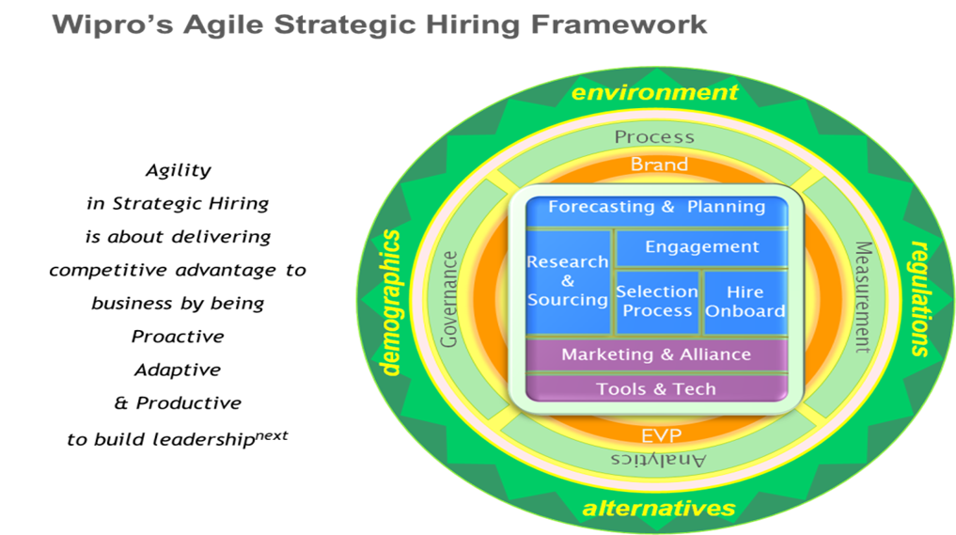
Figure 11 - Wipro's Hiring framework is central to our Talent Acquisition Methodology. We will use the framework in the Highland Council to fulfil our hiring requriements.
Wipro’s commitment to induct the best talent across the globe resulted in the offspring of a dedicated hiring engine in 2014 called the Global Strategic Hiring Group. A sub-group of the Human Resources Function it has a prima focus – identify, attract and induct Leadershipnext for Wipro. Approximately 100-member global team specializes in hiring talent in the following areas: Leadership, Go-To-Market, Consulting, Domain (Industry Advisory) & Functional.
Centred on agile hiring practices such as market mapping, gamification, cloud, big data profiling, new models of hiring it looks at delivering competitive advantage to customers by being Proactive, Adaptive & Productive to build next wave of Leadership. These models will be mirrored to work with the Authority in recognising talent that can be included in Wipro growth plans for the UK.
The Technical recruitment team in Wipro takes care of Technical skills hiring across the business unit. This team is responsible for volume hiring we do for all skillsets required for billable opportunities. May it be generic skills like java or C++ or niche skills which are vertical/ domain specific, this team takes care of all the requirement to keep our engine running. Previous year, this team hired more than 5300 qualified professionals across the globe. This same team will work with the Authority to realise any existing employees that would like to be redeployed or as anew employee working for e technology organisation.
Campus Hiring Team: Wipro is known to hire fresh talent and nurture it further. Our campus hiring team is the first and core step for this. This team supports both Technical and non-technical hiring process. For the skillsets to be hired, the Campus hiring team is divided into 3 further sub-divisions.
- Engineering Hires: Wipro hires quality candidates from over 100 Accredited Engineering Colleges of the country. There are a total of 7 location campus managers across the country for Asia and Europe.
- Non Engineering Hires: Today, Wipro has the capability to source across 30,000 non-engineering graduate colleges mostly through Europe
- Business Specific Hiring: The team follows the just in time hiring strategy to meet critical business demands. These hiring are vendor based models to fulfill niche skill sets
This team has a support of core team to keep the engine running:
- Operations: The operations team specifically focuses on accreditation process, offer letter distribution, quality control, processes and compliance enabling the teams to hire the best students across streams
- Marketing: The Marketing team focuses on brand building, awareness, Engagement and lead generation.
- Central Team: Central initiative works with various business and location campus managers to fulfill the requirements.
Output of the Talent acquisition team at Wipro is measured based on various factors such as Lead time and productivity, quality of hire and customer satisfaction. The Talent Acquisition Team described below follows a simple operational code of SMART hiring – centred around Systems and Processes, Market Knowledge, Alignment with Customers, Responsiveness & Total Cost.
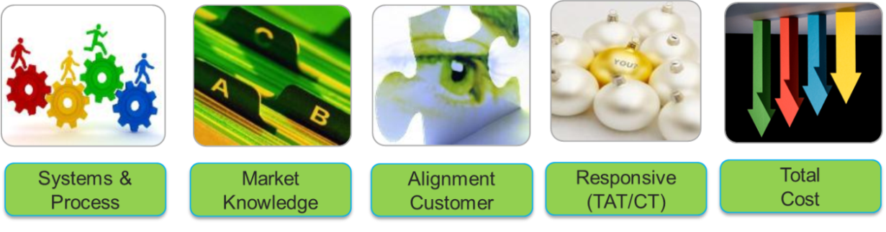
Figure 12 - Wipro's Talent Acquisition Framework
Latest tools and technologies are used to understand business needs and align with the hiring strategy. Our global spread and market research provides in-depth market intelligence with local flavours to source the right individual. Wipro’s customer centric structure creates a strong alignment with the business groups. Strong operational measures, controls and analytics with a specific focus on time & cost ensure right hiring, at the right time with the right price.
Systems & Process: Our strong system and processes are our core strength to make us achieve our goals.
Systems: With patents to our name and awards in our kitty our systems and processes are world class and SOX compliant. Wipro uses a world class, award winning, in-house Talent Acquisition System i.e. ‘Synergy’. Developed in-house exclusively for the hiring team it boasts of a customized workflow built on our already strong processes.
- Synergy is a Java-based portal application based on service-oriented architecture and hosted on Sun Solaris servers using Oracle DBA. It is a single repository for all recruitment information, as well as an efficient applicant tracking and e-recruitment system. Synergy acts as a single interface with all relevant stakeholders (Candidates, Hiring Managers, Partners, Social Networks & Enabling groups within Wipro) and ensures that the entire hiring process (From requisition to onboarding) is online and compliant.
- Synergy acts as a single interface with all relevant stakeholders (Candidates, Hiring Managers, Partners, Social Networks & Enabling groups within Wipro) and ensures that the entire hiring process (From requisition to onboarding) is online and compliant.
- A dedicated Talent Quality Group audits the hiring process and ensures veracity of information, individuals and compliance to standard practices and policies.
Processes: A dedicated Talent Quality Group that assesses the veracity of selected candidates and ensures compliance to standard practices and policies. At Wipro we ensure that integrity is of the highest importance in our candidates to uphold the Spirit of Wipro representing the values of the organization. Our policy on integrity is ingrained in our recruitment processes and is strongly believed by the teams.
Rigid selection and quality processes ensure that talented local candidates will be valued and selected while discouraging the fraudulent candidates, as well as fraudulent agencies and organized networks. Talent Quality Group (TQG) was introduced as a separate cell within Talent Acquisition Team as a means to develop a sustainable quality culture in the Talent Acquisition Team. The objective behind TQG can be summarized as below:
- Responsible for evaluation of internal hiring processes and also to check and identify if any education or employment documents submitted are fake or dubious candidates are hired from doubtful companies
- To check if any deviations have been taken while hiring the candidate
- These advisories and guidelines are framed based on inputs from the TED and Legal team to ensure that only genuine and deserving candidates are inducted into Wipro.

How is Talent Sourced
Working with the Authority and utilizing your existing models we would typically identifying the right needs for the Hiring Groups. SPOCs work closely with the hiring groups in understanding the hiring needs (both proactive & need based). Standard templates capture relevant information and post an approval work flow on the system gets directed to the right ‘recruiter’ on field to kick off the hiring process.
Jobs could be jointly published on the authority and Wipro web sites using multiple channels and applications sought both actively and pro-actively. Wipro is an equal opportunity employer and not only is any individual free to apply to a position in Wipro but are also given an opportunity to present their skills.
Wipro employs multiple channels for sourcing quality candidates. This is brought about by the Talent Acquisition team and they use the following sources of recruitment:
- Staffing partners
- Headhunters
- Advertisements
- Employee referrals
- Career site
- Job portals
- Social Media – LinkedIn, Facebook, etc.
- The % distribution of various sources used are mentioned here:
- Agencies – 20%
- Employee Referral – 10%
- Jobsites – 60%
- Direct source (includes the career site and promotions) – 10%)
All CV’s received through the process of Advertisements, Employee Referrals, Job portals, staffing partners, and Career site and from the database, are initially screened by Wipro recruiters. All technical screening is done by select technical panels. Final selection is done by the recruiter. Campus recruitment follows a stringent process of selection at the various campuses visited by Wipro. Internal movement of technical resources is handled by our Workforce Management Group.
There are dedicated Talent Acquisition (TA) groups across the globe to cater to geo specific needs. TA has teams in each geography consists of senior leaders and teams of experienced recruiters. The recruiters are dedicated to finding talent for specific Business Divisions and develop expertise in the talent needs of the business. Our dedicated teams focus on vendor management to ensure quality, cycle time and cost optimization. We use over 150 contract staffing partners and over 50 permanent staffing partners, globally.
We are working with Highlands and Islands Enterprise to ensure we have the abilities to source talent during the mobilisation stage. Wipro will also look forward to utilising the Authority resourcing suppliers to obtain the right talent.

Integrating Transferred Staff
When employees are transferred to Wipro we use our proven process of integrating new employees. Culture development and integration is on-going and dynamic in nature. We have described the communication initiatives to help in a smoother integration of transferred staff in Wipro:
- New employees on boarding - This is a structured 3 month plan for employees to help them integrate into Wipro, get acquainted with the processes and policies and get started with their roles. It begins with a buddy being chosen for each new employee who shall guide them on how things are at Wipro. Following which the employee is required to work on the Quick Start Plan which essentially is a checklist of items that a new hire must learn while the manager and buddy are there to assist him during the entire period. At the end of 3 months, feedback is solicited on the onboarding experience to assess the effectiveness of the process.
- New Manager Introduction - If a person has joined as a new manager, after 30 days, there is a New Manager induction session scheduled for them and team members to get a clarity on the role and set the expectations right from both the sides i.e. the manager and the team members. The process gives initial feedback that will help them manage and work better with their team.
- In Sync - This is a platform to consistently engage with employees every quarter through account/location level sessions. The goal is to ensure periodic face to face communication and increase awareness about directions Wipro is heading to. These interactions drive organisation vision, ensure team alignment and also inform the team about the corporation wide initiatives which helps bring visibility of the direction the company is moving in.
- All Hands Meet - All Hands Meet abbreviated as AHM, is a quarterly leadership connect initiative as a part of which the Business Head addresses all employees in his/her business. The idea is to apprise them of what is critical to the unit’s success, how we fared in the months gone by – what went well and what do we need to improve on. It is a platform where the senior leadership underlines the vision for the unit and the direction it is heading in. These business levels connect helps in orienting the new joiner to the business developments and how does the role fit into the bigger picture.
- Wipro Meets - This is an interactive session with the Chairman, CEO and others in Senior Management. Wipro Meets is a world-wide quarterly meet, live over a webcast and attended by employees across the globe. The Chairman and the senior management speak about the quarter gone by, new updates and employee engagement activities and various other topics which are current and people oriented. This is followed by an interactive session, questions being consolidated prior to the meet on the intranet portal.
- Yammer - In an organization like ours where knowledge is valuable, workforce is dispersed and innovation is the key to success, social networking tools find enormous benefits. To build a collaborative culture, connect geographically displaced teams, preserve and share knowledge, we launched this social networking space where employees and communities share thoughts, read what others have to say, upload photos, make new friends and simply network. It is a forum to communicate launch of organization initiatives, process changes and leverage employee reactions.
- Webchats with Senior Management - Virtual chat with the senior management is very popular at Wipro. There is a virtual chat-room available on the ‘Channel [W]’ Wipro’s intranet page where chats with the senior management are conducted depending on the current scenario. This is to encourage dialogue and increased interaction with the senior management on issues that have an impact on an employee’s life at work. The latest in this series was a talk with the HR Heads on the actions taken basis the feedback received in the Employee Perception Survey 2011. It was a series of interactive sessions with the employees where EPS actions were highlighted and employee queries around HR processes were answered.
- Channel W - Conceived in year 2000 the Channel W portal was made to empower the employees, be a voice and identity of employees, a place which will help the global employees bond with Wipro and other fellow colleagues. Vivek Paul, the then chairman had visualized it engineers and other senior as a portal which an employee leaving the organization would remember as a terrific experience and miss it in their new workplace. It was a place to address the employees’ need for bonding, belonging and sharing.

Bridge to Employment
We will actively participate in the Bridge to Employment Programme which is centrally managed by the Highland Council. As part of the contract, Wipro commits to an investment of (Redacted) over the term of the contract to:
- Promote ICT as a career
- Provide ICT infrastructure and guidance to schools to encourage the adoption of ICT and promote Automation / Artificial Intelligence related development activities and competitions
- Promote the training and apprenticeship opportunities in the areas of high un-employment. These areas will be agreed with the Council on annual basis.

Promoting jobs and vacancies
We will promote all vacancies and employment opportunities which exist within our Highland Council account for local recruitment in the Highlands. The information relating to employment opportunities will be provided on a regular basis to the local job centres and to recruitment agencies within The Highland Council as well as on the Bridge to Employment portal. This will make it easy for the interested students to look for ICT and Customer Service related opportunities available within Wipro.
We will also encourage our sub-contractors as well as supply chain partners to promote the jobs in the Highlands Council.
We will promote the job opportunities at the University of Highlands and Islands through campus interviews and annual job fairs.

Work Experience Training
We will publicise our Apprenticeship Scheme within The Highland Council by providing information to all schools, colleges, recruitment agencies and Job Centres on the qualifying criteria and recruitment timetable. We will create a work experience and work shadowing programme for school leavers aged 17 (Year 12 & 13 students) and 18 (Upper Sixth Form students). We will work with all secondary schools, colleges and Academies within the Highland Council to align placements with their curriculum, examination timetables and school holidays. These opportunities will be available in the following areas, but not limited to:
- Service Desk
- Desk Side Support Staff/ Engineers
- Application Support
- Account Management
- Project Management
We are providing 10 apprenticeship positions within the Highland Council area. It will provide work experience and work shadowing opportunities across multiple disciplines in Wipro’s service delivery team for the Highland Council. Additional opportunities available within our Glasgow and Aberdeen offices as well as with our sub-contractors – brightsolid (data centre hosting and hosted infrastructure services) in Dundee and Aberdeen. brightsolid provides managed infrastructure support and data centre services to a number of clients and SI partners in the UK.

Supporting potential employees with caring responsibilities
We recognise the need for flexibility of working hours, working style and empathy for those who have caring responsibilities. Our apprenticeship programme will support such carers through flexible hours and training programme that will be designed to support the work-life balance.
We will appoint a senior member of staff who will oversee the trainee / apprentice interaction with the mentor. The mentors will be adequately briefed on the caring requirements so that the programme fits around specific needs and individual circumstances. We recognise the course is likely to run for longer than the standard 3 – 6-month duration. The training programme will uphold consistent standards of performance for caregivers and non-caregivers alike.
We will ensure that job openings, acting positions, and promotions are communicated to all eligible employees regardless of caregiving responsibilities

Plan to support employee engagement and involvement in decision making
A plan which describes how your organisation supports employee engagement involving employees in decision making.
To ensure that employees are involved employees in decision making, staff are encouraged to participate in Staff surveys. The main reasons for this active participation are to establish facts rather than making assumptions about motivation our employees. Our philosophy of employee engagement and empowering staff in decision making process benefits us and our customers in the following ways:
- Employees feel valued. When you ask an employee for their opinion or tell them to go ahead and make the decision that they feel would work best, you indirectly tell people that you feel their opinion counts.
- Employees feel trusted. When an employee makes a recommendation and you say, “Go for it,” you indirectly tell your employees that you trust their judgment. Despite the risk, the employee learns firsthand what decisions don’t work and what decisions work best.
- Employees learn and grow. When you ask successful people how they became successful, many will tell you they have had a great amount of experiences in their life. When you ask them how they gained this experience, they will tell you that they have made a lot of decisions, some that were good ones, and some decisions that went bad. The more decisions you make, the more you have the opportunity to learn what works and what does not work.
- Employees feel a responsibility to think. When employees feel valued and trusted, they feel a responsibility to come up with ideas and suggestions of how to improve their work or resolve problems in their organization.
- Innovation and continuous improvement will increase. When employees feel a responsibility to think of ways to improve their job or the organization, innovation no longer solely resides with you, the leader.
- Employees will be more empowered and engaged to take action. When employees feel trusted and valued because they have been given a responsibility to think and improve the organization, most will feel energized and empowered to take action.
Wipro also uses Staff surveys in establishing whether staff in are motivated and therefore performing to best effect. Aside from the information that questionnaires reveal, the process of involving and consulting with employees is hugely beneficial and motivational in its own right. Facts rather than making assumptions about motivation when designing our own questionnaires on employee motivation. Wipro uses anonymized data in the survey once a year. Employees that transfer to will take part in the employee’s survey as soon as the next date when the survey is available. Facts are established and based on the following criteria: -
- The 'primary aim' of Wipro
- Employees are more motivated if they understand the primary aim of your business and how clear they are about your company's principles, priorities and mission.
- What obstacles stop employees performing to best effect?
- What really motivates staff?
- Do employees feel empowered?
- Are there any recent changes in the company that might have affected motivation?
- What are the patterns of motivation in our Company
- Are employee goals and company goals aligned?
- How do employees feel about the company?
- This is very pertinent and is asked at every survey, do our employees feel safe, loyal, valued and taken care of? Or do employees feel taken advantage of, dispensable and invisible.
- How involved are employees in company development?
- Is the company's internal image consistent with its external one?
Feedback from last employee’s surveys are 67% and 69 % respectively.
The plan will include all employees that transferred from the incumbent (Fujitsu). Everyone in Wipro would take part in the survey from the next anniversary date when the survey is due. The answers and locations are filtered so that the employee that take part in the surveys are anonymize. Any data that is forthcoming is acted on and used as part of employee’s communication committees and more importantly used as part employee’s objectives in appraisals.

Delivering our Commitments and Formal Governance Process
The table below describes the summary of Wipro’s commitments as part of our Section 5.2.1 and 5.2.2 requirements described in the Community Benefits – Workforce Matters.
Section | Area of Commitment | Wipro’s Proposed Commitment
5.2.1 | Career Path and Number of Trainees | Develop and Maintain Career Path portal  10 trainee positions per annum through Wipro and our sub-contractors
5.2.2 | Succession Planning | Succession planning for all key roles  Identify candidates for job rotation and develop training programme to retain and train talent from within the Highland Council
5.2.3 | Corporate Parenting | 1day workshop for 10 young people to support development of employability skills and ultimately facilitate entry to Modern Apprenticeship programmes, every year  1-week work experience with Wipro.  Opportunities through Apprenticeship and Internship Programme  The training resource packs for Schools that provide Teaching Assistance for candidates from Corporate Parenting Background.
5.2.4. | Skills Development and Training of Authority Staff | Training programme for Transformed ICT environment  Access to Training Programmes through Service Catalogue model to bring the best training and accreditation opportunities to the Council Staff
5.2.5. | Targeted Recruitment | Wipro commits to an investment of (Redacted) over the term of the contract to promote ICT as a career, provide ICT infrastructure and guidance to schools to encourage the adoption of ICT and promote Automation / Artificial Intelligence related development activities and competitions  Promote the training and apprenticeship opportunities in the areas of high un-employment. These areas will be agreed with the Council on annual basis  Promote all vacancies and employment opportunities which exist within our Highland Council account for local recruitment in the Highlands  Encourage our sub-contractors as well as supply chain partners to promote the jobs in the Highlands Council.  Promote the job opportunities at the University of Highlands and Islands through campus interviews and annual job fairs.
Wipro’s Community Benefits Officer will be responsible for implementation of our Community Benefits Plan. We aim to fulfil this role through secondment of a suitable Council staff for 1st year of the contract. At the end of 9 months, the role will transition to a suitable individual, preferably chosen from the candidates within the Corporate Parenting Programme. This approach will help us develop a strong link between the Highland communities, Wipro and Wipro Care, our CSR organisation.
In order to effectively manage the reporting and monitoring of progress regarding the delivery of our Economic Benefits commitments we will report the achievements and progress on quarterly basis through the formal Community Benefits Board as part of the Authority’s Schedule 8.1 – Governance. The figure below describes the alignment of our service delivery with the Authority’s Governance Boards as described in Schedule 8.1.
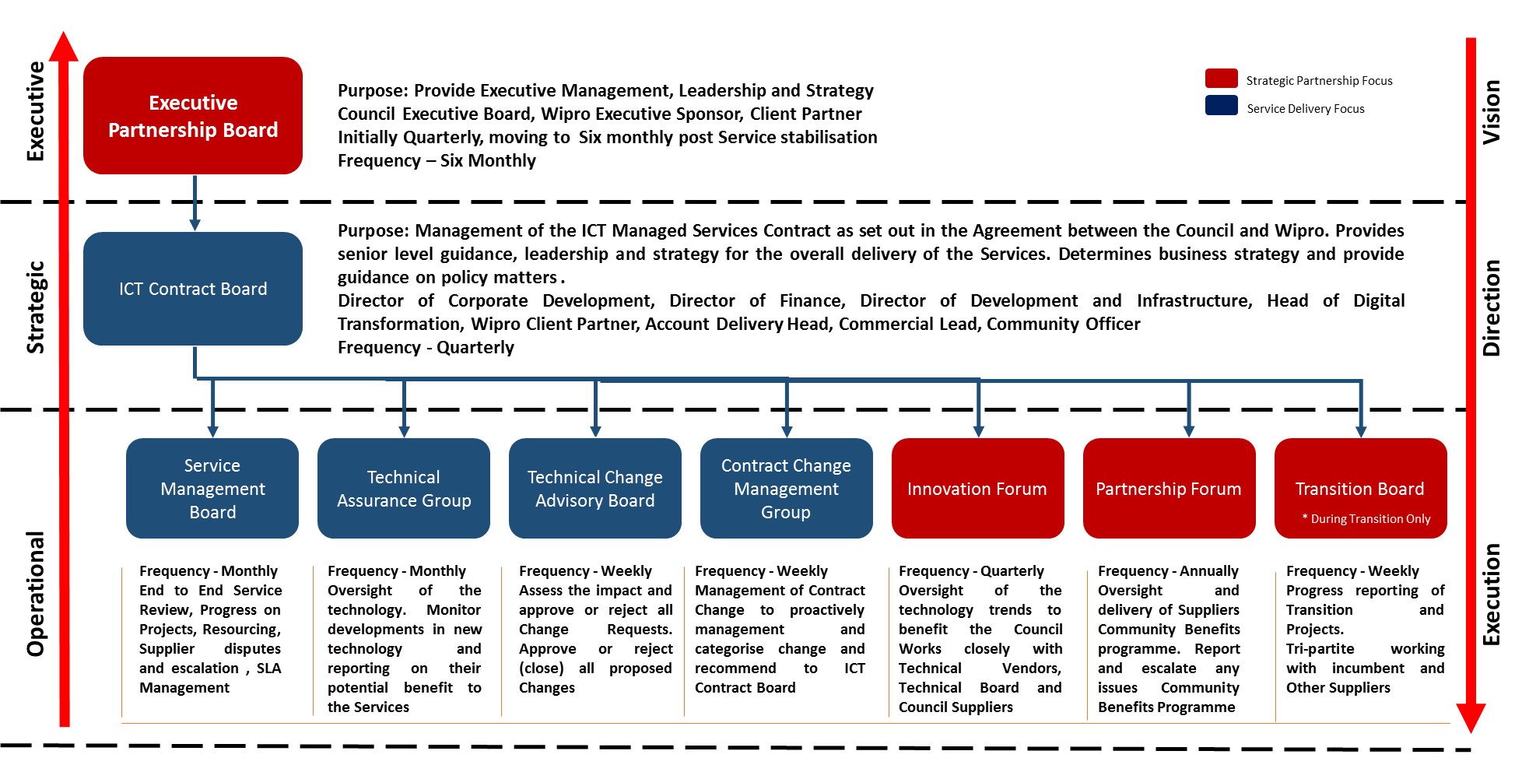
Figure 83 - Wipro will report the Community Plan to ICT Contract Board and Service Management Board through the Authority's Community Benefits Board
We will produce an annual report to report the progress against our commitments on the Community Benefits. The figure below describes our organisation structure and responsibilities and attendance to various Governance Boards.
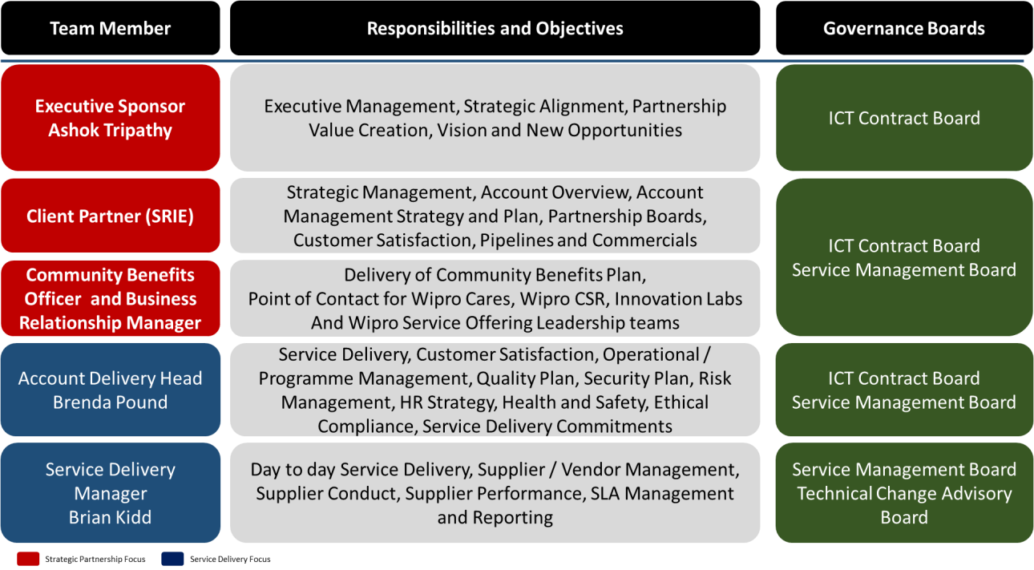

Figure 14 - Wipro's organisation structure maps with the Authority's Governance Model

