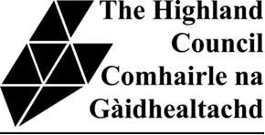
NEW BROADFORD PRIMARY SCHOOL DEVELOPMENT
PRE-PLANNING APPLICATION EVENT – 18 April 2024 15:00-19:00

Feedback Sheet

If you would like to comment on the display, please use this sheet and submit your form in the box provided or send by email to clestates@highland.gov.uk by 29 April 2024
Thank you for attending.
Dorothy Gibb, Principal Estates Officer

New Primary School and Nursery:

Other comments:

