LIST OF PROPERTY PROPOSED TO BE INCLUDED IN THE HIGHLAND COMMON GOOD FUND ASSET REGISTER IN RESPECT OF THE FORMER BURGH OF FORT WILLIAM

Asset plans for each of the Land and Buildings entries appear at the end of this list.

LAND AND BUILDINGS
Fort William was established as a Burgh of Barony in 1618. The Burgh underwent a number of name changes (Maryburgh, Gordonburgh and Duncansburgh) before becoming known as Fort William.

Name of asset | Location | Description
The Parade including:  Putting green and putting green shed, peace monument (with bell from former Town Hall), Sir Donald Cameron of Lochiel Memorial, war memorial and sundial. | High Street.  CAGUPRN: 130113413  Bordered on the south west by Parade Road, on the north west and north east by High Street and on the south east by the rear of the properties Alexandra Hotel, Duncansburgh Church, Manse and Parade House. | Area: 4046.86m² or thereby  Title deed: Feu Charter by Mrs. Cameron Lucy of Callart in favour of Provost, Magistrates & Councillors of the Burgh of Fort William registered 17 June 1914.  The deed states that the land is disponed to be held for “behoof of the whole body and community of the said Burgh of Fort William”. The deed contains a condition that the area of ground shall be forever held as “a pleasure ground for the residents of Fort William” and that no building shall be erected on the land other land of an ornamental character.  Inalienable.
Foreshore, amenity land and part of West End car park. | Achintore Road.  Car park CAGUPRN: 130087702  Bordered on north west partly by Mean Low Water Mark on foreshore and partly by area of reclaimed land acquired from Crown Estates in 1977 which forms the car park extension. Bordered on north east by road leading to car park from A82 island, on south east by A82 leading to Ballachullish and extending to a line opposite the south western edge of the access road adjacent to the south western border of the property known as Myrtle Bank. | Area: 10,290m² or thereby.  Title deeds:  - Feu Charter by Donald Cameron of Locheil in favour of Provost, Magistrates & Councillors of Burgh of Fort William registered 7 October 1904. Land between public road and High Water Mark. Disponed for “use and benefit of the inhabitants of the said Burgh” and to be converted into “an ornamental and recreation ground for the use and enjoyment of the inhabitants of the Burgh of Fort William”.  - Charter of Novodamus and feu charter by Colonel Donald Walter Cameron of Locheil in favour of Provost, Magistrates & Councillors of Burgh of Fort William registered 8 June 1914. Confirms above deed and adds the adjacent part of foreshore up to Low Water Mark.  Both deeds state that the areas of land are disponed for “use and benefit of the inhabitants of the said Burgh” and to be converted into “an ornamental and recreation ground for the use and enjoyment of the inhabitants of the Burgh of Fort William”. In respect of the 1914 deed, it also states that it is desirable in the public interest for the Provost, Magistrates & Councillors to have control of that part of the foreshore.  Inalienable.
Alma Road/Victoria Road play area | Alma Road/Victoria Road  CAGUPRN: 130113122  Located between Victoria Road (opposite Belford Hospital) on the north west and Alma Road (opposite 19-41) on the south east and adjacent to property known as Rhu Mhor on the north east and property known as Ardyne East on the south west. | Area: 9,900m² or thereby.  Title deed: Feu Charter by Dame Ada Christina Cameron Ramsay Fairfax-Lucy in favour of Provost, Magistrates & Councillors of the Burgh of Fort William registered 15 June 1937.  Given as a Coronation Gift to the Burgh “for behoof of the whole body and community of the said Burgh” to be used exclusively as amenity, pleasure, or recreation grounds.  Inalienable.
Grange Road play area (includes part of the car park) | Grange Road/Lundavra Road  CAGUPRN: 130113123  Located in the triangular corner area where Grange Road and Lundavra Road meet. | Area: 950m² or thereby.  Title deed: Disposition by Thomas Lawrie Brander and Elizabeth Anne Brander in favour of The Provost, Magistrates and Councillors of the Burgh of Fort William registered 16 September 1937.  Although there are no specified purposes in the deed it was gifted to the Burgh “for certain good causes and considerations”. This makes it more likely than not to be Common Good.  Inalienable by virtue of the public nature of the land use.
Amenity ground | Junction of Union Road and Fassifern Road just before the road island.  Narrow strip of sloped land between the 2 roads. | Area: 882m² or thereby.  Title deed: Feu Charter by Trustees of Dame Ada Christina Cameron Ramsay Fairfax-Lucy in favour of Provost, Magistrates & Councillors of the Burgh of Fort William recorded 5 October 1960.  Area of land is disponed “for behoof of the whole body and community” of the Burgh of Fort William. The deed also specifies that the area of land “should be preserved in all time coming as a pleasure or garden ground for the benefit of the people of Fort William” and is subject to the condition that it cannot be built upon and must be “used exclusively as a pleasure ground or garden in all time coming”.  Inalienable.
Amenity ground | Junction of Victoria Road and Hill Road adjacent to the west border of the property known as Mulroy, Victoria Road. The piece of land is a planted area with a footpath running through it. | Area: 329m² or thereby.  Title deed: Disposition by Ben Nevis Distillery (Fort William) Ltd in favour of Provost, Magistrates & Councillors of Burgh of Fort William recorded 22 June 1960.  The deed is silent as to specific purpose and was sold to the Burgh under exception of a small area of land previously sold for road improvement. There is no indication in the deed that this piece of land was anything other than a general acquisition by the Burgh and appears to have only been used as amenity land. As it was not acquired for statutory purpose or held on a special trust it is considered to be Common Good and may raise a question of inalienability if its consistent use has been for public access amenity.
Part of King George’s Field (Town Park) includes cadet centre.  (original acquisition of Victoria Park 1931 and Mill Dam 1937 are now held on trust following a disposition by the Burgh to itself in trust in 1939 and, therefore, not considered Common Good) | Belford Road, PH33 6BU  Two further acquisitions of land as additions to King George’s Field:  - Irregular shaped parcel of land bordered on the north by the existing King George Field and running westwards from a point 12 metres or thereby east from the south east corner of the tennis courts tapering to a point 21.5 metres south east of the property known as Rowan Cottage then running north east to a point 26.5 metres south of the start point.  - Irregular shaped parcel of land known as Whin Croft bordered on the north west and south west by King George’s Field. Original north border was 37.5 metres south of Glen Nevis Place following the curve of that road. Then bordered on the east and south east by Glen Nevis estate land. Area of 2,590m² was subsequently sold in 1974 (area south of northern border referred to above and to the west of Croft Road). | Total area: 20,850.00m² or thereby  Title deed area 1: Charter of Novodamus and Feu Charter by the Trustees of Dame Ada Christina Cameron Ramsay Fairfax-Lucy in favour of the Provost, Magistrates & Councillors of the Burgh of Fort William recorded 30 November 1950.  Area in this title – 3,173.4m² or thereby.  Title deed area 2: Charter of Novodamus and Feu Charter by the Trustees of Dame Ada Christina Cameron Ramsay Fairfax-Lucy in favour of the Provost, Magistrates and Councillors of the Burgh of Fort William recorded 20 August 1952.  Area in this title after 1974 sale – 17,676.6m² or thereby.  The Cadet Centre is located on this land and leased out.  Both of these areas seem to have remained as amenity land. The original Feu Charter of Victoria Park in 1931 (subsequently King George’s Field) was for the exclusive use of pleasure and recreation or for naval or military purposes (drilling of units). This and the additional area of Mill dam in 1937 we then contained in a trust disposition for the purposes of the National Playing Fields Association.  Although the two areas referred to above under title deeds areas 1 & 2 were not expressly brought within the trust, they were acquired as additional areas for the playing fields and clearly for the purposes of recreation. As such they are assessed to be Common Good and inalienable.
Claggan Park Playing Field  Including football pitch and Claggan Park grandstand. | Achintee Road, PH33 6TE.  CAGUPRN: 130113309.  Playing field bordered on the south west by Achintee Road, on the north west by the boundary of Willow Cottage and continuing in a straight line along land held on the Council’s HRA account to wooded land not owned by the Council, on the north east by this wooded land and on the south east by land within the title of the former Achintee tip.  (area of land this land and part of HRA land seems to have been sold for building of Willow Cottage. | Area: 26,305m².  Title deed: Feu disposition by The Trustees Corporation Limited in favour of Provost, Magistrates and Councillors of the Burgh of Fort William recorded 16 January 1969.  The title deed contains the condition that the land is not to be used for any purpose other than as a public recreation ground although the erection of pavilions of other buildings appropriate to a recreational use are permitted.  Inalienable by virtue of the public nature of the land use.
Croft tea room land (site of former Croft tea rooms) | Belford Road.  Area of land that was the former site of the Croft tea rooms. Bordered by the Belford Road on the south west, the curling rink pond on the north west, the river bank on the north east and open land on the north west.  North west corner is located approximately 9 metres east of the footbridge and on the opposite side of the river to Claggan Park. | Area: 1780m² or thereby.  Title deed: Disposition by David Mackie Rollo & Barbara McLean Curtis or Rollo in favour of Provost, Magistrates and Councillors of the Burgh of Fort William recorded 19 August 1971.  No specific purposes for purchase stated in the deed. At the time of purchase there were buildings (tea room and possibly accommodation) but these have subsequently been demolished and the land is now open access amenity land.
ART AND ARTIFACTS
Name of asset | Location | Description
Provosts Chain of Office | Charles Kennedy Building  Fort William  In safe. | Gold double chain. Pendant is broadly oval in shape comprising a garland of thistles containing a banner surrounding a shield bearing an oak leaf and acorn design. Banner has relief lettering stating “A DH’AINDEOIN C’O THEIREADH E’”.  Pendant is engraved in the reverse – “Presented by Sir Henry and Lady Cameron-Ramsay-Fairfax-lucy 1930”.
COMMON GOOD FUND
The Fort William Common Good Fund is in the process of being re-established therefore, as yet there are no Annual accounts or monitoring reports available.

ASSET PLANS
The Parade
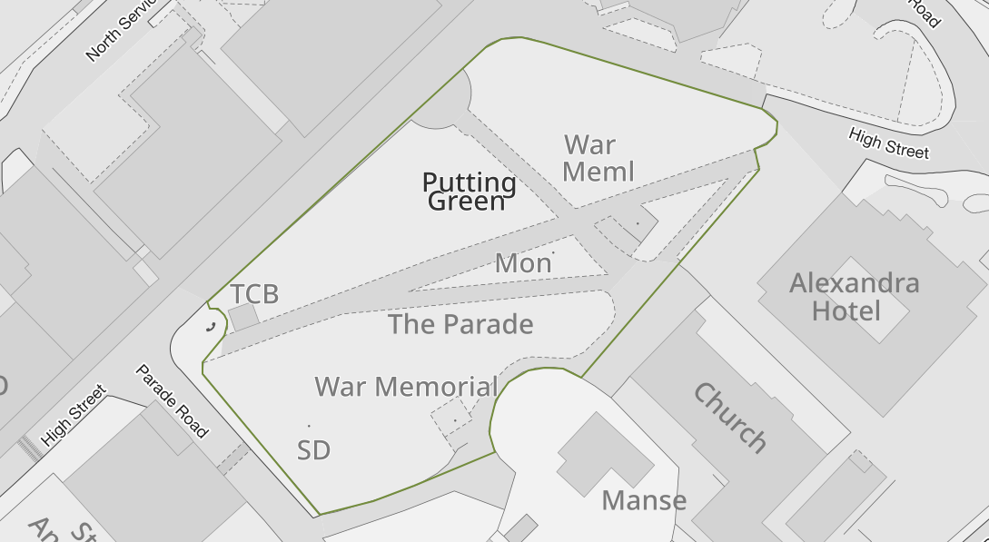
Foreshore, amenity land and part of West End car park
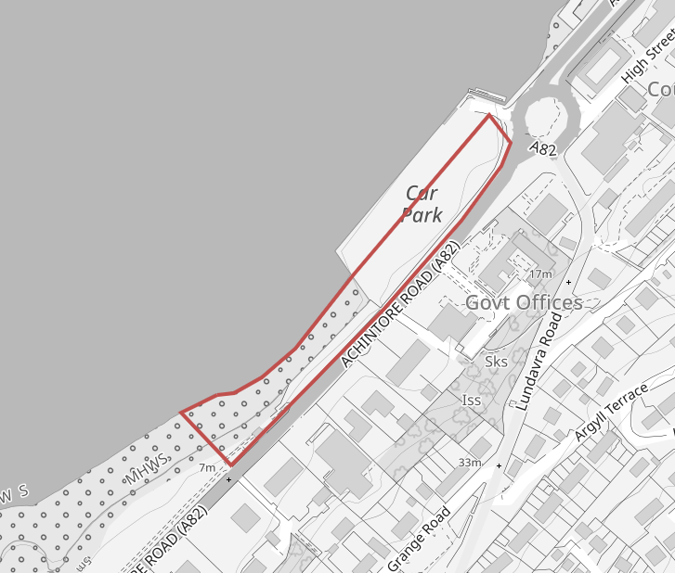
Alma Road/Victoria Road play area
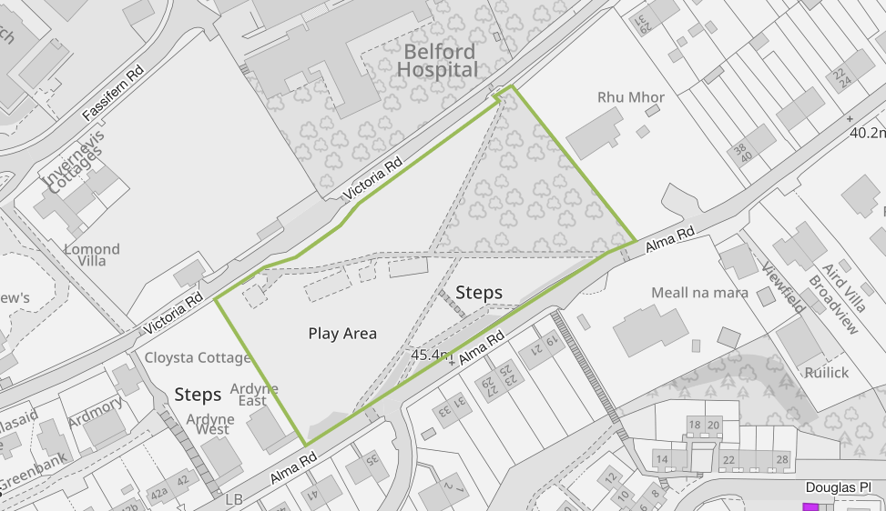
Grange Road play area
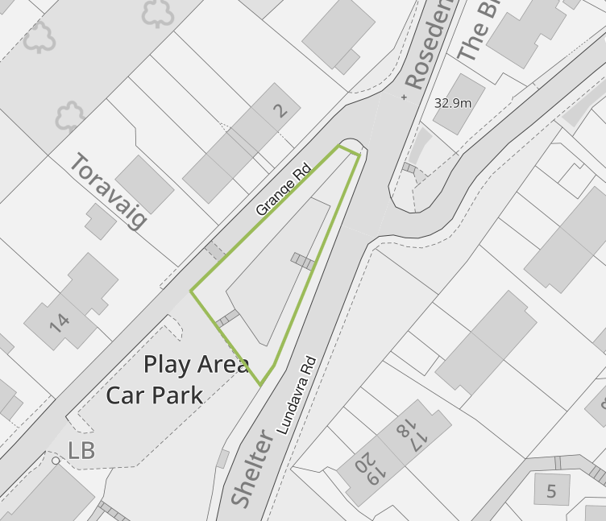
Amenity ground at junction of Union Road and Fassifern Road
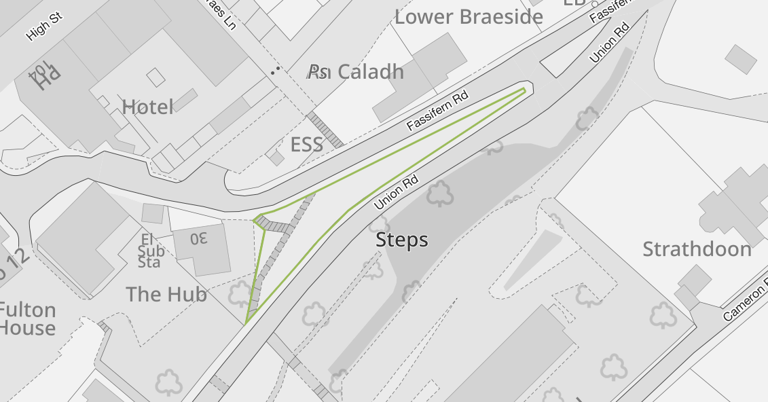

Amenity land at junction of Victoria Road and Hill Road.
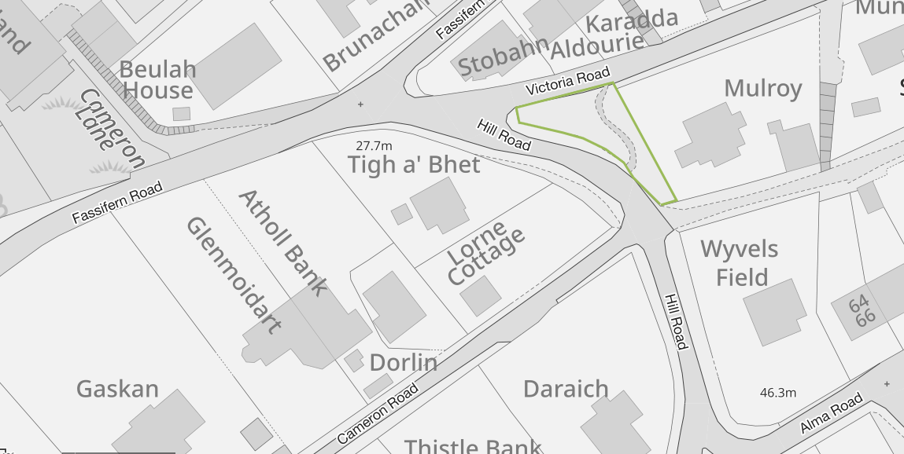

Part of King George’s Field (Town Park) – 2 deeds/areas
1950 addition to King George’s Field
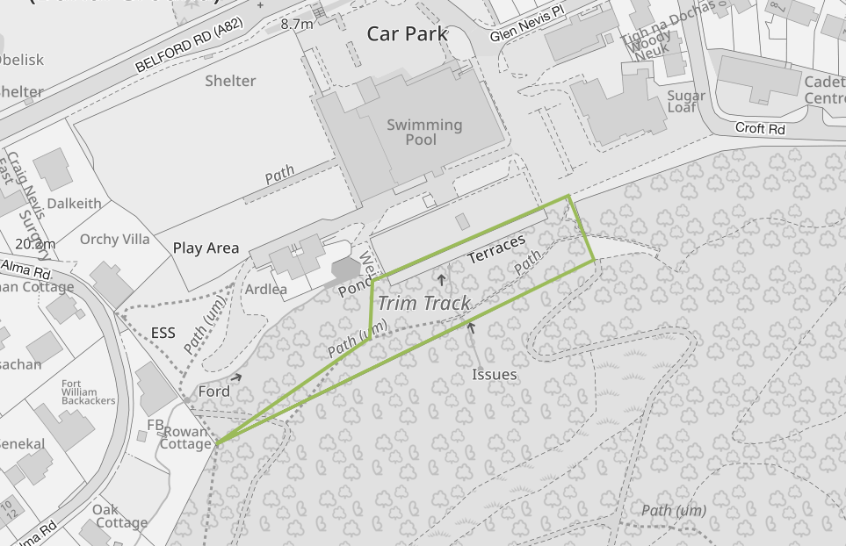
1952 addition to King George’s Field (less area sold for Health Centre and car park)
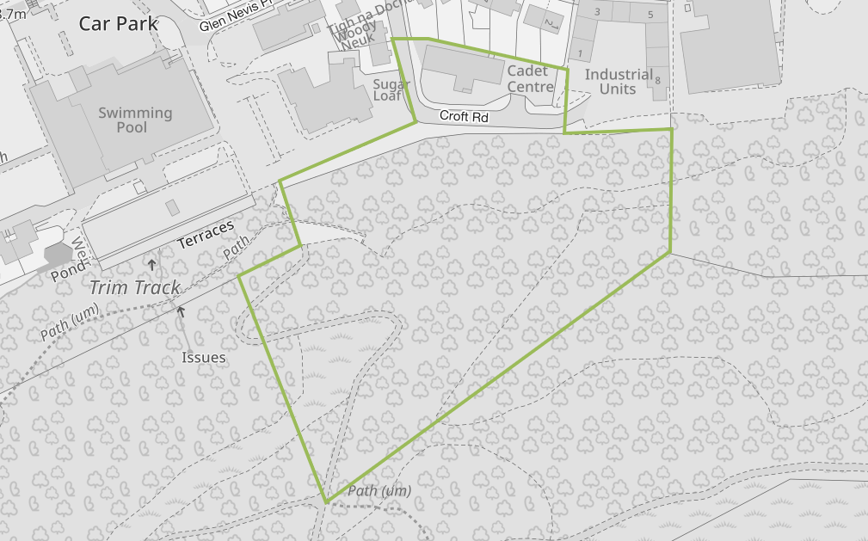
Claggan Park Playing Fields
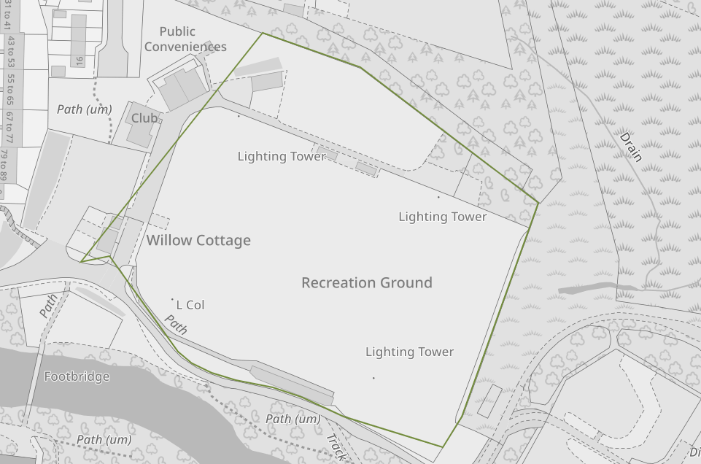
Croft tea rooms
