2023-2024
STANDARDS AND QUALITY REPORT AITHISG INBHEAN IS CÀILEACHD

Kinlochleven Primary School

Introduction: Local and National Context
Ro-ràdh: Co-theacsa Ionadail agus Nàiseanta

This Standards and Quality Report is influenced by both Highland and national priorities. These can be summarised as follows:

Highland Priorities  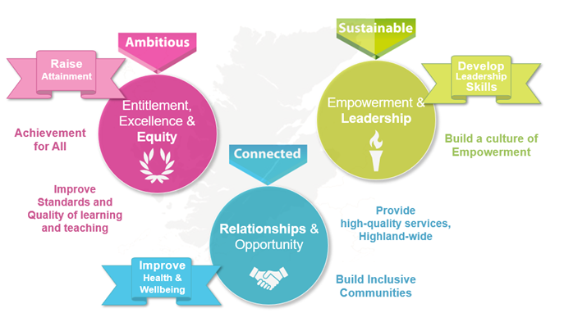  Entitlement, Excellence & Equity:  We will raise attainment and achievement for all, especially for children and young people from disadvantaged circumstances, including rural deprivation. We will focus relentlessly on improving standards and the quality of learning and teaching, to ensure that entitlement, equity and excellence are delivered across the system.  Empowerment & Leadership:  We will develop leadership skills at all levels of the system, for now and the future, building a culture of empowerment and professional capital.  Relationships:  We will maximise health and wellbeing for all children and young people, to give them the best possible start in life. We will ensure every child and young person feels part of the community they live in.  Opportunity:  We will maximise opportunities for our children and young people, and for the wider Highland community and its visitors, through the provision of high-quality services. | National Improvement Framework Priorities  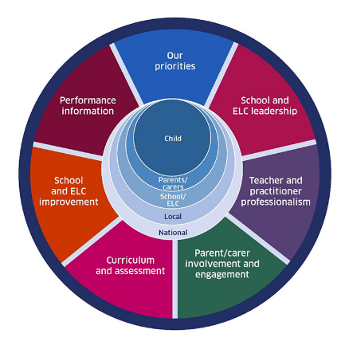  The key priorities outlined in the National Improvement Framework are:  - Placing the human rights and needs of every child and young person at the centre of education  - Improvement in children and young people's health and wellbeing  - Closing the attainment gap between the most and least disadvantaged children and young people  - Improvement in skills and sustained, positive school-leaver destinations for all young people  - Improvement in attainment, particularly in literacy and numeracy.  Self-evaluation  To support self-evaluation, quality indicators from the national evaluative framework How Good Is Our School?4 are referenced.  Links to these sources (and others referenced) can be found here:  National Improvement Framework Improvement Plan  HGIOS? 4 and HGIOELC  Health and Social Care Standards  National Gaelic Language Plan
In this report the following words are used to describe the numbers and proportions used:

All | Almost all | Most | Majority | Less than half | Few
100% | Over 90% | 75% - 90% | 50% - 74% | 15% - 49% | Up to 15%

We are pleased to present our Standards and Quality Report for Session 2023-24. This report forms part of our quality improvement framework and provides important information regarding our school’s progress to date and our next steps in school improvement.

Self-Evaluation for Self-Improvement is at the heart of our practice. We continue to develop our practice in making robust use of evidence as a basis for judgements regarding the impact of our work on our learners. All staff understand that self-evaluation is an integral aspect of our approach to continuous improvement through addressing the 3 key questions:

- How well are we doing?
- How do we know?
- What are we going to do now?

Throughout the year we continuously evaluate what we do and how it makes a difference to our learners. We want to know what is working well for our school community and what needs further improvement. We inform decision making and actions through a continuous process of looking inwards, outwards and forwards.

Looking inwards - starts with those working with our children and young people
We focus on the impact on outcomes for learners. Our self-evaluation processes triangulate information, data, people’s views and observation of practice to measure impact and inform planning for improvement.

Looking outwards - learning from others
Looking to others for new ideas that challenge our practice and support continuous improvement allows us to learn from what works and what doesn’t. This includes practice in other schools, learning communities and learning from educational research.

Looking forwards - creating a vision and planning for implementation
Through leadership at all levels, we anticipate challenges and explore creative solutions. This helps us to create an aspirational vision for our school which shapes our actions and provides a focus for improvement.
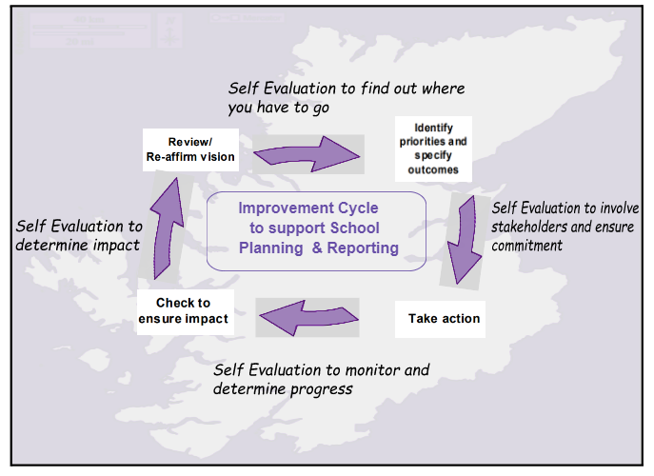
Our children and young people are actively consulted and involved in this process. We also give staff, parents/carers, and other partners the opportunity to participate in discussions and activities to shape our improvement journey.

When we develop our improvement plan, we use key questions at scheduled review times throughout the session to know how well we are progressing towards achieving these positive outcomes and changes.

Together we are working hard to ensure the Highlands is the best place for children and young people to grow up safely, learn, develop and achieve.

With positive experiences, our children and young people will always see the Highlands as home.
Le eòlasan deimhinneach, bidh ar cloinn is ar n-òigridh daonnan a’ faicinn na Gàidhealtachd mar dhachaigh.

Lauren Morrison
Head Teacher
Kinlochleven Primary School

School Profile
Pròifil na Sgoile

The following information can be found on Parentzone Scotland. It is important to remember that statistical data alone is not a measure of how well we are doing. All schools are unique. To understand how well we are doing it is important for us to look at a range of different data sources.
Attendance  94% |  | Average Class Size  16.7 |  | Meeting PE Target  Target Met
Pupil Numbers (inc nursery)  48 (+ 10 nursery) |  | Teacher Numbers  4 |  | Pupil Teacher Ratio  14.3

Kinlochleven Primary School is part of a small rural 3-18 campus located in the village of Kinlochleven. The campus includes a nursery, secondary school and Kinlochleven Primary School. The roll is currently 48 with children organised across three composite classes, P1-2, P3-4 and P5-7.

There is a separate nursery for 3 and 4 year olds.

The depute has overall responsibility for the day-to-day management of the primary school. The headteacher has overall responsibility for the leadership of the 3-18 campus.

As the school roll comprises a small number of children, attainment and progress will be expressed in ‘overall’ statements, rather than specific year groups or Curriculum for Excellence levels. This is to ensure the identity of individuals is not disclosed.

Overall, attainment across the school in literacy and English and numeracy and mathematics is satisfactory. The majority of children achieve appropriate CfE levels in literacy and numeracy. Across the school, a number of children could be achieving more. The majority of children who face barriers to learning are making satisfactory progress towards meeting their individual targets.

Overall children are making the following progress:

Reading |  | Writing |  | Listening and talking |  | Numeracy
Satisfactory progress |  | Satisfactory progress |  | Satisfactory progress |  | Satisfactory progress

We have had no exclusions this year.

School vision, values and aims
Lèirsinn, luachan agus amasan na sgoile

Vision
At Kinlochleven 3-18 Campus we believe that a happy child is a successful child. We believe that to ensure success for each of our pupils we need to provide a high-quality education in a safe, respectful and inclusive environment, which builds a foundation for life-long learning.

At Kinlochleven 3-18 Campus we believe that working collectively and creatively with our whole school
community ensures positive and sustained successes for our pupils.

Values

Respect Aspiration Resilience Equity

School Motto
“Small school, big ideas”

Aims
At Kinlochleven 3-18 Campus we aim to:
- provide a safe environment that is built on mutual respect
- be aspirational for every pupil, preparing them for future life
- support our pupils to build their resilience
- embed equity and equality into the campus ethos

This session, we will be revisiting the values and aims with the community to reflect the school’s setting, local heritage and culture.

Review of progress for session
Ath-sgrùdadh air adhartas airson an t-seisein

These projects are linked to the vision and priorities for Scottish Education based on delivering excellence and equity. Parent/Carer information is available here.

School Priority:
3.2 Raising Attainment and Achievement. Focus on the use of assessment and data to improve the attainment and achievement of all pupils.

Purpose:
This project intended to embed approaches and systems to support the use of data to improve outcomes for children and young people through the introduction of:
- cycles of attainment meetings to support progress
- use of data driven dialogue to examine patterns and trends in performance and to identify ‘root cause’
- use of a variety of data to support discussions about progress

Progress:  - Primary school staff used National Standardised Assessments (NSA) and Scottish Online Formative Assessments (SOFA) to assess progress in literacy and numeracy  - A calendar cycle of attainment meetings and yearly assessment schedule was established  - Teaching staff participated in school and cluster wide moderation activities to support judgements about achievement of a level  - High quality assessment tasks were created to provide children with an opportunity to apply key learning and skills in new and unfamiliar contexts  - Early Years Practitioners attended floor book training and began to use these to record key learning in nursery | Impact:  - Approaches to assessment have been impacted by the changes of leadership. This has reduced teacher confidence in the use of assessment to inform planning and to support their judgement of children’s progress.  - A few teachers have meaningful evidence to show children’s progress within stages and through a level, however, this is not consistent in all classes.
Next steps:
- The headteacher and depute headteacher will support teachers to review assessment approaches and reintroduce an agreed assessment programme.
- Teachers will take part in Highland Moderation Collaborative, together with school and cluster moderation, to support further their confidence in accurately judging children’s achievement of a level.
- Teachers will reengage with national Benchmarks and review assessment tasks.
- Formative assessment will be used meaningfully during learning and teaching to ensure children have the correct level of difficulty and pace in learning.

School Priority:
2.3 Learning, Teaching and Assessment

Purpose:
To enhance learning and teaching across the campus with a particular focus on professional learning. The key themes were:
- staff professional development
- adopting researched, evidence-based pedagogy
- establishing a learning culture in school for both staff and students

Progress:  - Staff worked together to identify and agree what makes a good lesson.  - A monthly focus on an aspect of learning and teaching was planned.  - Observations of learning were undertaken.  - The depute headteacher has introduced a helpful peer and self-assessment check list for writing tasks. | Impact:  - In almost all lessons, teachers share the purpose of learning with children and explain clearly what success looks like.  - In a few lessons, teachers encourage children to co-construct their success criteria. In almost all lessons, teachers provide children with clear instructions and explanations for tasks and activities.  - Teachers use a range of questioning techniques to support children's engagement in learning.  - In almost all lessons, teachers provide tasks for children which are clearly structured.  - A few teachers provide learning at different levels.  - Teachers provide children with helpful oral praise and feedback during learning.  - Writing guidance has provided children with clear guidance on the expectations in writing. This writing guide is beginning to have a positive impact on children’s understanding of the specific steps required to improve their writing. Children use these well as they develop the skills to give effective peer feedback.
Next steps:
- Share and develop the co-construction of success criteria practice across the school.
- Extend the use of questioning to check children’s understanding and to challenge their thinking.
- Collectively review the features of high-quality learning and teaching to create a shared approach.
- Allow opportunities for teachers to share good practice.
- Moderation to become a more regular feature of professional learning time.
- Build in regular opportunities for children to build the skills to co-operate and learn more successfully in groups.
- Develop agreed and robust planning approaches. Introduce collaborative planning meetings to ensure all learning is planned well to meet the varying needs and the range of abilities in each class.
- Monitor quality of written feedback to support children to know how to improve in learning.

School Priority:
3.1 Ensuring Wellbeing, Equality and Inclusion

Purpose:
This was an ambitious and wide-ranging project aimed at ensuring wellbeing, equality and inclusion for all children and young people while also contributing to reducing the poverty related attainment gap and raising attainment and achievement. The project will included the following:
- appointment of a Children’s Service Worker (1.0fte)
- provision of equipment for all
- provision of outdoor learning opportunities to support mental health and wellbeing, including purchasing a polytunnel
- development of policies
- participation in the Equally Safe at School initiative
- use of HGIOURS to improve student voice
- work towards Rights Respecting Schools accreditation

Progress:  - A Children’s Service Worker was appointed in October 2023  - An Equipment for All store has been created to ensure all children and young people have access to what they need.  - Staff reviewed Highland Council policies to ensure existing school policies were aligned.  - Pupil voice groups have been recently established. | Impact:  - All staff have created a welcoming and inclusive environment which supports children to feel safe and happy in school.  - Children are supported well by partners, including from Children’s Services. They take part in group sessions and activities to develop their confidence and learn strategies to help them when they are upset or worried.  - Partners currently deliver a few clubs and a daily breakfast club which is free to all.  - Children are learning about their rights through a newly formed pupil group, led by a class teacher. All classes have developed their own helpful class charters and children’s rights are discussed appropriately as part of assemblies. This is supporting all children to understand the expectations of their behaviour and what they can expect from all adults.  - Staff follow The Highland Council Promoting Positive Relationships Framework which helps them to support children’s behaviour well.
Next steps:
- Staff should work together to share good practice and agree shared approaches to support positive behaviour. This will support all children to know how adults will respond and support them.
- Continue to collate and analyse this information from wellbeing trackers to identify trends or areas which require further support. Use these trackers to plan interventions.
- Record the impact of interventions on children’s progress and plan further action based on this data.

Progress and impact of Pupil Equity Fund
Adhartas agus buaidh Maoin Cothromas Sgoilearan

Pupil Equity Fund (PEF) provides a free breakfast club for the campus, run by partners. This ensures children have a daily opportunity to have food when they come to school, which is supporting children to engage better in learning. Support staff provide literacy and numeracy interventions for a few children who require support to make progress with learning.

Our next step is to ensure they measure more robustly the impact of interventions, particularly for children impacted by the poverty related attainment gap. This will ensure PEF is used effectively to close gaps in learning.

Wider achievements
Coileanaidhean nas fharsainge

Children’s achievements are celebrated at assemblies and in classes. Children receive certificates linked to the school values and for achievements within and out with school, for example music awards. Children are proud of their successes and value the experiences they take part in.

Children are achieving a few skills, including teamwork and problem solving, through being involved in a few sporting clubs and events which include Ninja and football. They would like more opportunities to take part in clubs and events.

Comments from learners, families, stakeholders and staff
Beachdan bho luchd-ionnsachaidh, teaghlaichean, luchd-ùidhe is luchd-obrach

The school was recently inspected in May 2023. Surveys completed by children, families, stakeholders and staff can be found here: survey link

Capacity for continuous improvement
Comas airson leasachadh leantainneach

Using indicators from ‘How Good is our School 4’ together with learner, parent, carer, partner and community feedback we believe we have made the following progress this session:

 | ELC | PRIMARY
QI 1.3  Leadership of change | Satisfactory | Satisfactory
QI 2.3  Learning, teaching and assessment | Satisfactory | Satisfactory
QI 3.1  Wellbeing, equality and inclusion | Satisfactory | Satisfactory
QI 3.2  Raising attainment and achievement/Securing children’s progress | Satisfactory | Satisfactory

Our overall evaluation of our capacity for continuous improvement is:
We are confident in our capacity for continous improvement.
Key priorities for improvement planning
Prìomhachasan airson planadh airson leasachadh

Key priorities for next session are:
- Raising attainment in numeracy
- Raising attainment in literacy with a particular focus on reading comprehension and listening and talking. We are also taking part in the national writing programme.
- Assessment and moderation

Planning ahead
A’ planadh air adhart

Full details of the school’s 2024/25 improvement priorities and actions are detailed on the school improvement plan, which can be accessed on our website or by contacting the school office.

