**1. Attendance & Apologies**

**2. Action Note from previous meeting 28th November 2014 – Matters Arising**

**3. District Partnerships, Community Development and Community Planning**

**Bill Alexander,** **Director of Care and Learning, Highland Council**

**4. Integrated Adult Services - Overview of Adult Social Care Initiatives**

**Joanna Macdonald, Director of Adult Social Care, NHS Highland and**

**Deborah Jones, Chief Operating Officer, NHS Highland**

**5. A.O.C.B.**

**Next Meeting – Wednesday 24th June 2015**

**INVERNESS EAST DISTRICT PARTNERSHIP**

Wednesday 18th March 2015

Council Chamber, Town House, Inverness, Inverness

10 a.m. – 12 noon

Agenda

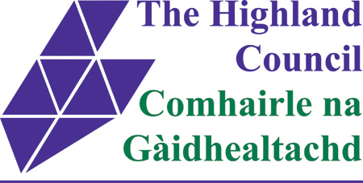

[NHS Highland Logo](http://www.nhshighland.scot.nhs.uk/)