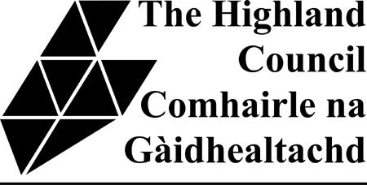

Cromarty Firth Ward and Tain & Easter Ross Joint Ward Forum

Wednesday 18th March 2015
7.30 pm to 9.30pm

Invergordon Social Club, Castle Road, Invergordon

AGENDA

1. Welcome and introductions
2. The Council’s Planning Policy on Wind farms – presentation followed by Q&A session
3. Community Resilience
5. AOB and Public Question and Answer Session

