Agenda

1. Welcome and introductions
2. Notes from Meeting on 20 March 2014
3. **Community planning and development**
   1. Merkinch community development (cradle to grave resilience) – Wendy Allman/Donellen Mackenzie/Sandra MacAllister/Pablo Mascarenhas
4. **Developing the Change and Improvement Plan**
   1. Community led best practice discussion:
      1. Glen Urquhart Care Project
      2. Beauly cares
      3. Boleskine Cares
5. Youth activities in the Aird – Andy Macleod
6. Public views/suggestions
7. Date of next meeting – Friday 18th September 2015 (10 – 12 p.m.)

Members of the public are welcome to attend and observe this meeting

For further information contact Charles Stephen on 01463 785010

**INVERNESS WEST DISTRICT PARTNERSHIP**

Friday 19th June 2015

Phipps Hall, Beauly

10 a.m. – 12 p.m.

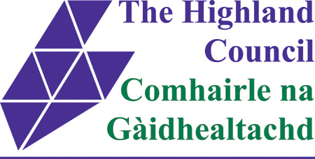

[NHS Highland Logo](http://www.nhshighland.scot.nhs.uk/)