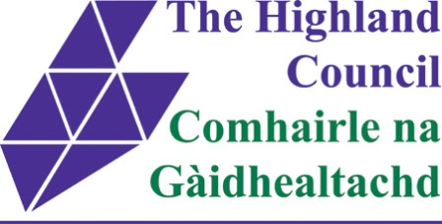
INVERNESS EAST DISTRICT PARTNERSHIP
Wednesday 16th December 2015
Raigmore Community Centre
10 - 12 a.m.
Agenda

1. Attendance & Apologies

2. Action Note from previous meeting 17th September 2015 –
Matters Arising

3. Hilton Networking Group – Feedback

Jay Muirhead, Chief Development Officer,
Signpost

4 Home Energy Scotland Update

Alan Grant, Home Energy and Partnership Liaison Officer,
Home Energy Scotland

5. Meeting Dates 2016
- 18th March
- 17th June
- 16th September
- 16th December

6. A.O.C.B.

