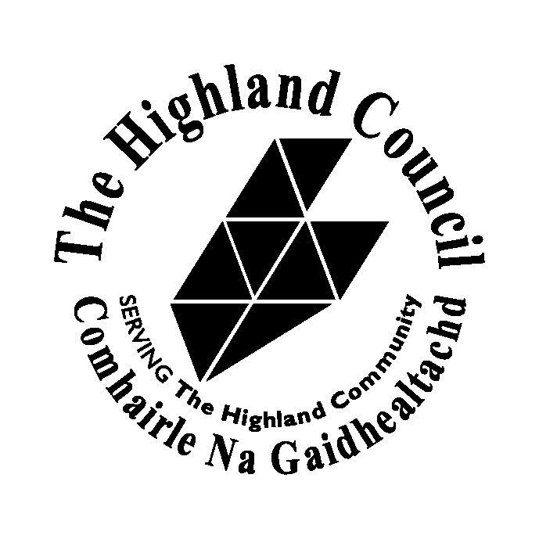

MEMBERS INSURANCE COVER

Insurance cover provided by Highland Council for Members falls within four classes, Liability, Libel & Slander, Personal Accident and Business Travel. Loss of No Claims Discount/Excess is a voluntary scheme. The cover provided is explained in more detail below:

If you have any queries or require advice in relation to the insurance cover provided or in connection with a claim please contact: Insurance & Risk Management Section, Finance Service, Glenurquhart Road, Inverness.

Ailsa Mackay | Insurance & Risk Management Manager | (01463) 702414
Colin Mackenzie | Insurance Assistant | (01463) 702417

Fax: (01463) 702004

Email: insurance_services@highland.gov.uk

PUBLIC LIABILITY

In the event of negligence being found against any Member, the Council’s Public Liability insurance policy will indemnify that Member against legal liability in respect of damages and claimants costs incurred arising from injury to any person or damage to property.

Limit of liability £25 million

OFFICIALS INDEMNITY

The policy provides indemnity in respect of negligent acts, errors or omissions committed in good faith by Members in the course of the Council’s business.

Limit of Indemnity £2.5 million

LIBEL & SLANDER

Cover applies in respect of all claims first made against the Council arising from Libels or Slanders made by Members’ in the course of their duties.

Cover is not provided in respect or oral slander by a Member against any other Member or Official of the Authority.

Limit of Indemnity - £1 million (Member contributes 10% of the cost of claim.

PERSONAL ACCIDENT

Cover is provided for any Member of the Council less than 80 years of age as follows:

Death | £100,000
Loss of limbs or sight | £100,000
Permanent total disablement | £100,000
Permanent partial disablement | £10,000
Temporary total disablement | £300 per week for 104 weeks

LOSS OF NO CLAIM DISCOUNT AND EXCESS

The policy covers loss of or reduction in No Claims Discount and payment of any excess incurred as a result of an accident involving a motor vehicle registered under the scheme, which at the time of the accident was being used on Council business.
Under the terms of the policy only Members or designated drivers advised to Insurance Services are covered under the scheme.

Any Member wishing to join the scheme should complete the attached
application form for each vehicle to be insured under the policy and return to Insurance & Risk Management Section. (Please Click Icon)

Cover is provided as follows:

1. | In the event of a loss of No Claims Discount the insurer will pay the loss of or reduction in the ensuing years No Claim Discount between that earned and that which would have been earned had the accident not occurred.
2. | The calculation of the amount to be paid will be based on the scale of No Claims Discount in force at the time of the accident.
3. | On request the person insured will provide from their motor car insurer evidence stating:  - The amount of No Claims Discount permanently lost  - The scale of No Claims Discount  - The date of the accident and location  - The amount and reason excess applied

Exceptions Insurer will not be liable for:

Temporary payment of excess or loss of No Claims Discount. An insurer may pay excess or remove No Claims Discount on the basis that they could be returned if after the accident had been investigated it was ruled that the driver was blameless. On this basis insurers are not prepared to accept a claim until the No Claims Discount or payment of excess will actually stand.

Claims Procedure

In the event of an accident a completed claim form must be submitted within 30 days of incident. Please contact Colin Mackenzie, Insurance & Risk Management Section for a claim form.

BUSINESS TRAVEL

Where Members travel abroad on Council business a separate insurance policy has been taken out to provide the wider range of cover necessary when Members undertake these duties. Business Travel form can be completed online (Please Click Icon)

Information regarding cover is provided on form.

